

User Manual

Team Freeware

**Staff Engagement, Visualisation & Experience Engine (Steve)**

Team members

Ali Mohammed

Alex Mccoy

Duc Hung Tran

Hamza Shaikh

James Worcester

**Lecturer:** Scott Mann

Table of Contents

Index 4

0.0 Attribution 4

0.1 Copyright 4

0.2 Warranties and Contractual Obligations 4

0.3 List of Illustrations 4

1.0 Introduction 5

1.1 Audience Description 5

1.2 Applicability Statement 5

1.3 Purpose Statement 5

1.4 Document Usage Description 5

1.5 Conventions 5

2.0 Introductory Kit 6

2.1 Summary of System Features 6

2.2 Getting Started Guide 6

3.0 User Manual 7

3.1 Identification of services/functionalities (use cases) 7

3.2 Services 8

3.3 Screens and navigation 17

4.0 System Administration Guide 21

4.1 Requirements 21

4.2 Logging into AWS 21

4.3 Setting the Right Region in AWS 23

4.4 Secrets Manager 24

4.5 Cognito 25

4.6 RDS 26

4.7 AWS Amplify 29

4.8 AWS AppSync 31

4.9 Updating AppSync/GraphQL information on the frontend 33

5.0 Installation Guide 34

5.1 Requirements 34

5.2 GitHub & File Structure 34

5.3 Installing the app on Android phones 34

5.4 Installing & Setting up the Development Environment in Windows 10 35

Step 1: Install node.js 16.17.1 LTS 35

Step 2: Install the AWS Amplify CLI 39

Step 3: Configuring the AWS Amplify CLI 41

Step 4: Cloning the GitHub repo 46

Step 5: Install Android Studio & Configure an Android Emulated Device 51

Step 6: Installing Expo and booting up 65

Step 7: Cleaning Up 69

Step 8: Opening the app up again 70

Glossary 72

Bibliography 72

Appendix 72

# Index

Amazon Aurora, 21, 29

Amazon Web Services, 5, 6

AWS Amplify, 21, 29, 31, 33, 34, 39, 41

AWS AppSync, 21, 31

CloudWatch, 27

Cognito, 21, 25, 26, 31

Dashboard, 6, 9, 10, 12, 16, 34

GraphQL, 21, 32, 33, 34

RDS, 21, 25, 26, 29

Secrets Manager, 21, 24, 25, 29

System Administrator, 5

# 0.0 Attribution

## 0.1 Copyright

Copyright for the STEVE app, including all frontend and backend code is attributed to the members of Team Freeware: Ali Mohammed, Alex McCoy, Duc Hung Tran, Hamza Shaikh and James Worcester. Trademarks and brand names appearing in this document are the property of their respective owners.

## 0.2 Warranties and Contractual Obligations

The STEVE application comes with no warranties or obligations and any unintentional damage to hardware or software after installing it is entirely the responsibility of the user.

## 0.3 List of Illustrations

3.2 Services: Illustrations showing app functionality

3.3 Screens and Navigation: Illustrations showing app functionality and navigation

4.0 System Administration Guide: Illustrations showing how to administer and maintain the system

5.0 Installation Guide: Illustrations showing how to install the STEVE app and set up the development environment

# 1.0 Introduction

This document contains the user documentation of the Staff Engagement, Visualisation & Experience Engine (STEVE) for Planit, an NRI company.

## 1.1 Audience Description

This document's intended audience is our client Planit Testing. It contains user information regarding how to interact with the mobile application as well as technical information, which requires some expertise that will be addressed in further depth in the relevant sections.

## 1.2 Applicability Statement

The STEVE mobile application was developed with relation to the Planit employee system and network but it yet to be integrated into their systems.

The hosting of the mobile application and the database was achieved using Amazon Web Services (AWS) and the tools used to code and test were Visual Studio Code and Android Studio. In addition, GitHub was used as the official repository of the mobile application and to house the source code. The current system satisfies the client requirements based on the supplied specification document.

## 1.3 Purpose Statement

STEVE allows creating, assigning, and viewing surveys through the mobile application. In addition, other features include chat channels, a user directory and the creation of teams.

## 1.4 Document Usage Description

The following sections are included in the document:

* Introduction

Provides a succinct overview of the project's objectives and intended consumers.

* Introduction Kit

Offers an overview of system features and a getting started guide.

* User Manual

Includes service identification, description, user interface, and input data for the user to read prior to utilizing the app.

* System Administrator Guide

This section contains the requirements and technical information intended for system maintenance and administration by system administrators.

* Installation Guide

Provides the ultimate how-to and step-by-step solution to download and install STEVE mobile application from the official repository at GitHub.

## 1.5 Conventions

We utilized some visual conventions when creating this user manual. To begin, we employed Microsoft Word's Table of Contents which provides readers with a summary of the document and allows them to easily navigate between sections, with the Calibri font being used throughout. To distinguish headings and subheadings, blue headings were used with a larger font size.

# 2.0 Introductory Kit

## 2.1 Summary of System Features

**- Sign up/Authentication Page**

Allows users to create their own accounts using a verification code emailed to them via Amazon Web Services. Forgotten passwords can be recovered through an emailed code as well. Currently the editing and removal of users must be done through AWS.

**- Team Creation/Allocation**

The ability to create teams and assign users to different teams. This allows users to be allocated specific tasks, chat rooms, surveys and other similar things based on their team allocation. Multiple teams can be assigned to one user, and they may view the other members from the pages in the app.

**- Surveys**

Managers/administration can create and allocate surveys to specific users in multiple forms. They may also view all the surveys that have been created and see a graphical visualization of the survey’s results, which come in bar and line graph form. Other forms may be added in the future if needed.

**- Chat Channels**

A chatroom function is also present in the app like that of current existing apps such as Telegram, WhatsApp etc. With a familiar UI users may create rooms and communicate with other users.

**- User Directory**

Currently the user directory simply lists all the users that have been registered, but a directory search may be added for those who want to quickly find an individual.

## 2.2 Getting Started Guide

Once you get the application installed on your device you can open the app and successfully run it. The first screen that you will be prompted to is the sign in screen, in which, you can sign in using your email and password. If you don’t have an account, you can click on sign up to create an account. Also, if you forgot your password, you can click on reset password.

If you have successfully logged in, you will be prompted to the dashboard screen, where you can see a navigation bar at the bottom of the screen with appropriate icons and names. The table below shows the main activities that you can test and use in the mobile app.

|  |  |
| --- | --- |
| Activity Name | How-to |
| Log in | In the log in screen, input your email and password and click on log in |
| Sign up | Click on the sign-up button in the log in screen, fill out your information and click on the submit button |
| Reset password | Click on the reset password and enter your email, follow instructions in your email to reset your password |
| Create a survey | Navigate to the survey screen, click on create a survey, fill out the information, and hit the button |
| Assign a survey | Select a survey from the list and assign it to the appropriate users or teams |
| Visualize a survey | Select a survey from the list and visualize the data in your choice of diagrams |
| User directory | Navigate to the user directory to find a list of all users |
| Create a chat channel | Navigate to the chat channel, click on the plus icon, fill out the information and hit the button |
| Send and receive texts | Navigate to the chat channel, click on the appropriate chat channel, type your message to send or stay in the chat to view received messages |
| Create a team | Navigate to the team screen, click on create, fill out the information and hit the button |
| View profile | Navigate to the profile screen, view your profile |
| View other user's profile | Navigate to the user directory, click on the user to view their profile |

# 3.0 User Manual

## 3.1 Identification of services/functionalities (use cases)

**Login Page:**

Allows users to sign up to accounts using their email, and a verification code, with a simple credentials check to access the features of the app.

Incorrect inputs will display prompts on the screen and if the user has forgotten their password, they may recover it using the button provided.

**Admin Tools Page:**

Currently the administration page is just for the creation of teams. The admin may create a team and assign members, or view existing teams, and assign them from there. A team description can also be added.

**Home Page:**

Currently this page simply shows the user if they have any assigned surveys.

**Survey Page:**

Here is where the user may create surveys, view all the surveys in the database, and view the results of the surveys in a graphical visualized form. Survey questions may be either on a scale from (agree/disagree) or short answer.

**Chatroom Feature:**

The app also has a chat function, like that of WhatsApp, Telegram etc. Where the user may create chat rooms with a familiar UI.

**User Directory:**

Currently the user directory simply shows the list of users that exist in the database, a search function may be added to access user profiles.

**User Profile:**

A simple UI for a user profile where the user displays some of their information. They may sign out here using the button on the top right.

## 3.2 Services

**User / Admin platforms**

**Log in/Create Account function:**

* The user will be redirected to the app home page where they can pick a variety of options.
* The User can click on the “**Don’t have an account? Sign up**” button and can fill in their credentials and create an account

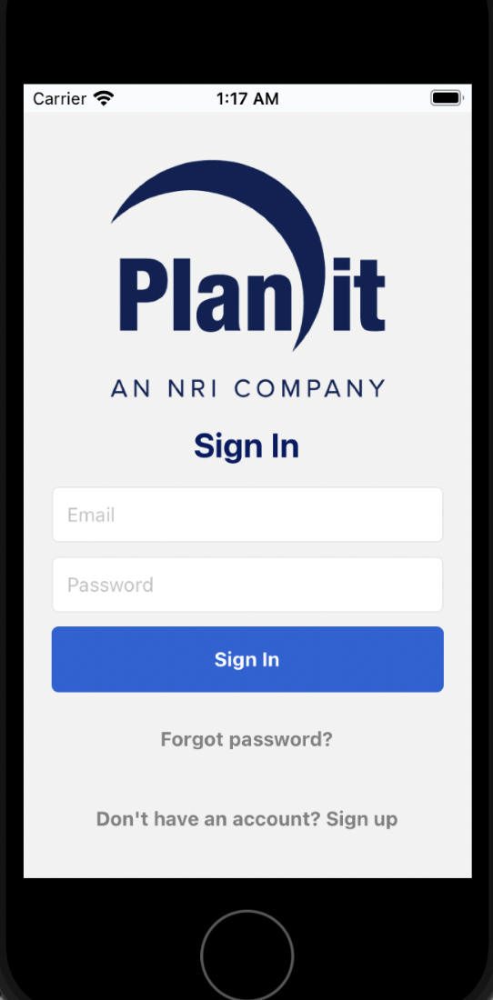

**Dashboard function:**

* Once users have logged in. They will be directed to the home page of the app.
* Users will be able to access every function of the app in the dashboard at the bottom of the screen.
* Features of the app include Admin, Home, Surveys, Chats, Directory, and Profile

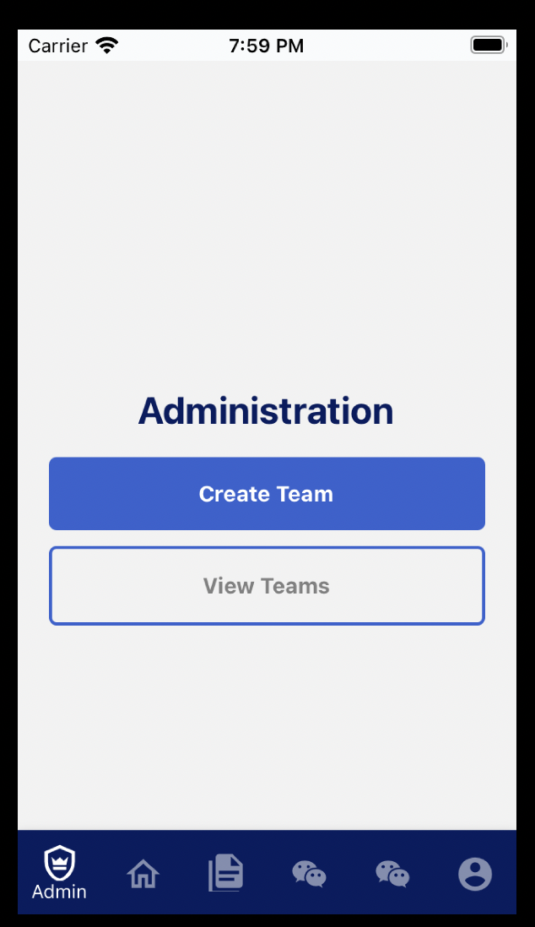

**Team function:**

* If user clicks the dashboard button “**Admin**” they will be able to create a team.
* User can fill in the team description and make a team and add the team members they like.
* Once the description has been filled in, they can click “**Create Team**”.

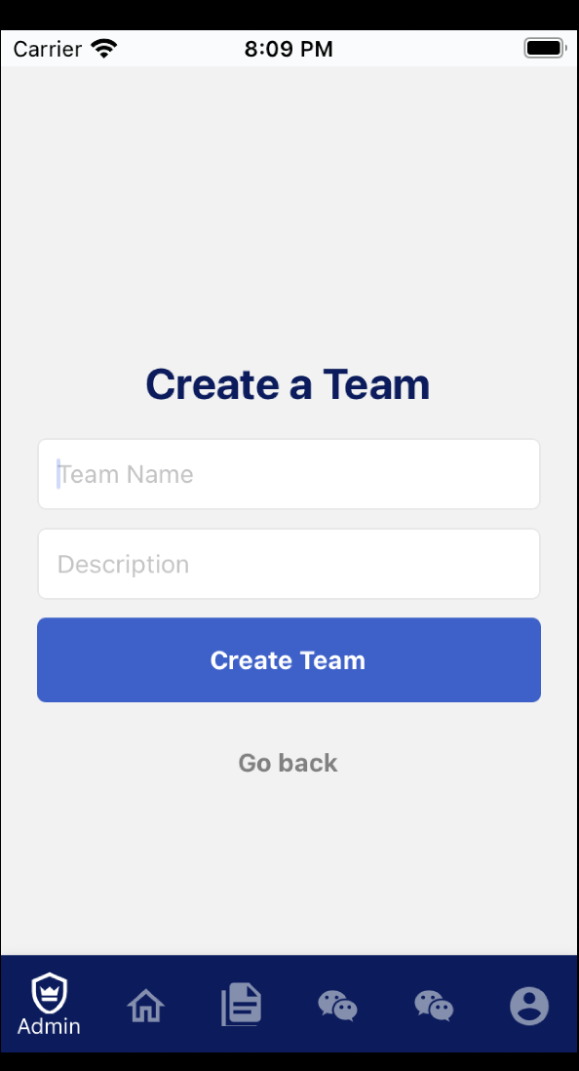

* Once the team has been created the user will have an option to click a button “**View Teams**”. This button will allow them to view the team they just created.

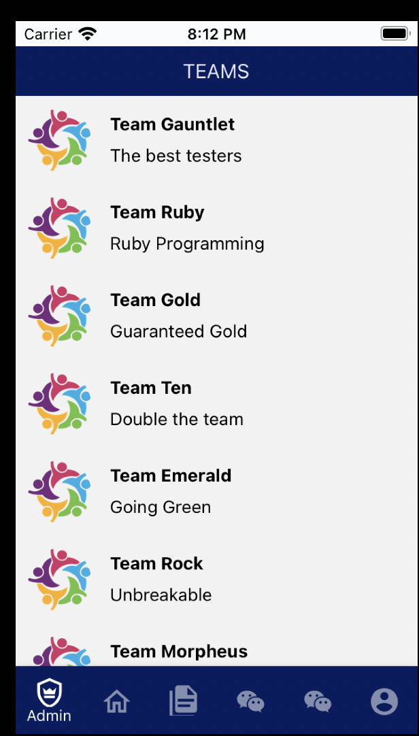

**Survey function:**

* The user can click the “**Survey**” button in the dashboard at the bottom of the app
* 3 options will be displayed. “**Create Survey**”, “**View all Surveys**” and “**View Survey Results**”

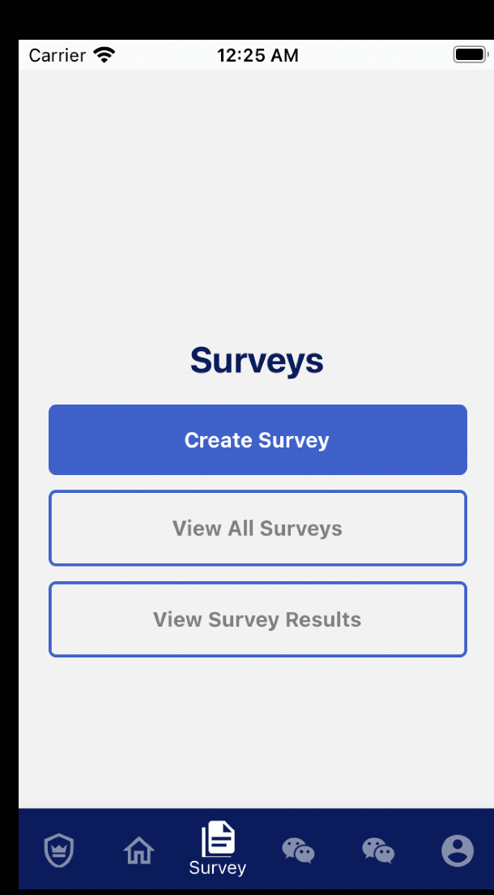

* A User can answer survey questions that have been assigned to them based on how they feel
* When creating a survey, an administrator can change the content of questions and question type to create a custom survey
* Once a survey has been completed survey results can be viewed by clicking the “**View Survey Results**” button
* Users will be able to view all the surveys they have created and view the results of those surveys
* Survey results will be visualised in either a bar graph or line graph to help show the results of each survey

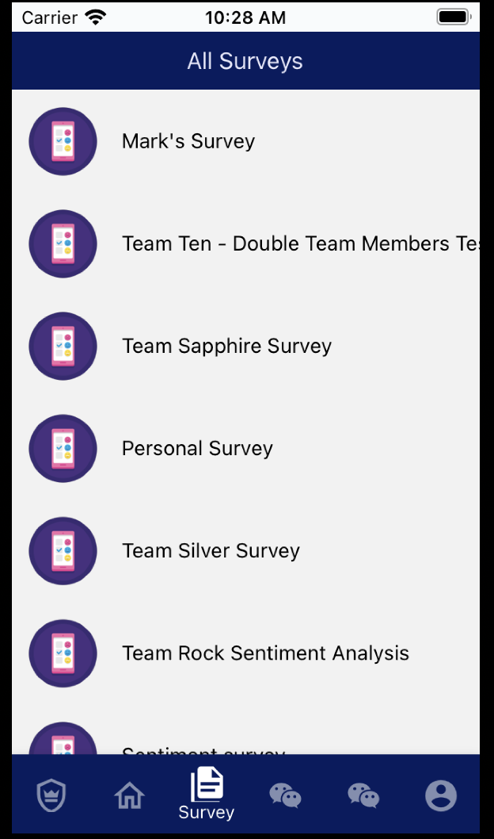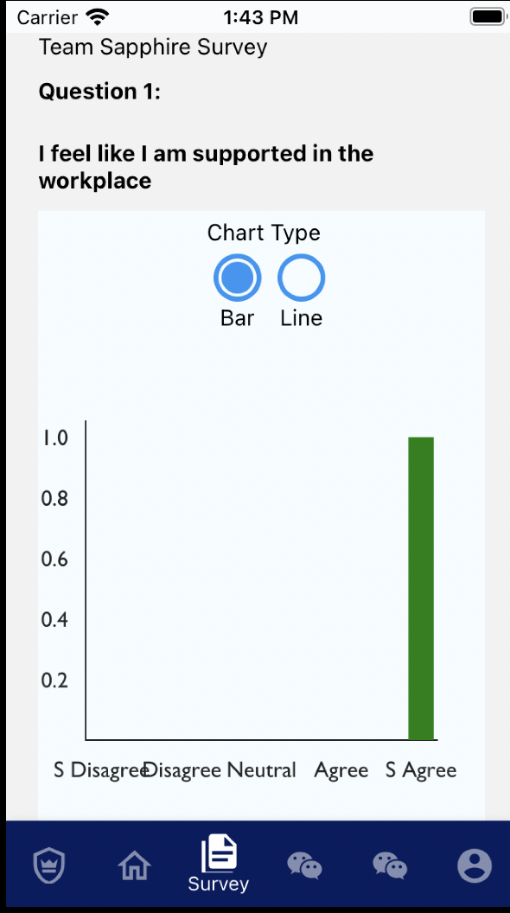

**Chat Channel function:**

* Users can communicate with each other and create their own multi-user chat channels
* A floating “**+**” can be clicked on that will allows the user to create a new chat channel with a description for that channel

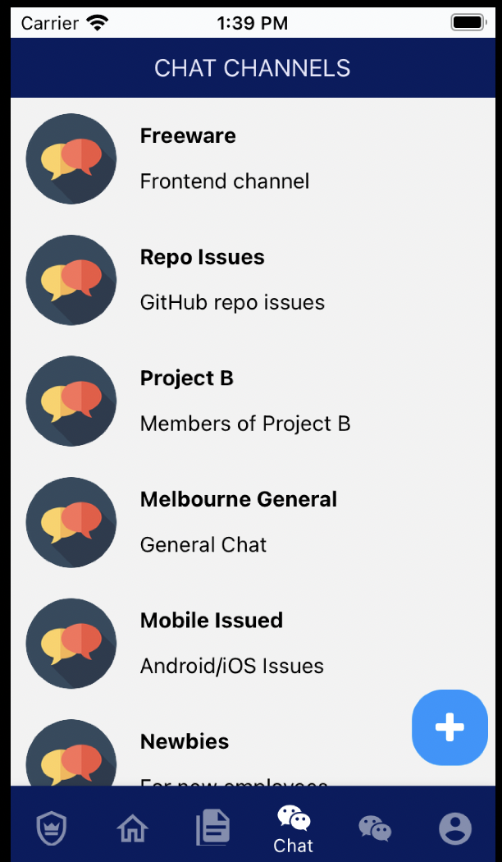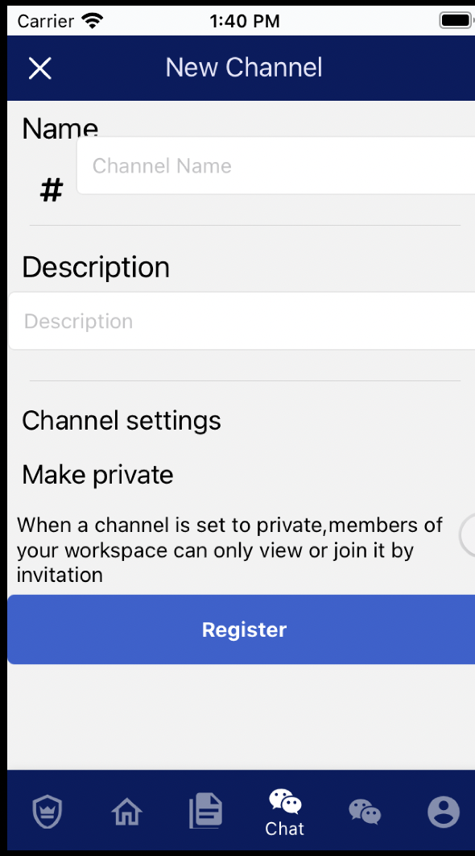

* When viewed, a chat channel will clearly show the other people you are speaking with and will allow you to send and view messages

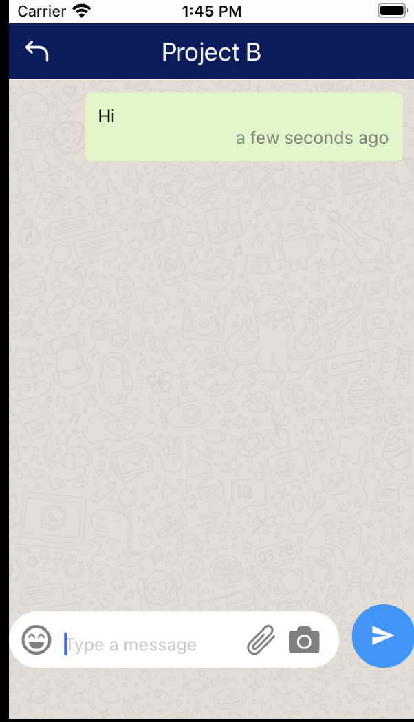

**User Directory function:**

* Users can click the **“Directory”** button in the dashboard to view a list of all users, and can click on a user to view their public profile

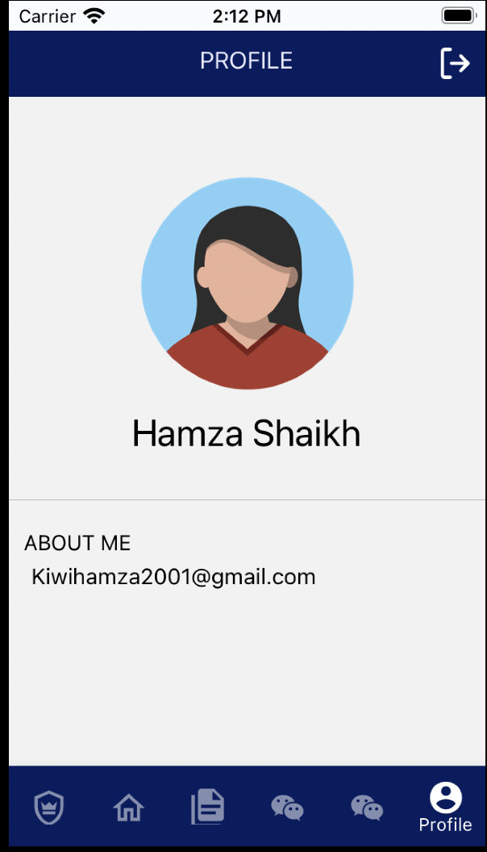

**Profile function**

* The final feature of the app is the User Profile. Uses can click this button in the dashboard to view their profile

## 3.3 Screens and navigation

**Authentication function:** Sign in screen, sign up screen and forgot password screen

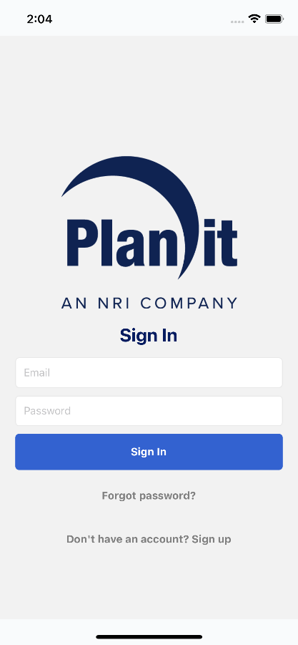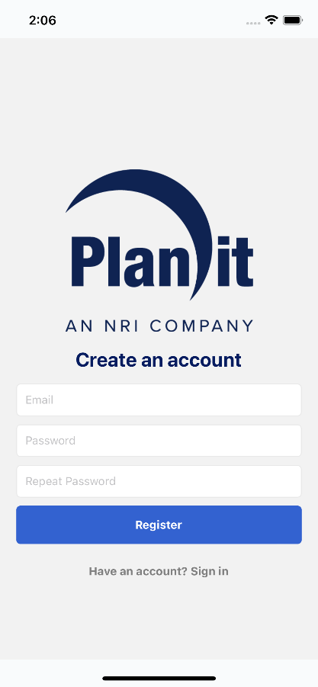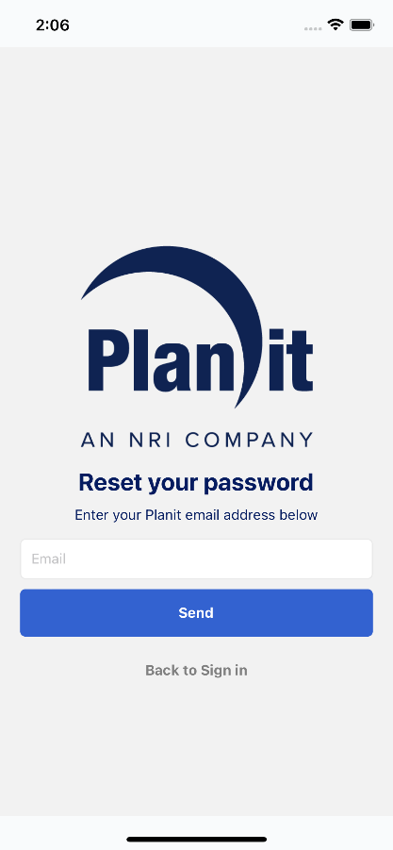

**Survey function:** Survey tab screen, create survey screen, all surveys screen and survey results screen

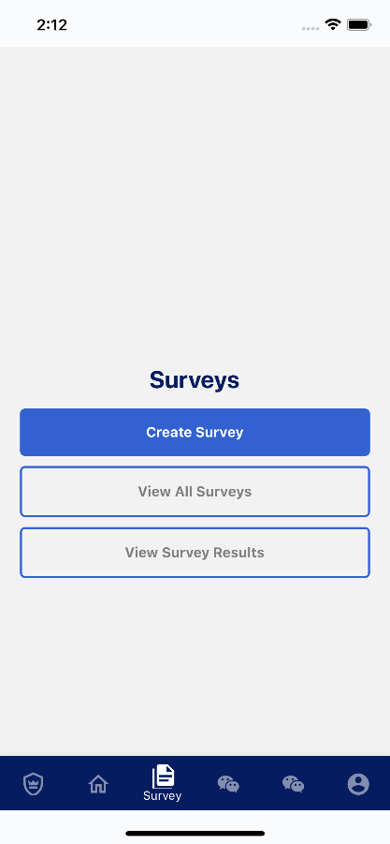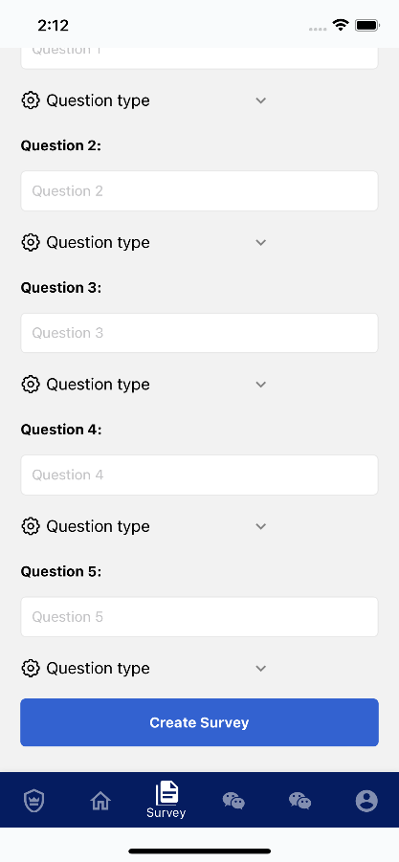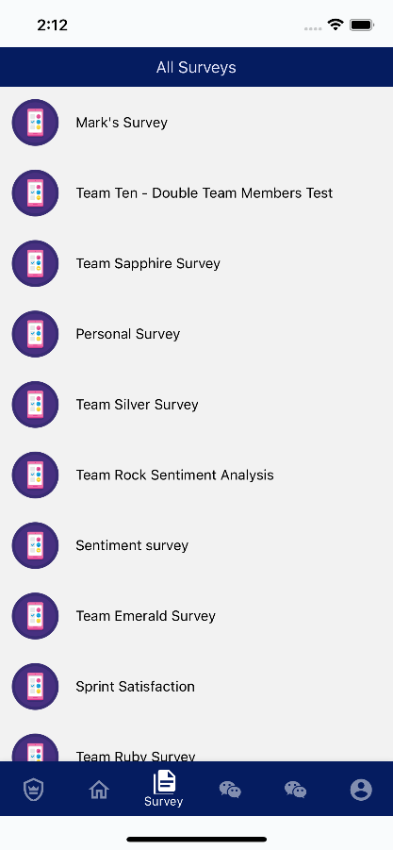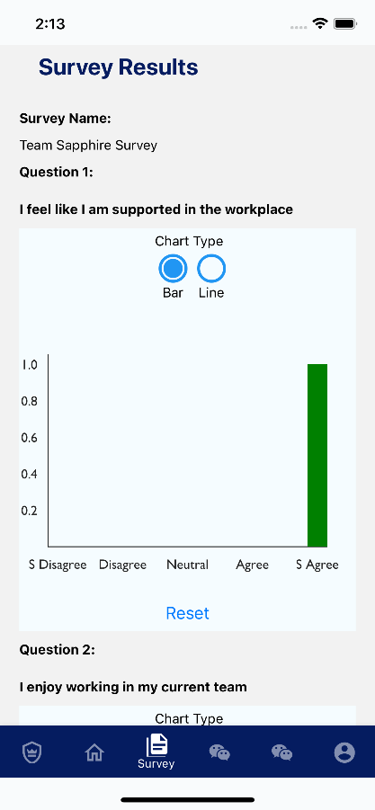

**Team function:** Admin tab screen, create team screen, list of team screen, add new mem screen

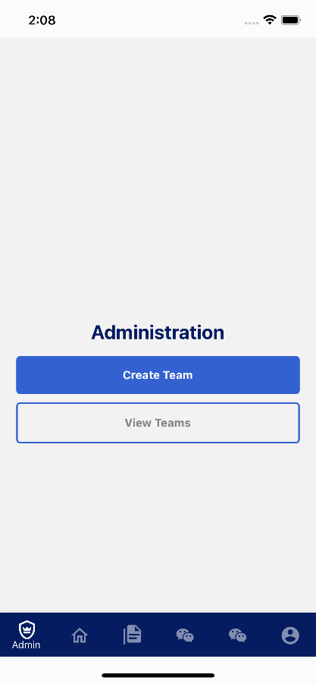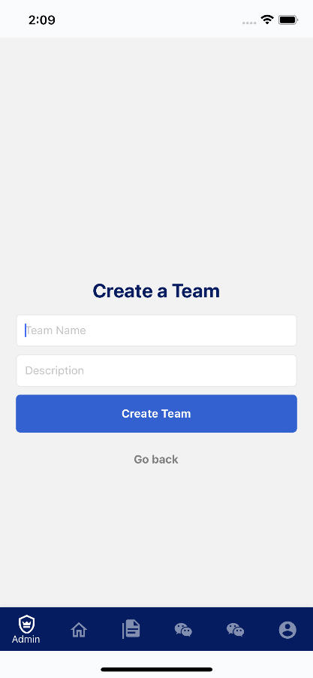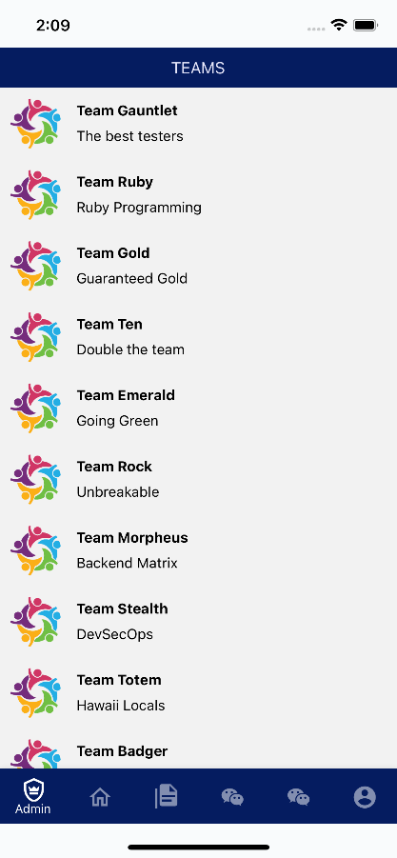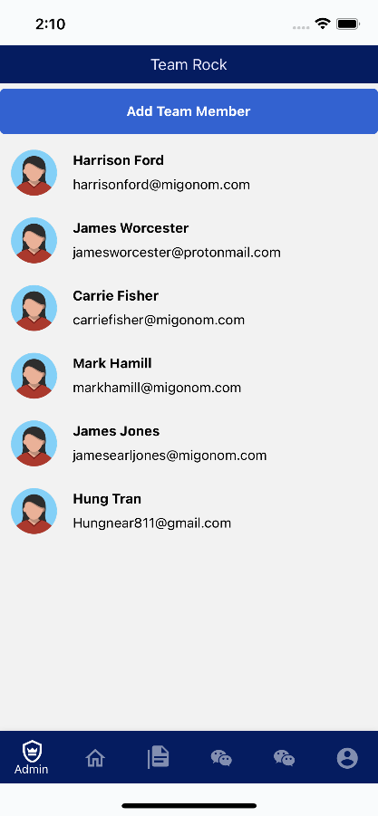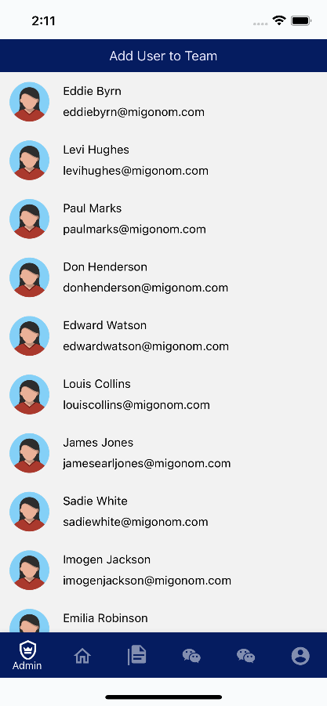

**Chat function:** List of channel screen, chat screen and create new channel screen

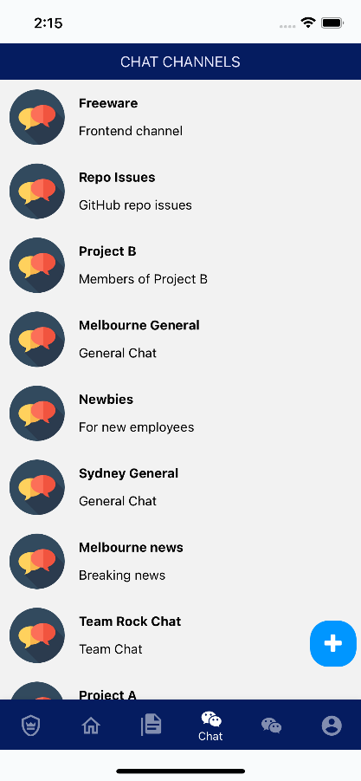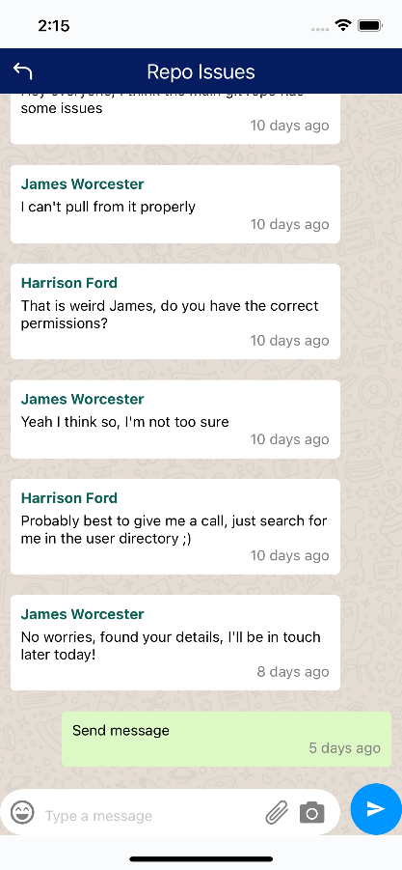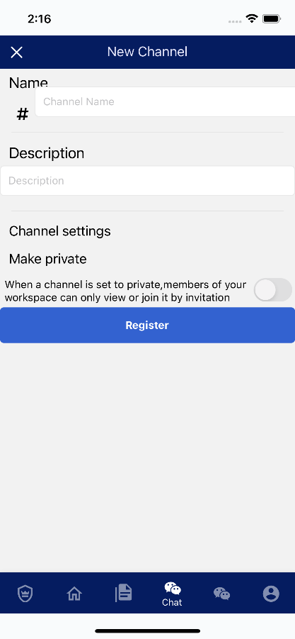

**User Directory screen and Profile screen:**

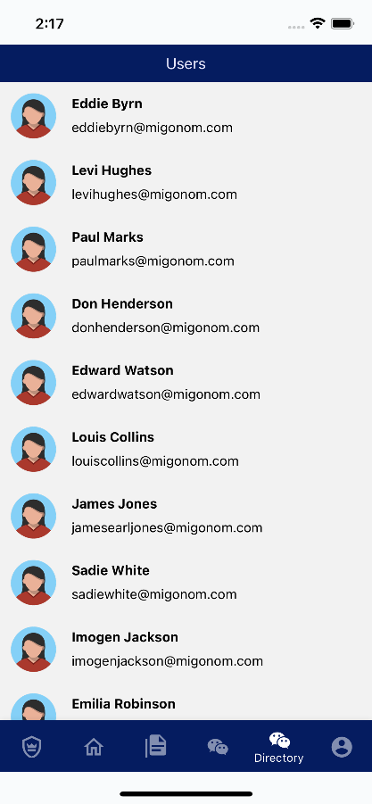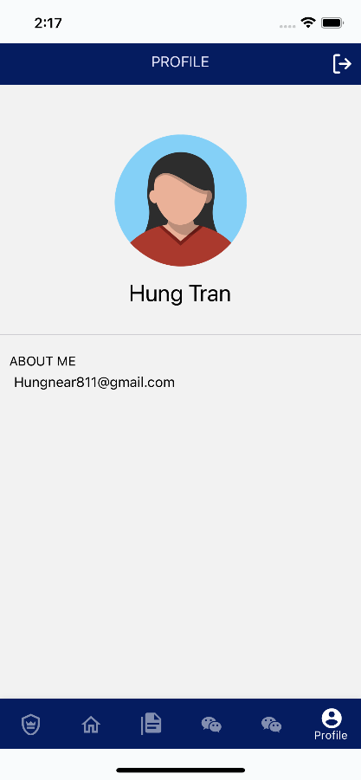

# 4.0 System Administration Guide

This system administration guide is intended for administrators who have at least a basic understanding of AWS and its services, and provides information on how to properly administrate the backend, API and frontend of the Team Freeware STEVE app. It covers topics including the AWS services: RDS, Amazon Aurora, Cognito, Secrets Manager, AWS Amplify and AWS AppSync; as well as how to sync the AppSync/GraphQL API on the frontend after changes have been made to it on AWS.

## 4.1 Requirements

1. You must have been supplied with an AWS Administrator account with a username and password

2. If you intend to administrate the frontend, including syncing the GraphQL code on the frontend, please follow the Installation Guide further on in this guide for installing and setting up the development environment in Windows 10, and make a note of the requirements for it.

If you don’t have access to these details, please contact James Worcester from Team Freeware and we will provide them to you.

## 4.2 Logging into AWS

1. To start, navigate to <https://aws.amazon.com/console/> and click the ‘Sign In’ or ‘Log In’ button:

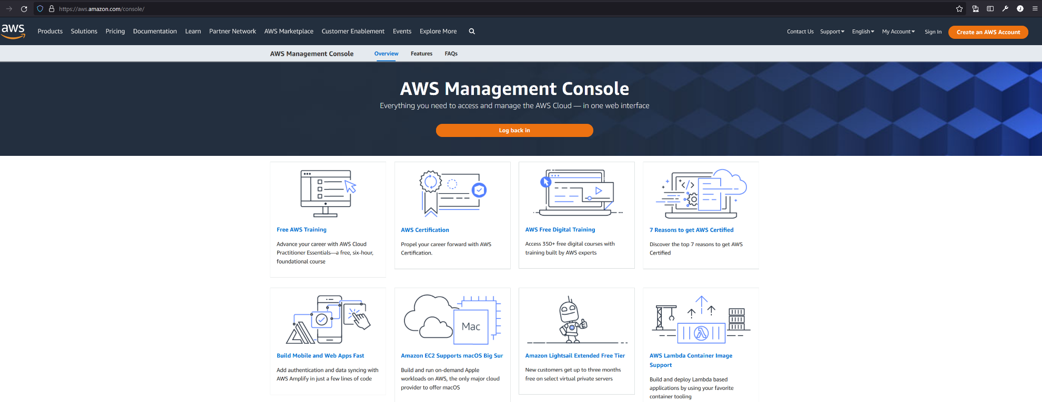

2. You should then be presented with a screen asking if you are a ‘Root user’ or an ‘IAM user’. Make sure to select ‘IAM user’, and when it asks for the ‘Account ID (12 digits) or account alias’, enter:

freeware

and click ‘Next’

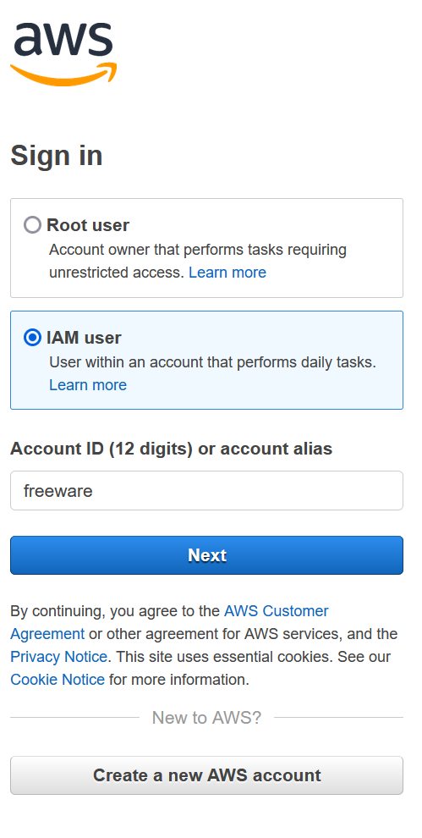

3. Then, when it asks for your IAM username and password, enter the details for the AWS Administrator account you have been provided with:

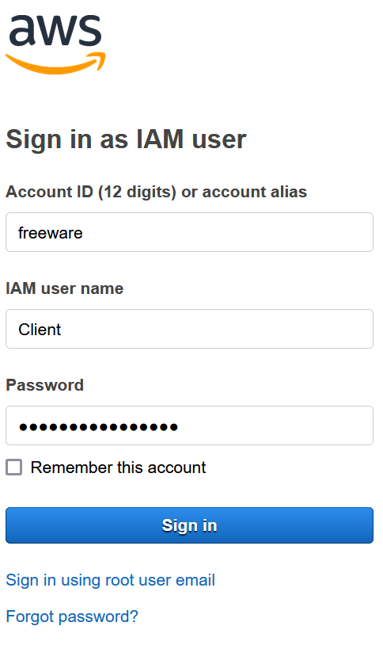

4. You have now successfully signed into AWS

## 4.3 Setting the Right Region in AWS

1. Once logged in, to set the right region in AWS look in the top right of your browser where it will say a region, in this case ‘N. Virginia’:

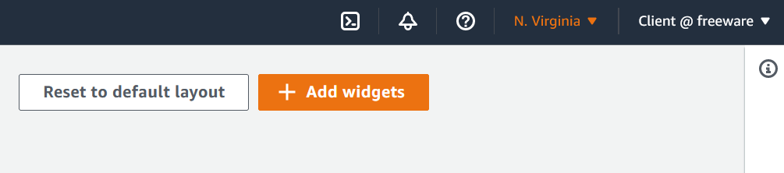

2. Click on the dropdown and select ‘Asia Pacific (Sydney) ap-southest-2:

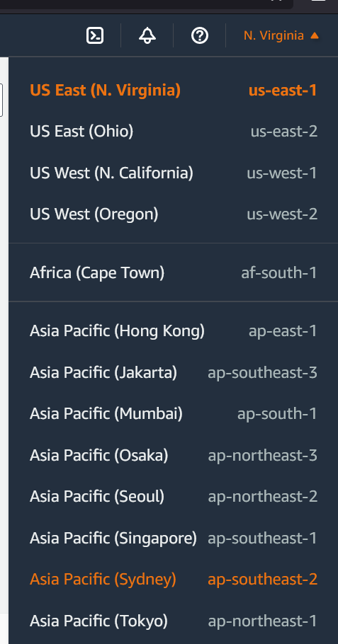

4. You have now successfully selected the correct AWS region

## 4.4 Secrets Manager

1. To access Secrets Manager, search for it in the top left while logged in to AWS: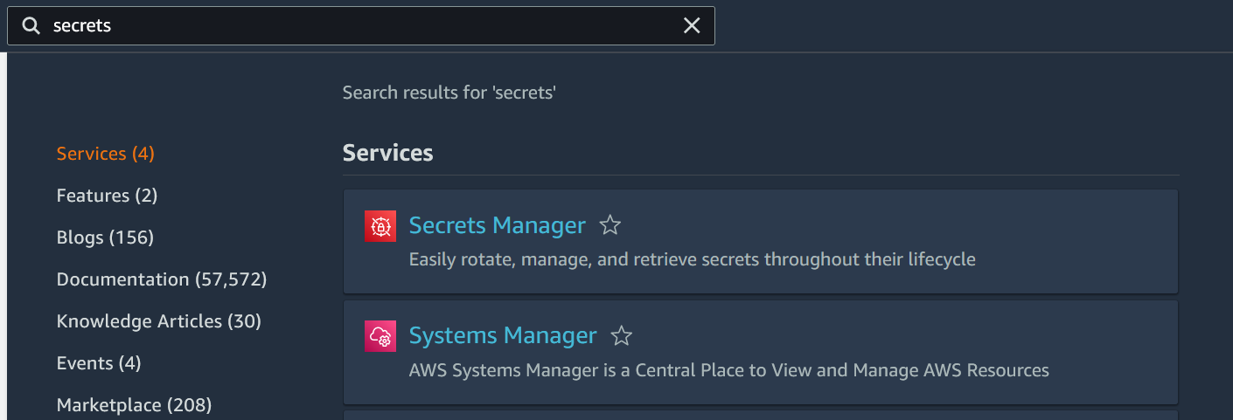

2. Once you are viewing the different secrets, click on ‘Secret-steve-db-cluster’:

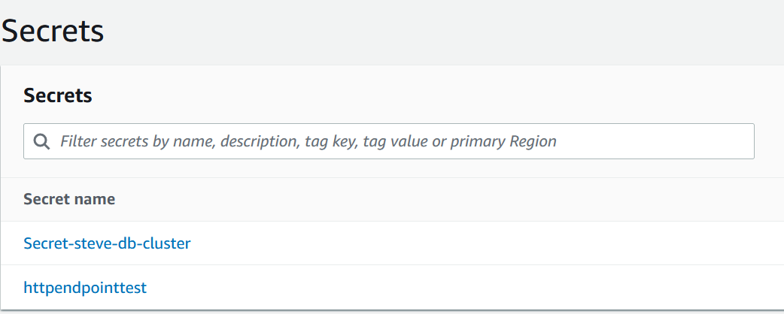

3. After clicking on the secret, you will be able to view the Secret details. Make sure to make a note of the ‘Secret ARN’, as it will be needed when administering the SQL database in RDS

4. You have now successfully navigated the Secrets Manager

## 4.5 Cognito

1. To access Cognito, search for it in the top left while logged in to AWS

2. Once you’ve navigated to it, you are then presented with a screen showing you the different User pools that have been created. The user pool that has been used for the STEVE app is simply named ‘STEVE’, so click on that one:

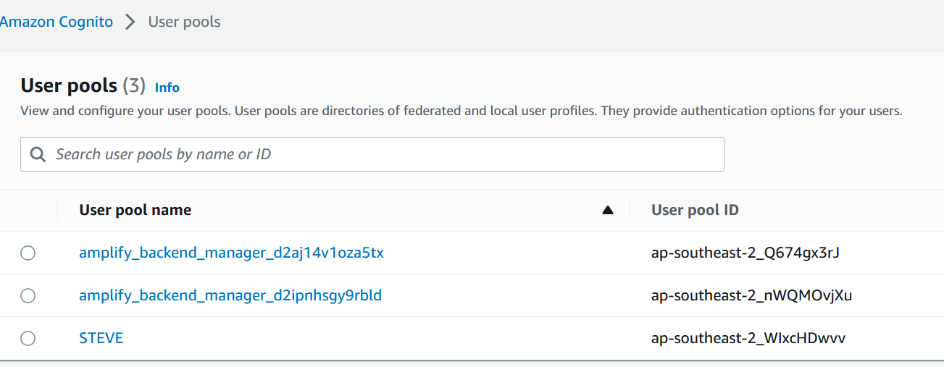

3. After clicking on the user pool, you will be presented with a screen that lists all the users that have created accounts in the app. You will be able to see their username (id) and email address amongst other values. From here you can select individual users and disable their access or reset their password, change the password policy and change the authentication messaging system:

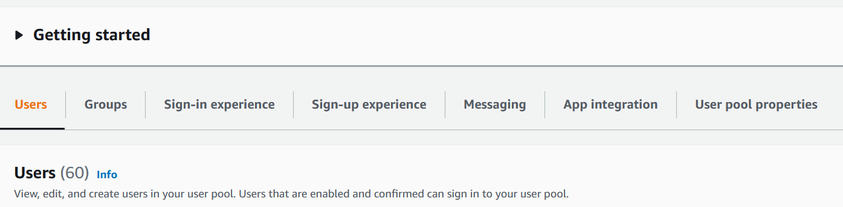

**Please note: It is strongly not recommended to create a new user outside of the app, as when a user is created in the app important information is also created for them in the RDS SQL database, whereas creating a new user in Cognito will mean that that user will be unable to log in as the appropriate records will not exist for them in the database.**

4. You have now successfully navigated Amazon Cognito

## 4.6 RDS

1. To access RDS, search for it in the top left while logged in to AWS

2. Once navigated to, you should see a screen with many links. Please click on the ‘Databases’ link in the navigation bar on the left:

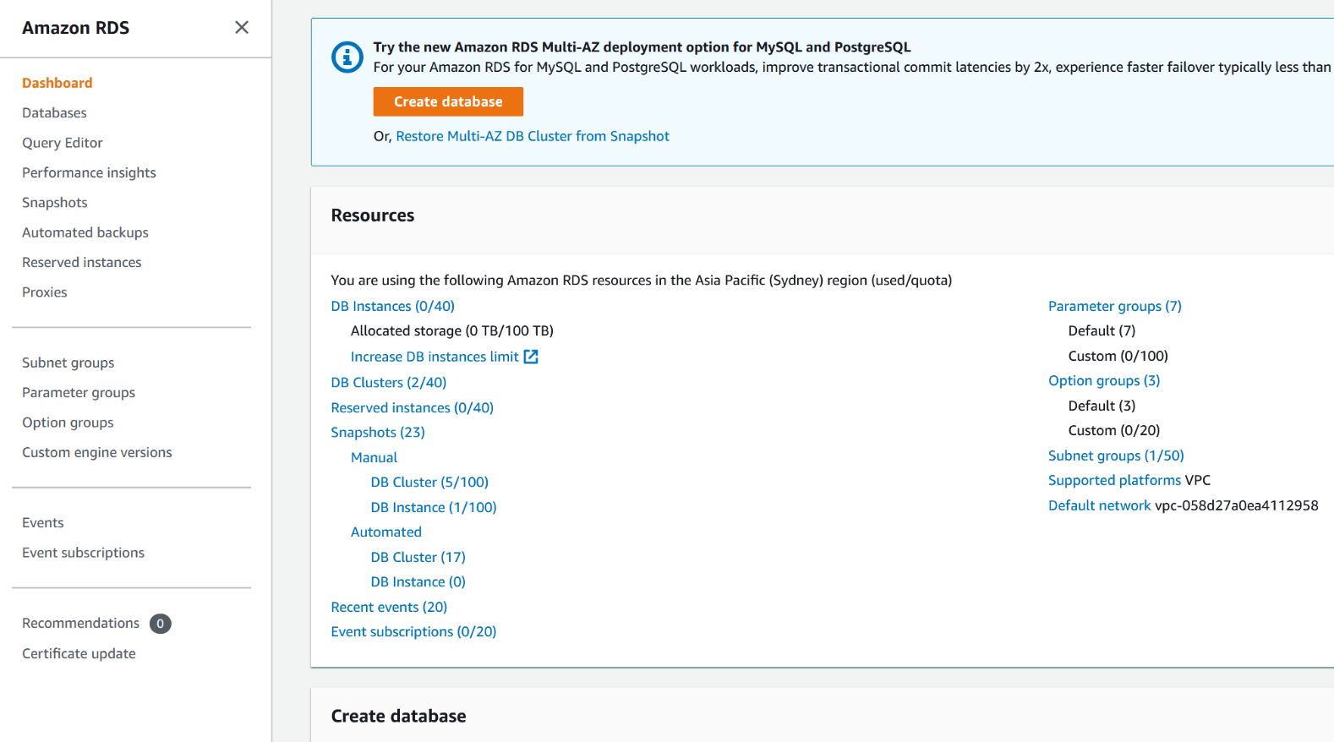

3. STEVE uses an RDS cluster to manage a SQL database. The cluster is simply called, ‘steve-db-cluster’, so click on that:

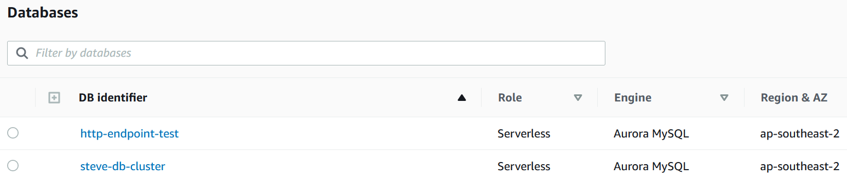

4. From this screen, you will be able to monitor the STEVE database cluster using CloudWatch, view logs, view and change the cluster configuration, view and download automated backups and change backup schedule.

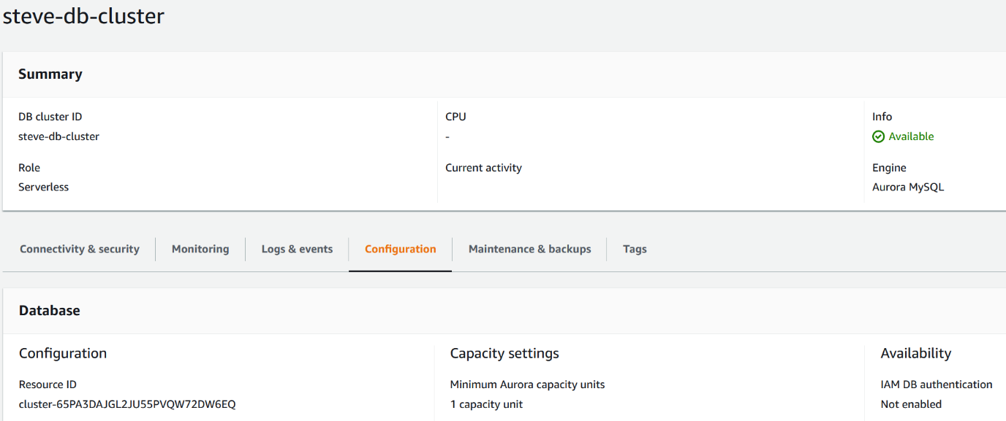

5. In the top right there should be a button called ‘Modify’, so please click on that

6. Once you’ve navigated to the next screen, you will be able to modify the database cluster, including setting a master password, changing the database capacity, autoscaling timeout, time to autoscale to 0 Aurora Capacity Units, toggle deletion protection as well as see that this database cluster is making use of the Data API to easily connect to the AppSync API:

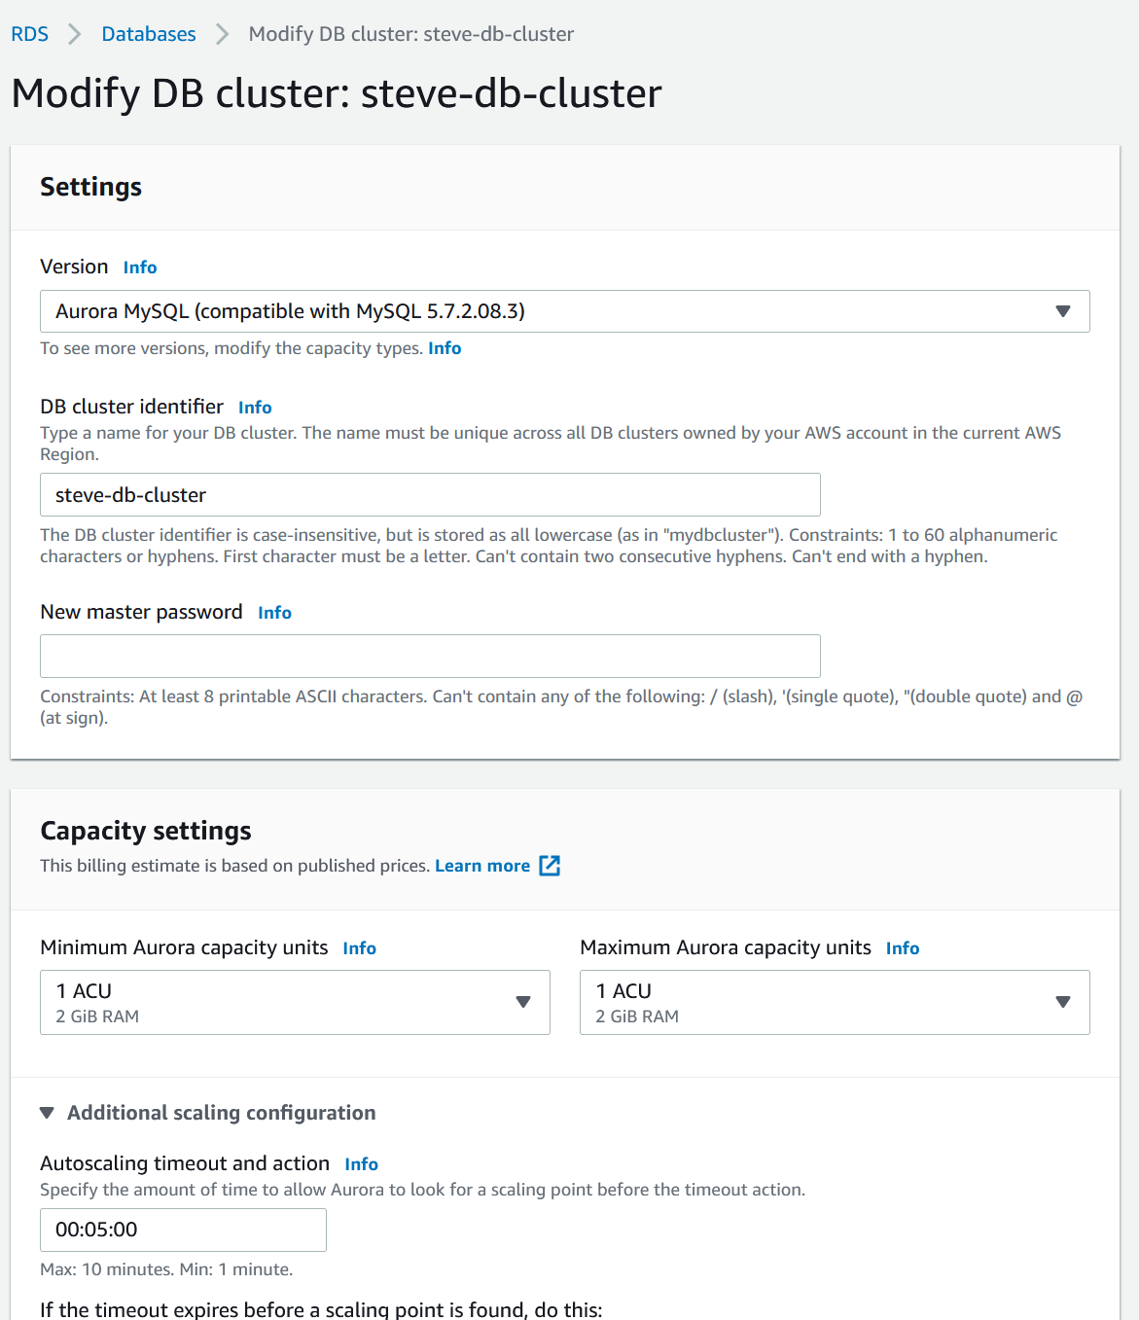

7. Click on the ‘Query Editor’ in the navigation bar on the left

8. From here you will be prompted to connect to the database cluster.

* For ‘Database instance or cluster’ select ‘steve-db-cluster’
* For ‘Database username’ select ‘Connect with a Secrets Manager ARN’
* For ‘Secrets manager ARN’ copy the secret from the Secrets Manager mentioned earlier

Then click ‘Connect to database’. Please note, if the connection fails, wait one minute to try again, as the Amazon Aurora Serverless backend needs a minute to spin up its compute functions.

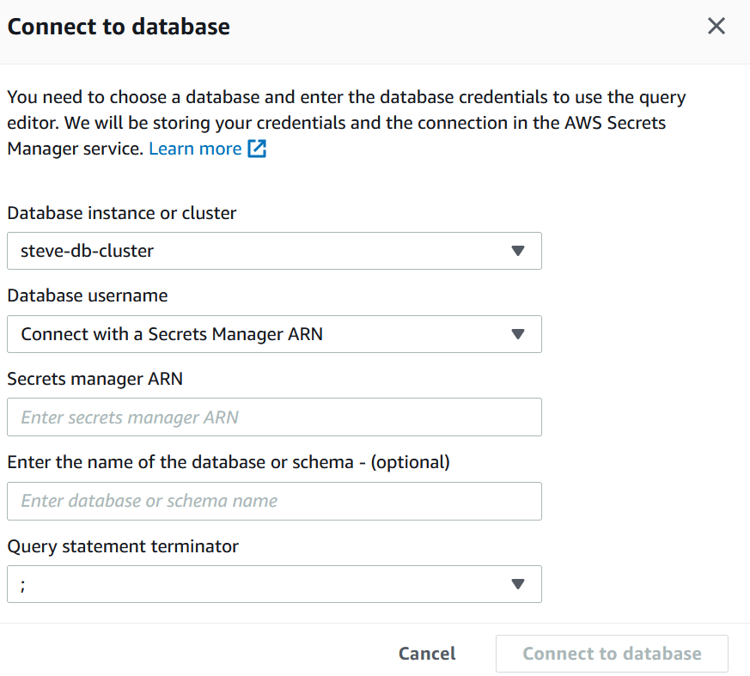

9. From here, you can execute SQL queries directly on the database cluster, and the database. The SQL database the STEVE app uses is simply called ‘steve_db’:

10. You have now successfully navigated Amazon RDS

## 4.7 AWS Amplify

1. To access AWS Amplify, search for it in the top left while logged in to AWS

2. The STEVE app uses an Amplify instance called ‘STEVE-Amplify’, so click on that:

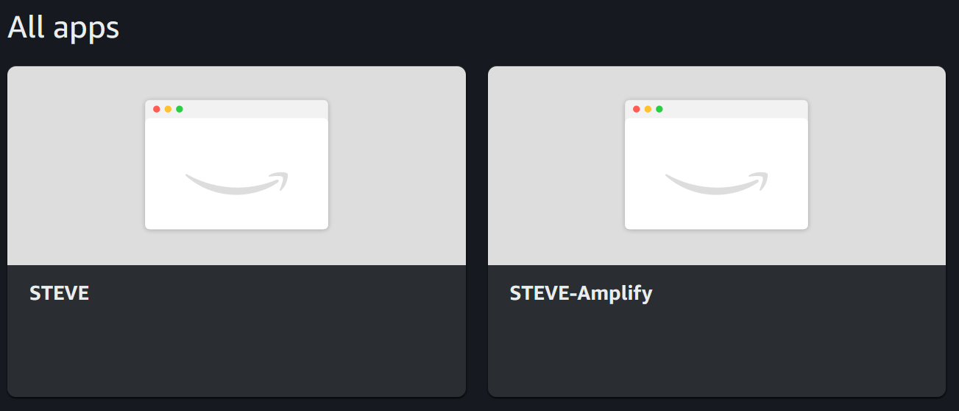

3. For a backend environment, the STEVE app uses one called ‘staging’, so click on the orange ‘Launch Studio’ button under that:

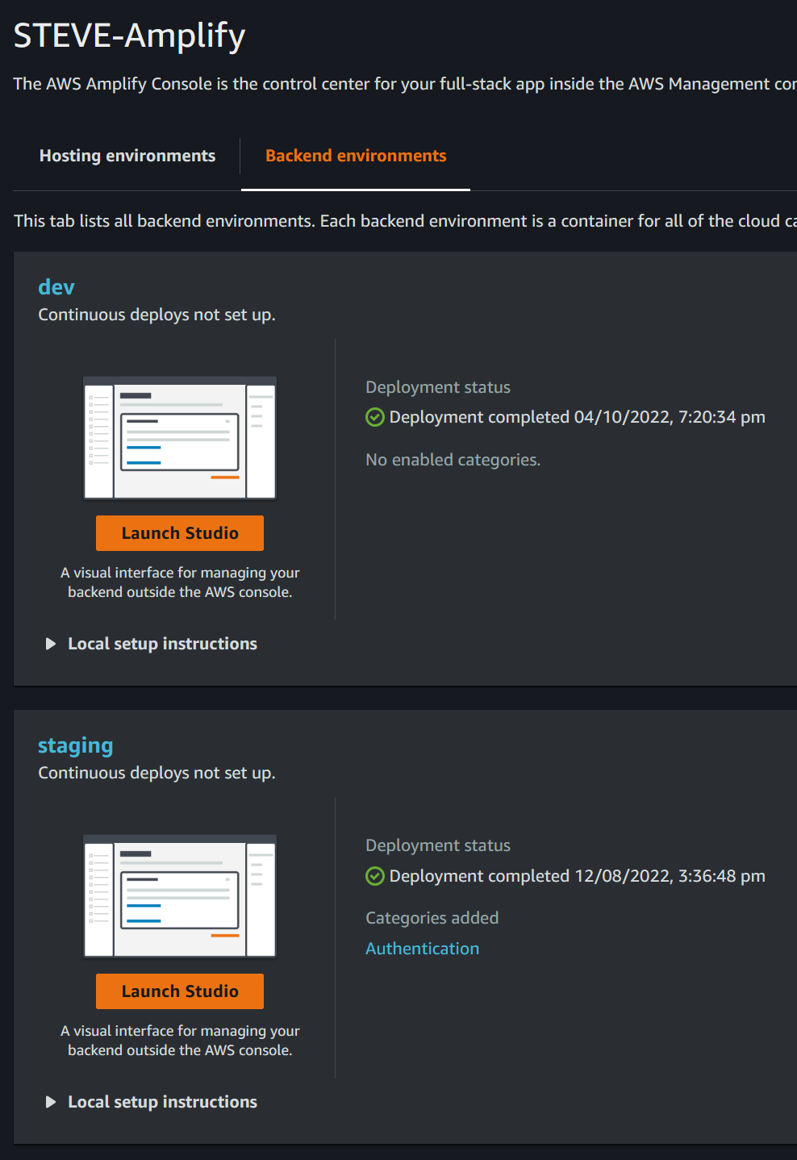

4. In the new window, you should see a rundown of STEVE-Amplify’s staging environment, with navigation on the left allowing you to: view Cognito user pool users and view the linked Cognito authentication. There are many options here that could be used in the future to expand the capabilities of the app, including notifications, analytics and storage:

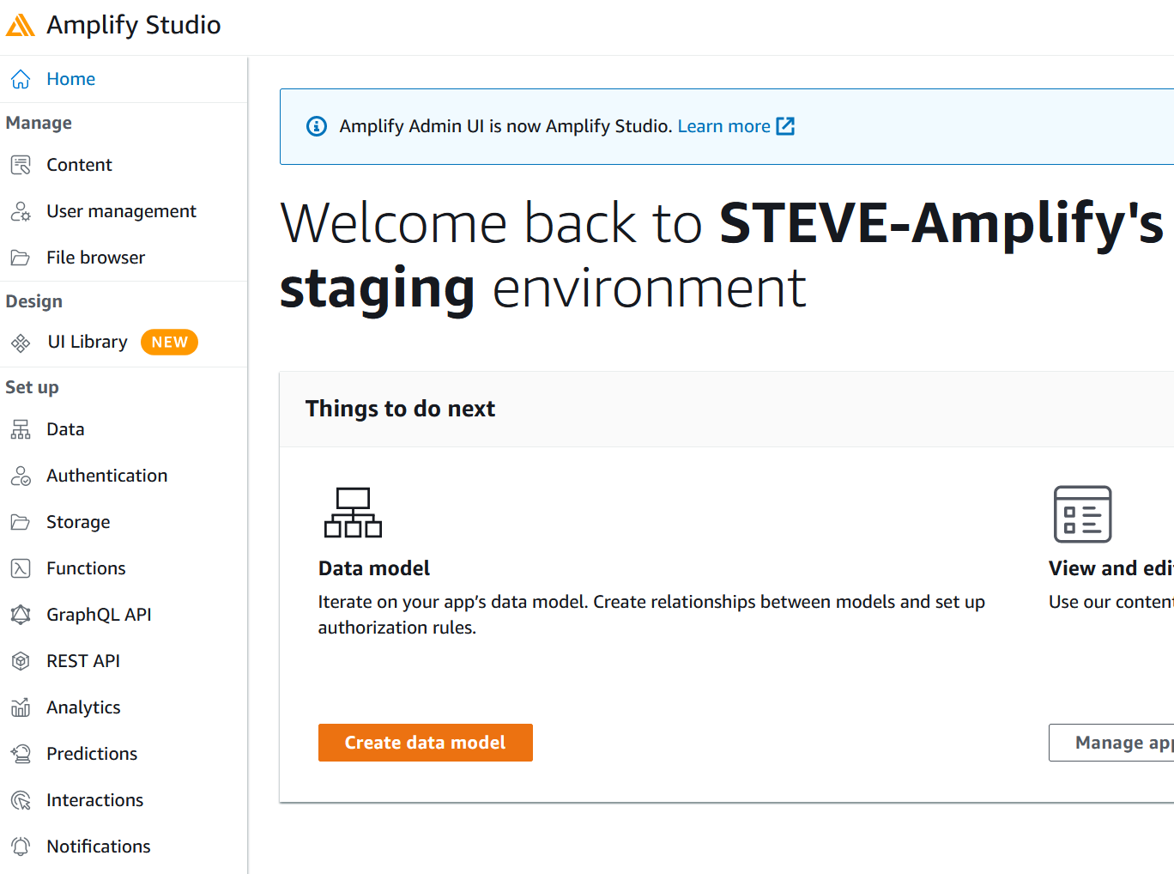

5. You have now successfully navigated AWS Amplify.

## 4.8 AWS AppSync

1. To access AWS AppSync, search for it in the top left while logged in to AWS

2. The STEVE app uses an API called ‘STEVE-API’, so click on that:

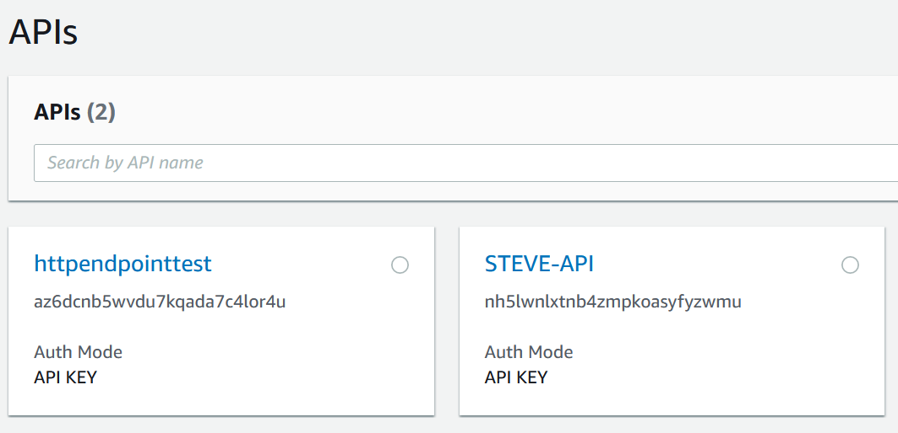

3. You should now see a window with navigation on the left allowing you to view the Schema, Data Sources, Queries, Caching, Settings and Monitoring amongst others.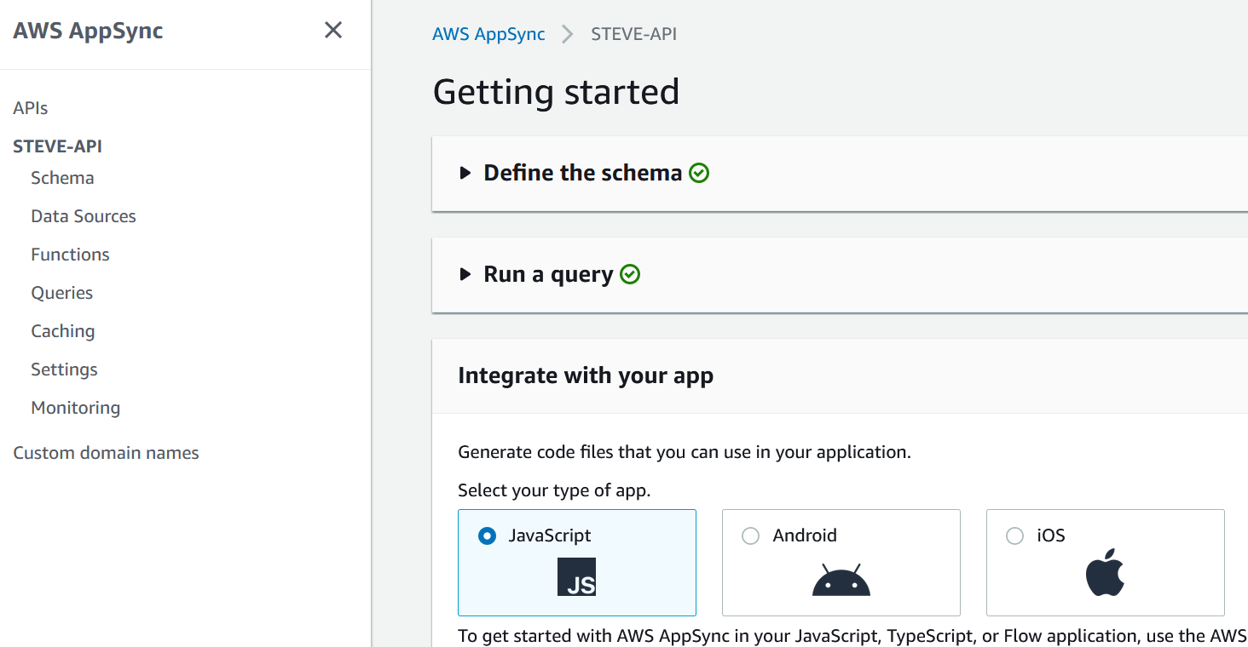

4. If you navigate to ‘Schema’, you will be able to see the GraphQL schema of the app on the left, including types, inputs, queries and mutations; and you can click on the handwritten SQL resolvers on the right attached to view the SQL code that has been attached to mutations and queries:

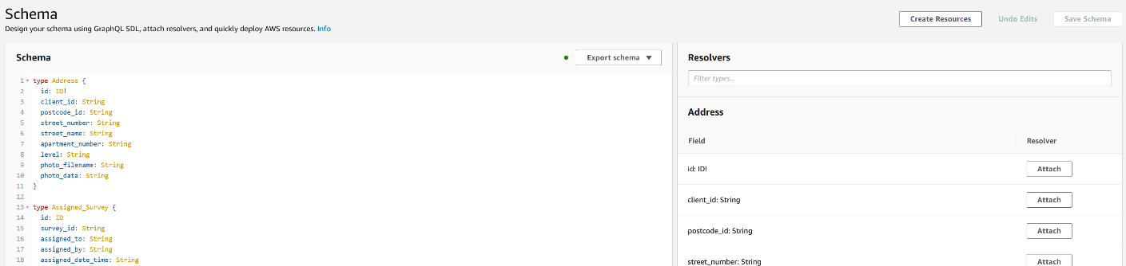

5. If you navigate to ‘Queries’, you will be able to easily use the developed GraphQL Queries and Mutations to effect the database through the SQL resolvers

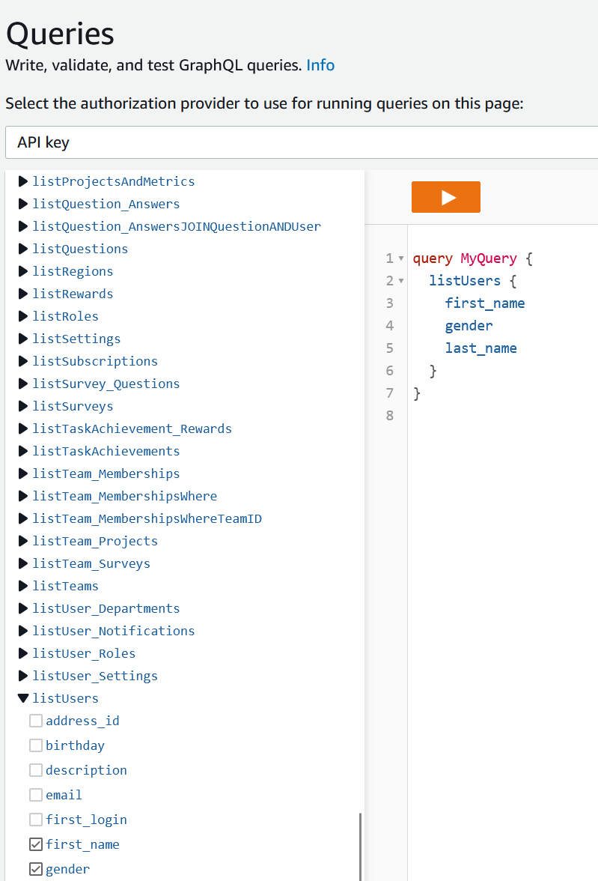

6. You have now successfully navigated AWS Appsync

## 4.9 Updating AppSync/GraphQL information on the frontend

**Please note: this section requires you to have successfully completed the Installation Guide by installing and setting up the development environment on Windows 10.**

If you make a change to the GraphQL schema or a query or mutation on AWS, you will need to propagate that change to the frontend so that AWS Amplify knows how the new or altered schema works. Doing so is quite easy, just cd into the STEVE-main folder that you set up during installation:

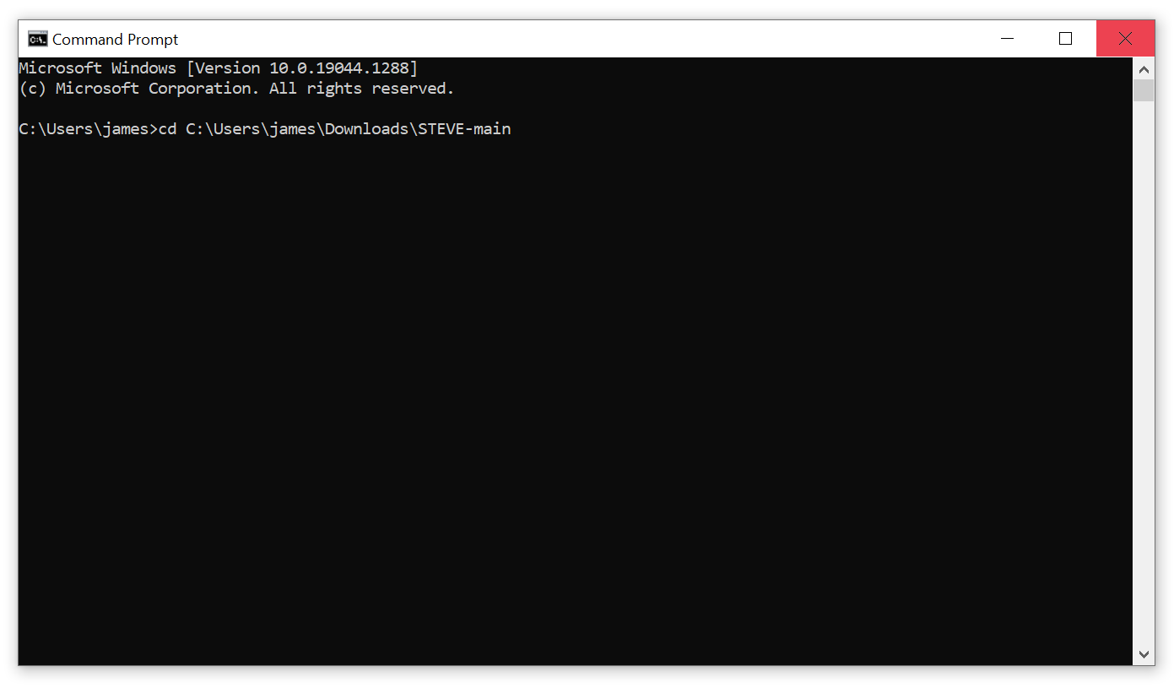Then just type:

amplify codegen

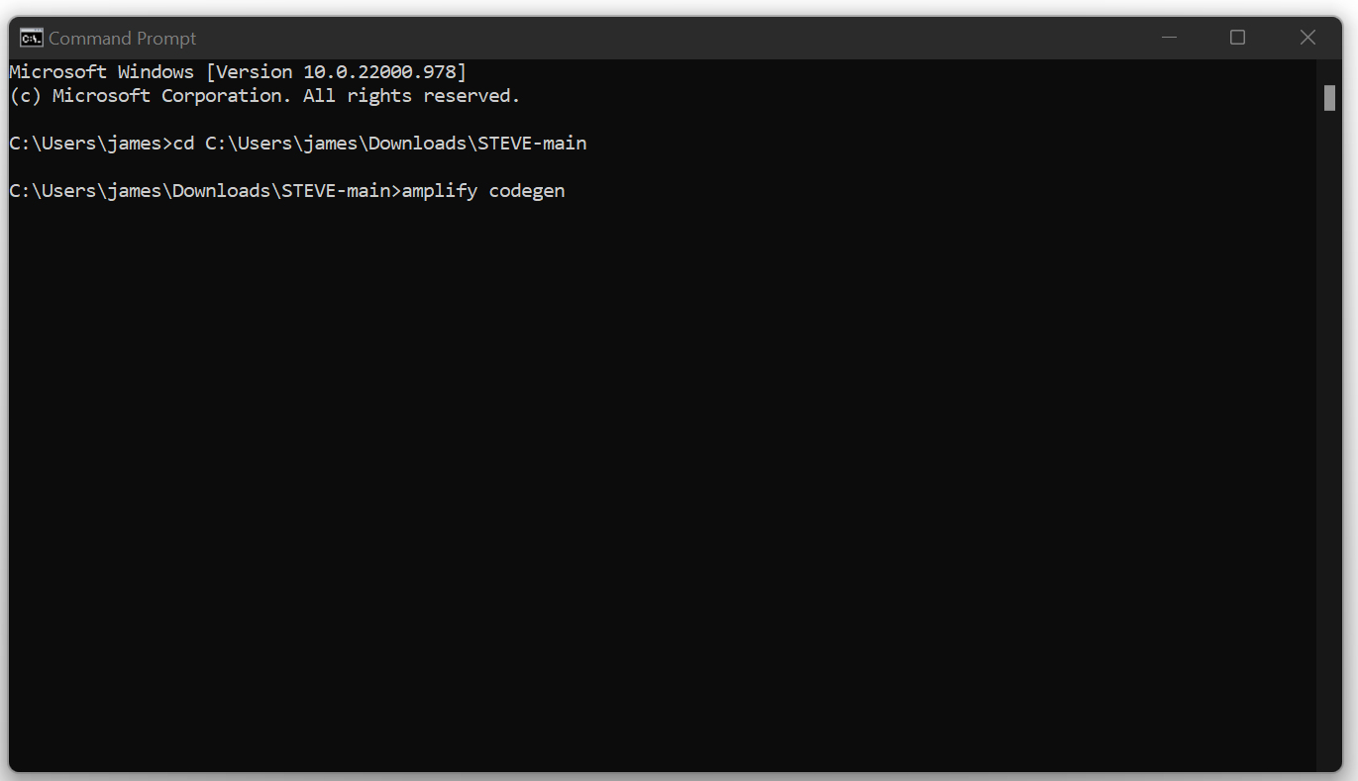

Let it download the introspection schema and generate the GraphQL operations and that’s it. You’ve now successfully synced the GraphQL/AppSync information from the backend to the frontend.

# 5.0 Installation Guide

This installation guide covers installation of the STEVE app on Android phones as well as setting up the development environment with Android Studio on Windows 10.

## 5.1 Requirements

1. You must have been supplied with the ‘accessKeyId’ and ‘secretAccessKey’ for the ‘amplify-user’ user

2. You must have been supplied with the ‘aws-exports.js’ file

3. You must have been supplied with the ‘STEVE_main.apk’ file

4. You must have a copy of the source code or access to the STEVE GitHub repository to download the source code

If you don’t have access to any of these details or files, please contact James Worcester from Team Freeware and we will provide them to you.

## 5.2 GitHub & File Structure

The GitHub repo and file structure have been organised in a sensible way to try to keep track of what each file, component and screen do. The root file structure includes the ‘App.js’ file that initialises the whole system and navigation. An up to date ‘README.md’ markdown file is included, and the ‘eas.json’ file should be noted as it contains configurations to build the app into an .apk using EAS Build (<https://docs.expo.dev/build/introduction/>).

The ‘amplify’ folder consists of files created automatically by AWS Amplify and should not be edited. The ‘assets’ folder contains all the images, placeholder images and test API data for the app.

The ‘backend_backups’ folder contains a manual backup of the SQL code used to create the database, and a manual backup of the GraphQL Schema and Resolvers for each mutation and query.

The ‘src’ folder contains a ‘components’ folder with custom designed reusable components including lists, inputs, buttons etc. It also contains a ‘graphql’ folder that has files that contain all the graphql mutations, queries and schema that have been automatically generated by Amplify and should not be edited. The ‘navigation’ folder contains an ‘index.js’ file that handles all navigation not handled by the Dashboard, and the ‘screens’ folder contains folders with all the individual screens used throughout the app. Each screen folder will usually contain an index, a main JavaScript or TypeScript file, and potentially a CSS styles file. The ‘Dashboard’ screen is special in that it handles navigation between screens using dashboard tabs at the bottom of the app. The ‘types.tsx’ file in the ‘src’ folder is also important to take note of, as it describes all the types used by TypeScript in the app.

## 5.3 Installing the app on Android phones

**1. Transfer the supplied ‘STEVE_main.apk’ file to your Android device**

**2. Install the .apk file**

**3. Open the newly installed ‘STEVE’ app**

## 5.4 Installing & Setting up the Development Environment in Windows 10

### Step 1: Install node.js 16.17.1 LTS

**1. In your browser, navigate to** [**https://nodejs.org/en**](https://nodejs.org/en)

**2. Click the green button that says’16.17.1 LTS Recommended for Most Users' to download the node.js installer:**

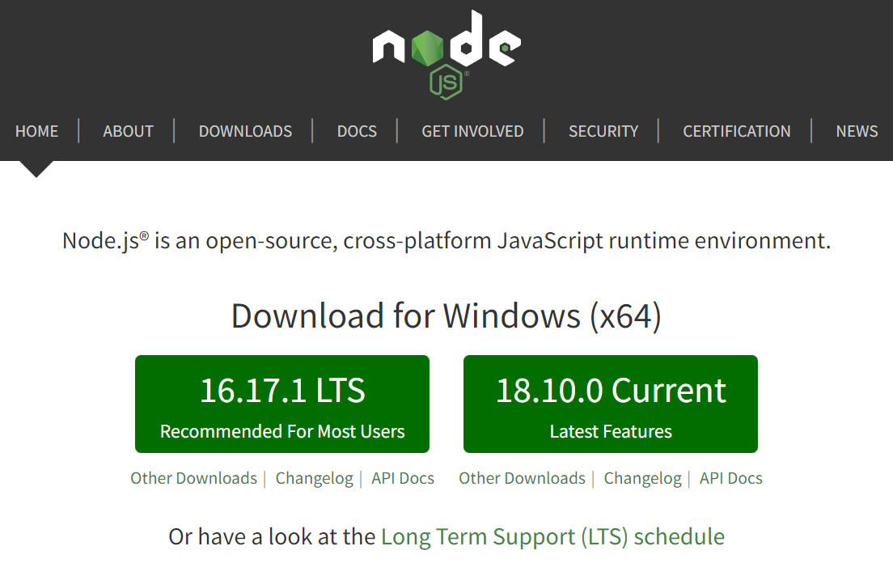

**3. Once the .msi file has been downloaded, click on it to begin the installation process**

**4. Click on ‘Next’:**

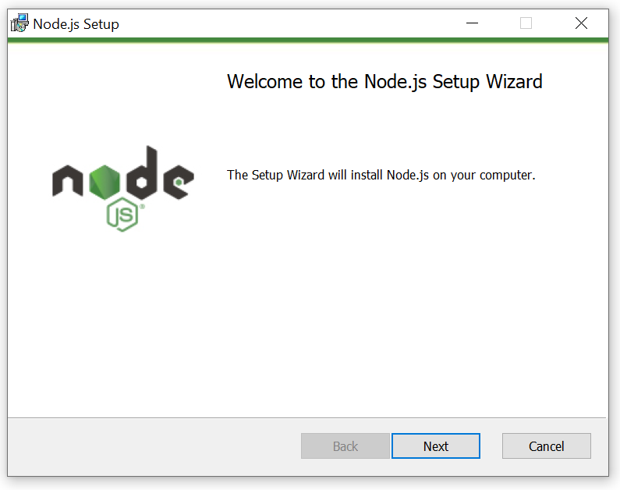

**5. Accept the terms in the License Agreement and click on ‘Next’:**

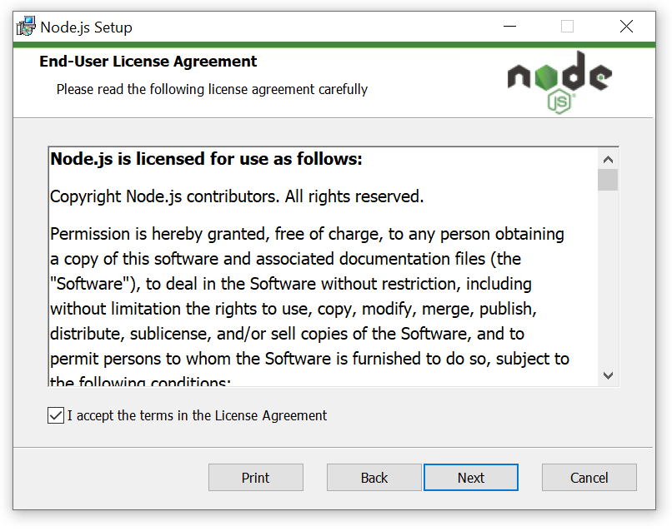

**6. Click on ‘Next’:**

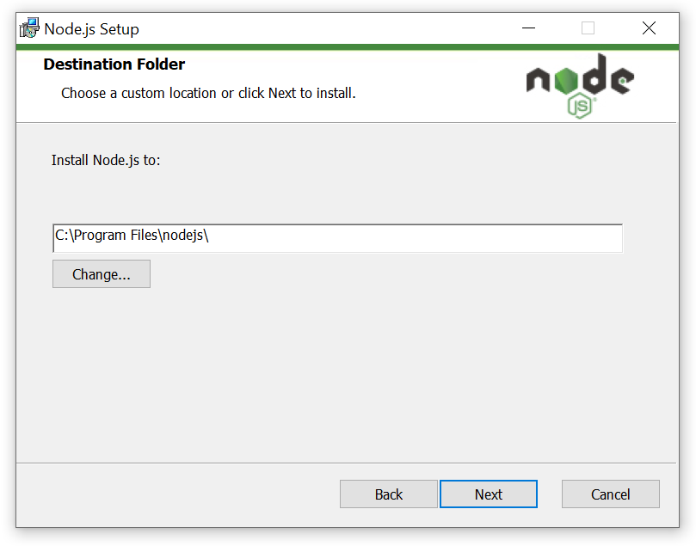

**7. Click on ‘Next’:**

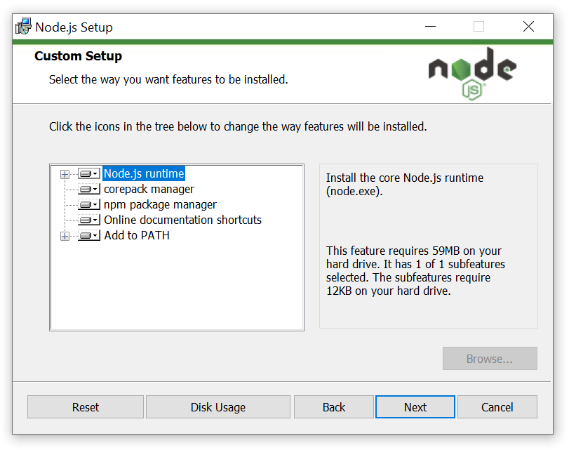

**8. Click on ‘Next’:**

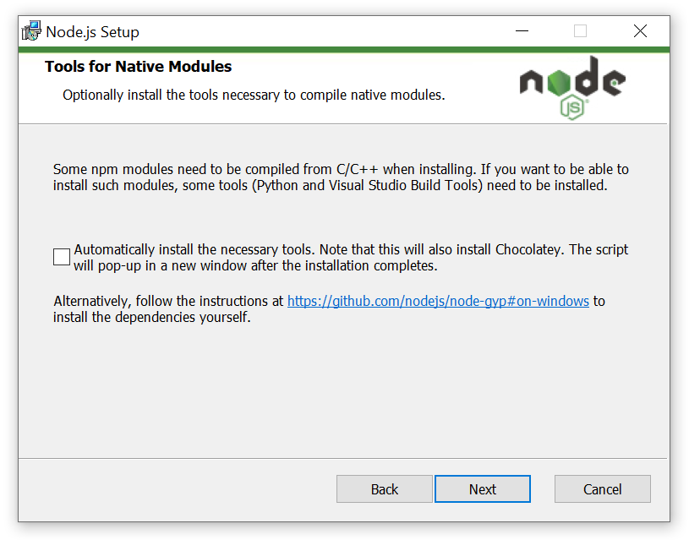

**9. Click on ‘Install’:**

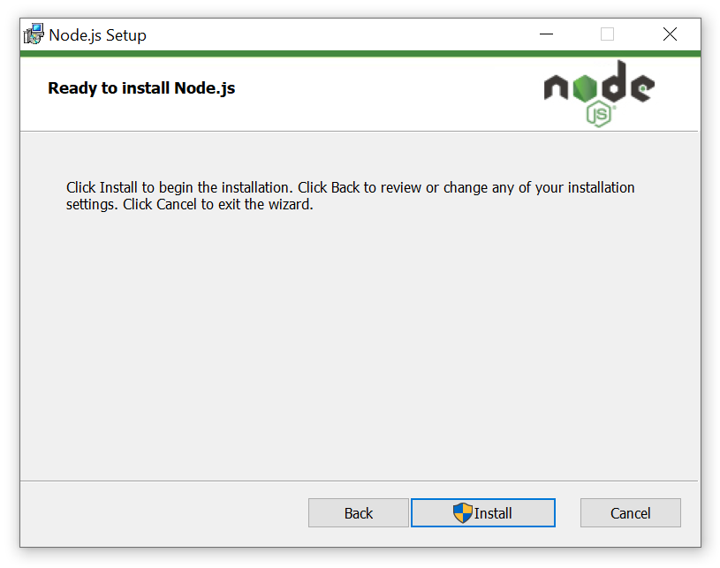

**9a. If a screen pops up asking you to allow this app to make changes to your device, click on 'Yes'.**

**10. node.js will then begin installation. After it has been installed, click on ‘Finish’:**

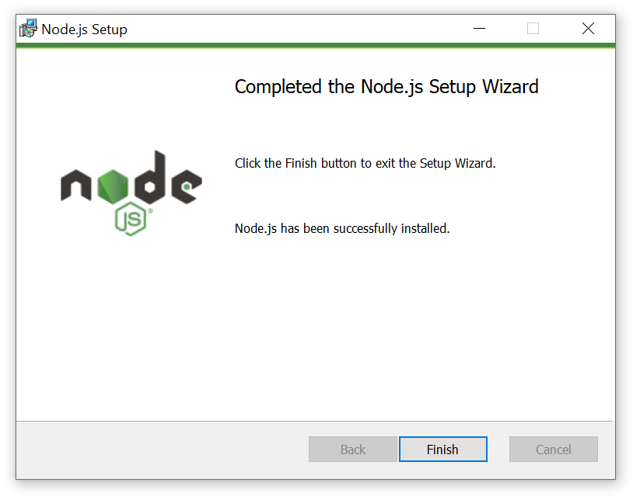

### Step 2: Install the AWS Amplify CLI

**1. Open Command Prompt:**

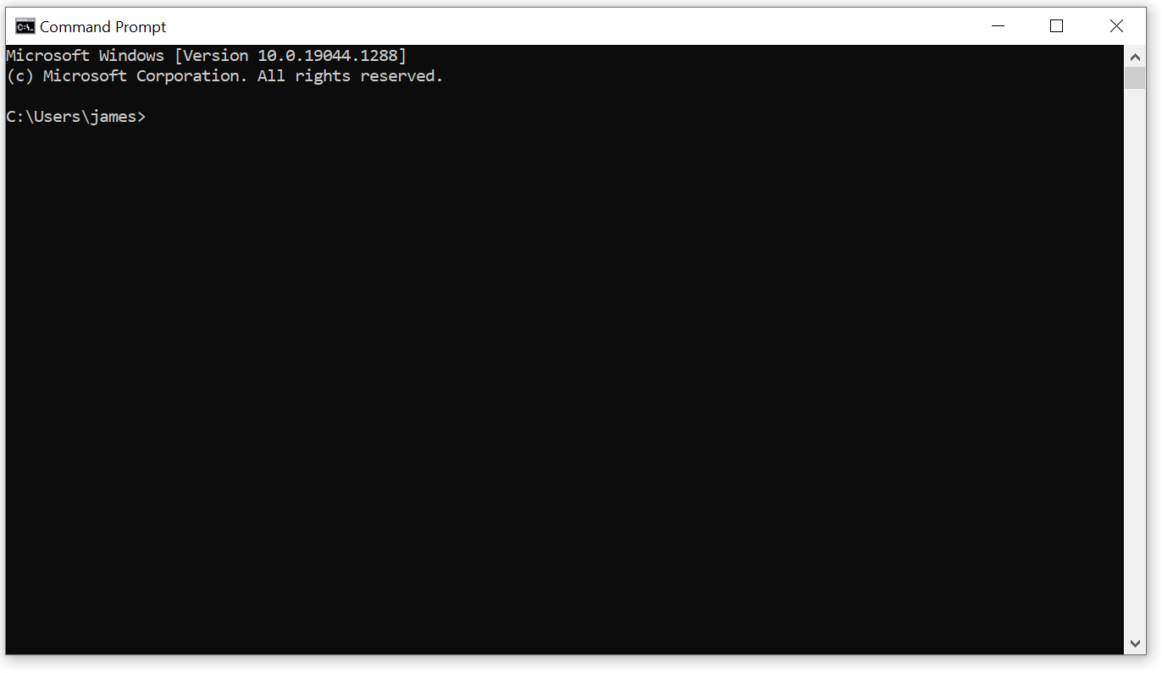

**2. Paste the following code into Command Prompt:**

curl -sL https://aws-amplify.github.io/amplify-cli/install-win -o install.cmd && install.cmd

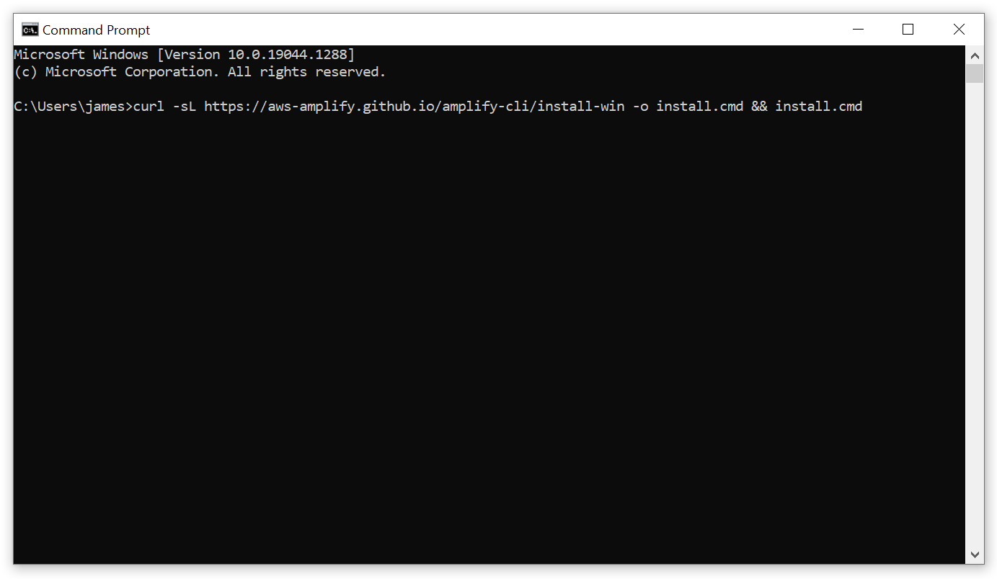

**3. Press Enter to execute the line of code. The Amplify CLI will then install:**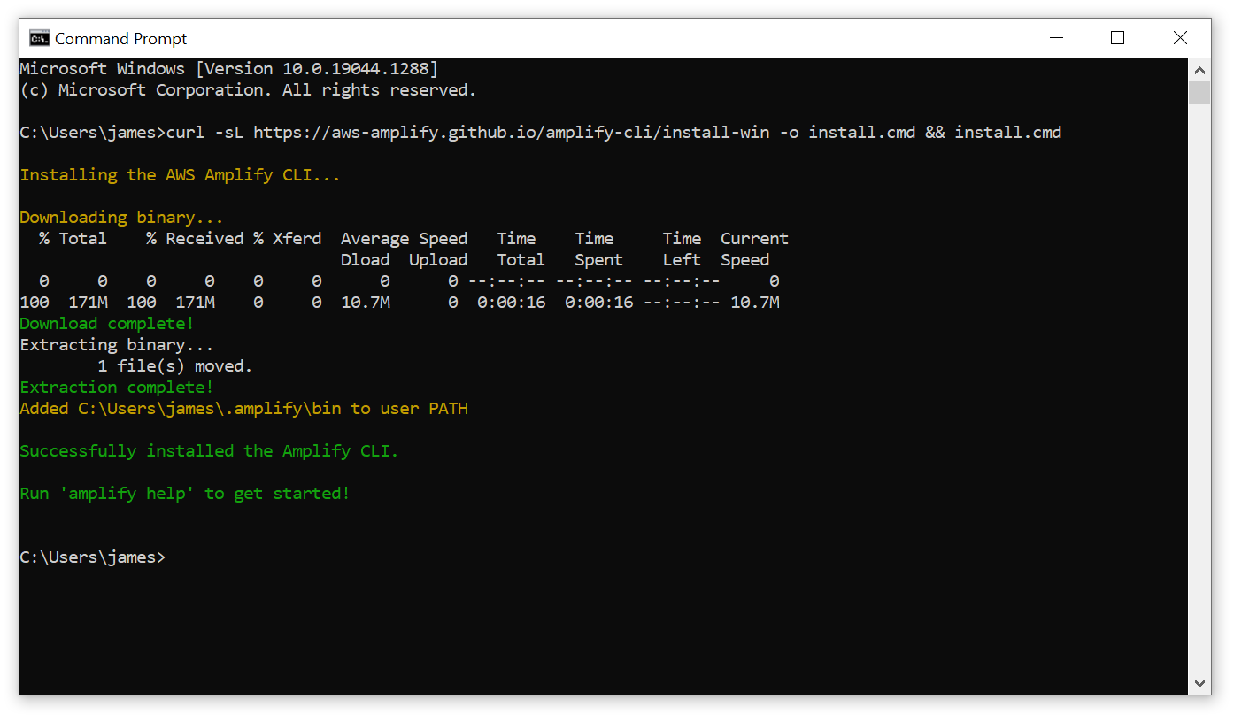

### Step 3: Configuring the AWS Amplify CLI

**1. Open Command Prompt.**

**2. Type:**

amplify configure

**and press Enter to execute the command:**

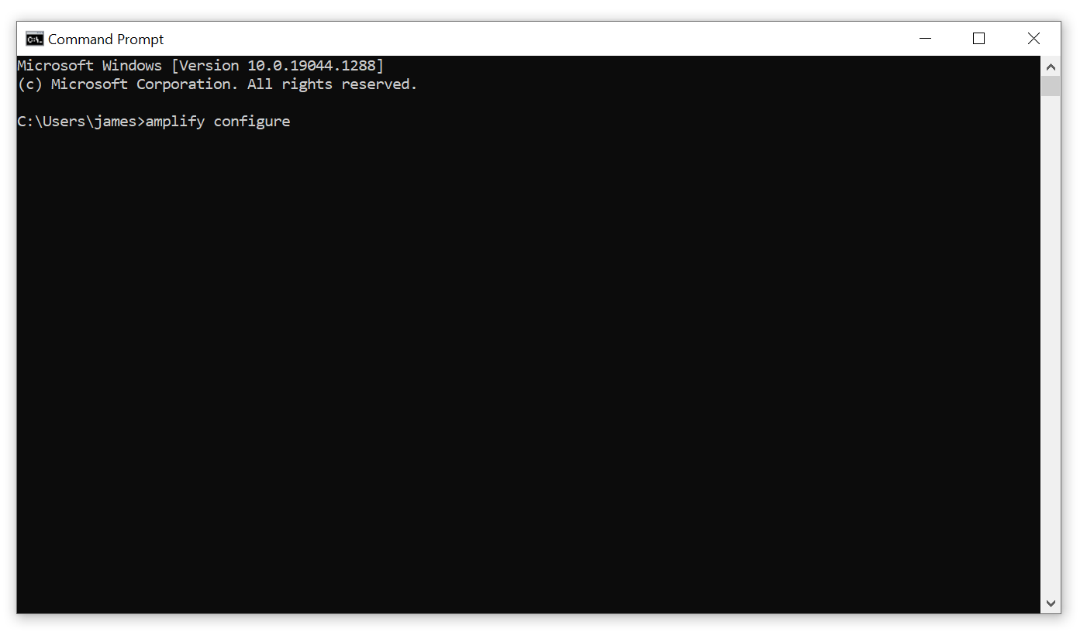

**4. The Command Prompt will ask you to ‘Sign in to your AWS administrator account’ and will open a browser window. Please ignore this, close the browser window, and press Enter in the Command Prompt to continue:**

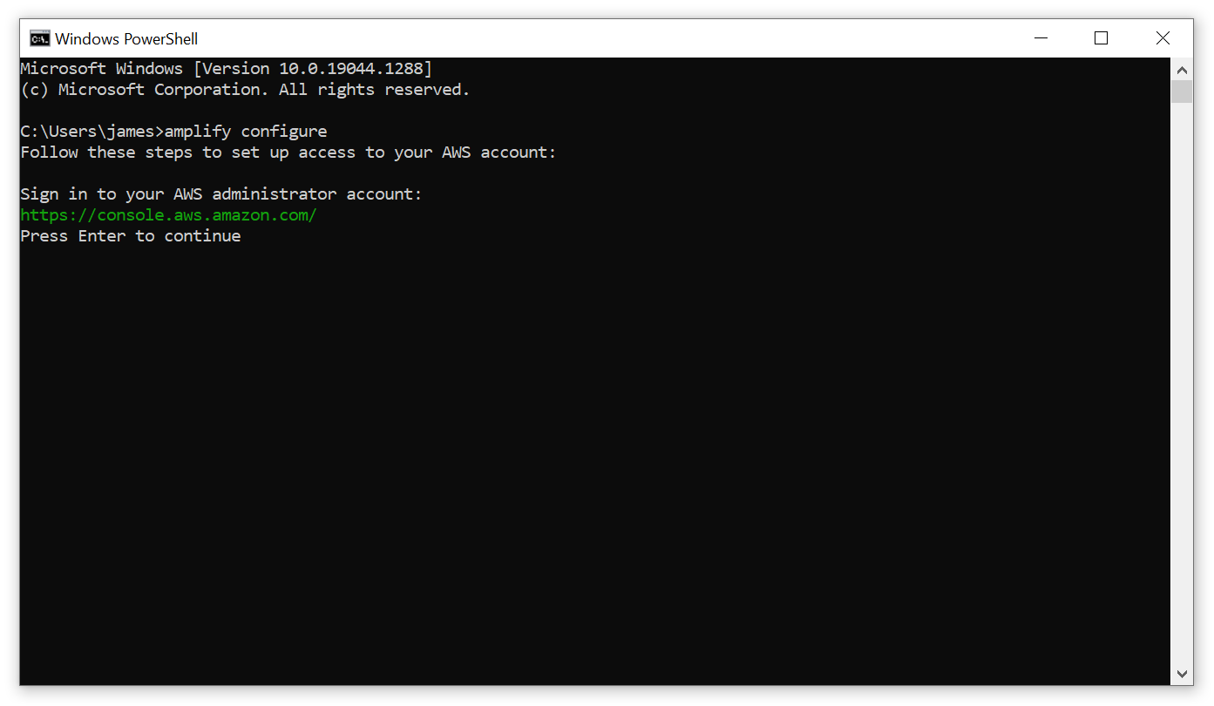

**5. You will be asked to ‘Specify the AWS Region’. Use the Up and Down arrow keys to navigate to ‘ap-southeast-2' and make sure it is highlighted in blue before pressing Enter to confirm the region:**

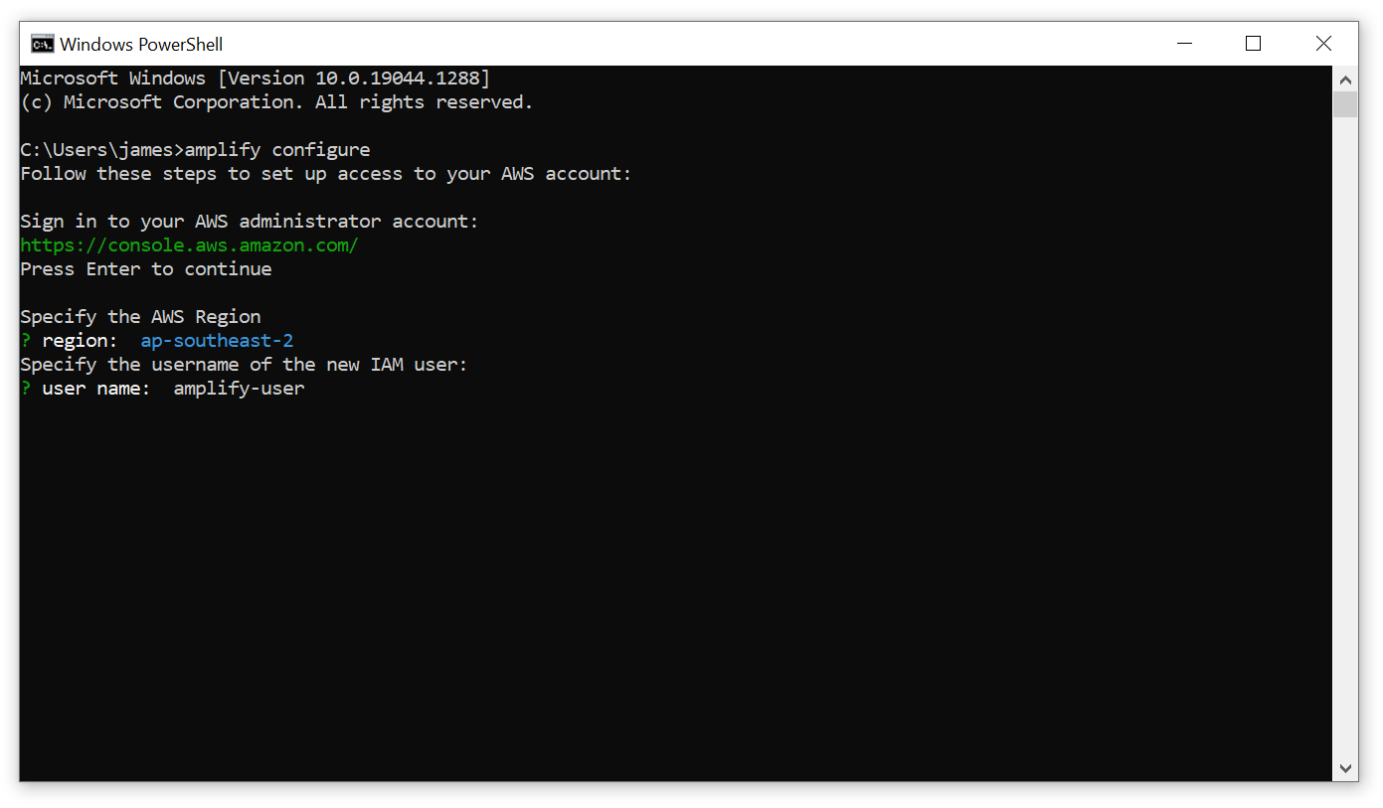

**6. You will be asked to ‘Specify the username of the IAM user'. Please enter:**

amplify-user

**and then press Enter:**

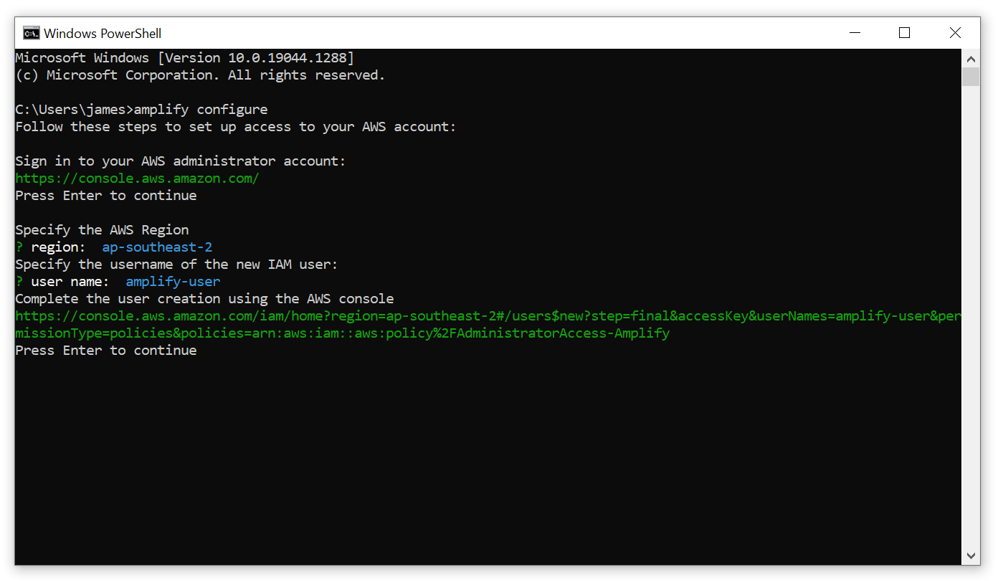

**7. The Command Prompt will ask you to ‘Complete the user creation using the AWS console’ and will open a browser windows. Please ignore this, close the browser window, and press Enter in the Command Prompt to continue.**

**8. You will now be asked to enter the access key of the newly created user. For the ‘accessKeyId’, please copy and paste the amplify-user ‘accessKeyId’ you have been supplied with and then press Enter.**

**(Please note: to copy something into Command Prompt, first copy the text, and then right click in the Command Prompt window)**

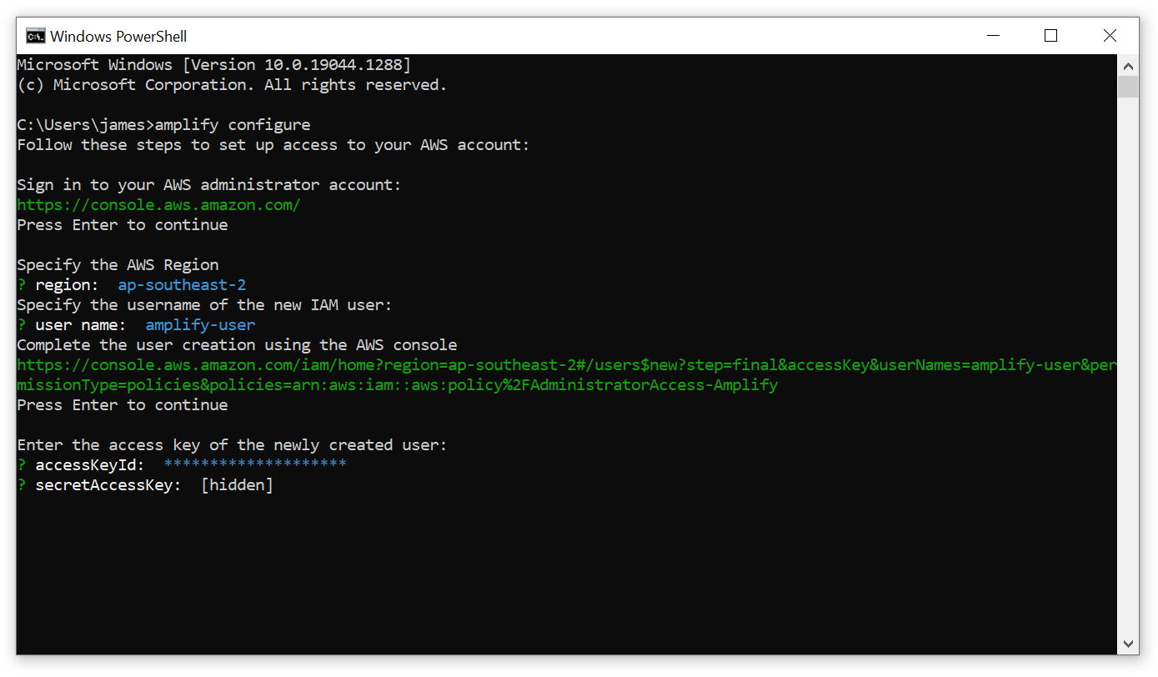

**9. When it asks you to enter the ‘secretAccessKey’, please copy and paste the amplify-user ‘secretAccessKey’ you have been supplied with and then press Enter:**

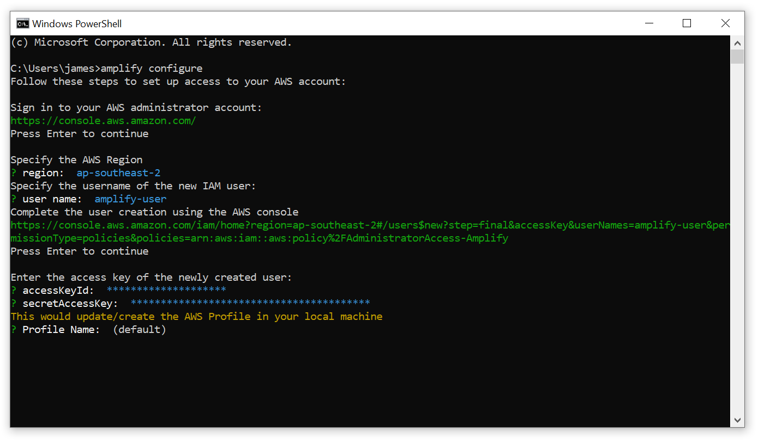

**10. When it asks for a ‘Profile Name’, simply press Enter to select the default profile**

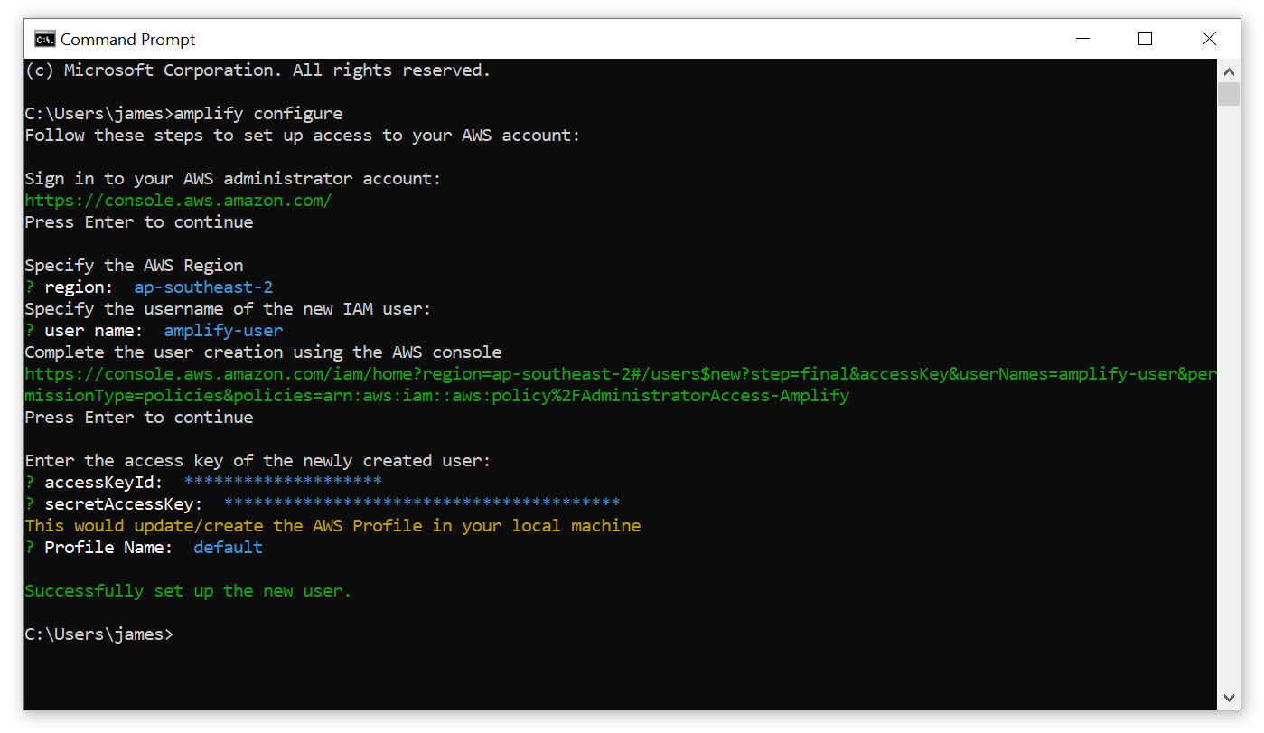

**11. Command Prompt will notify you that it has ‘Successfully set up the user’. Installation of the Amplify CLI is now complete, and you may close the Command Prompt.**

## Step 4: Cloning the GitHub repo

**1. In your browser, sign in to the same GitHub account where you have access to the Team Freeware STEVE repository. Then navigate to** [**https://github.com/jamesworcester/STEVE**](https://github.com/jamesworcester/STEVE)

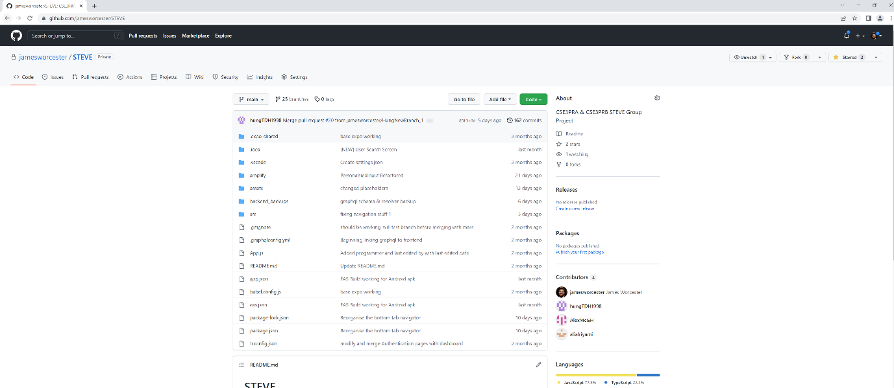

**2. Click on the green button that says ‘Code’, then click on ‘Download ZIP’:**

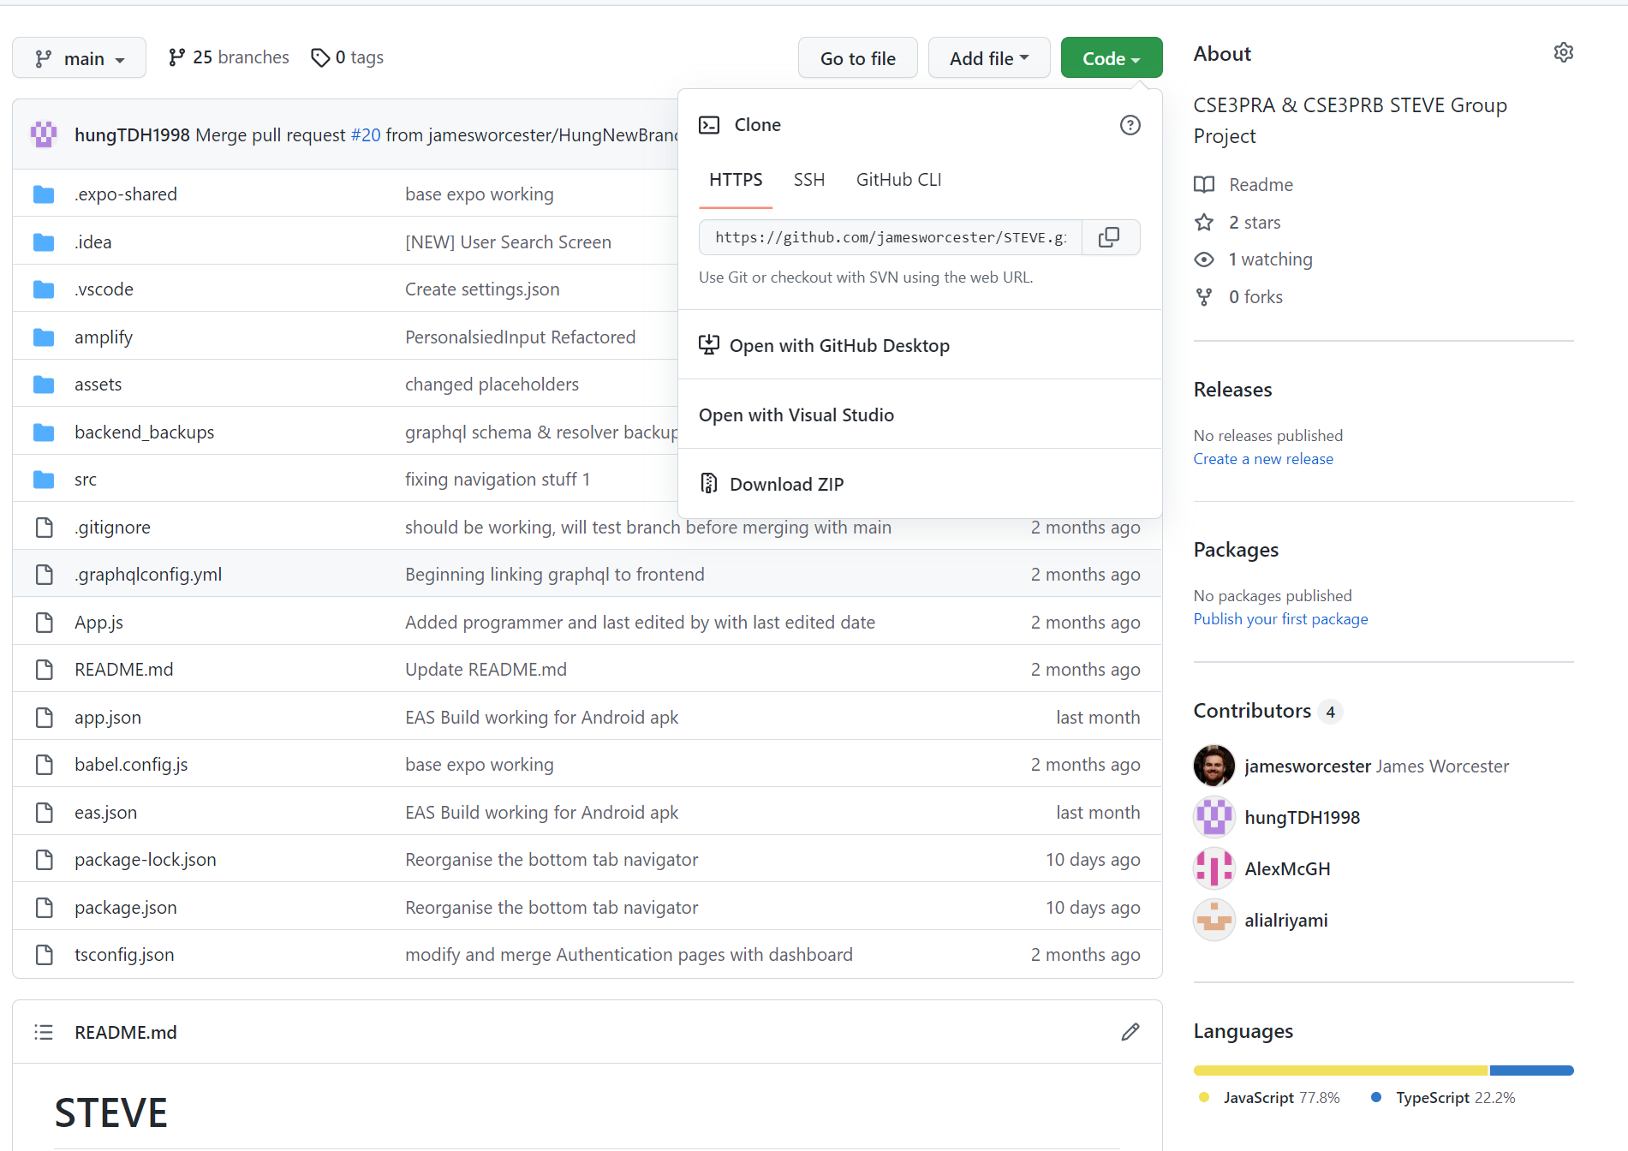

**3. Once the zip file has downloaded, open the folder it downloaded into:**

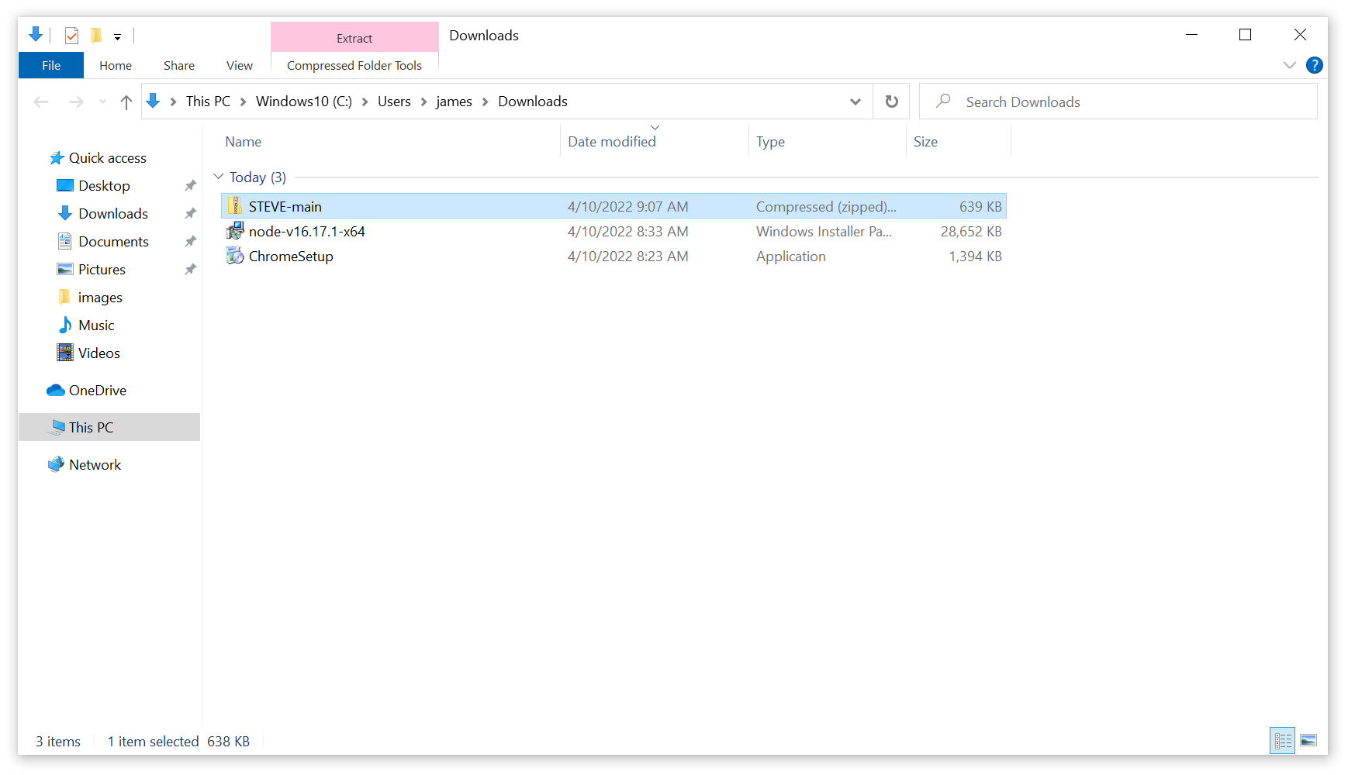

**4. Right click the ‘STEVE-main’ zip file, and click on ‘Extract All’. Where it says ‘Files will be extracted to this folder:’ make sure that the path you enter says ‘C:\Users\[INSERT YOUR USERNAME]\Downloads’. In this case, I will be extracting the files to ‘C:\Users\james\Downloads’:**

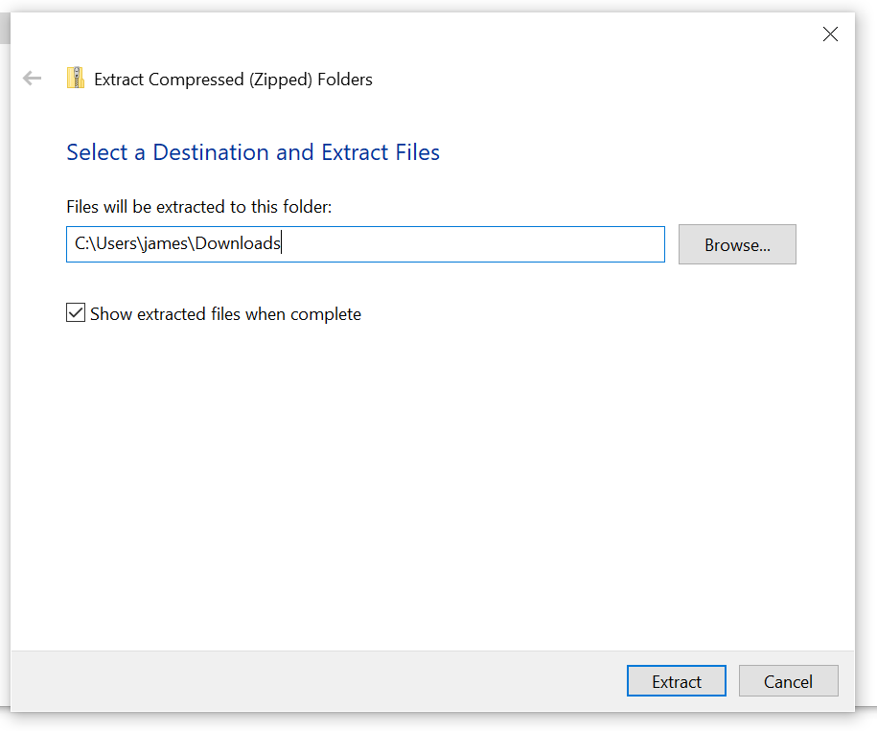

**5. Click on ‘Extract’:**

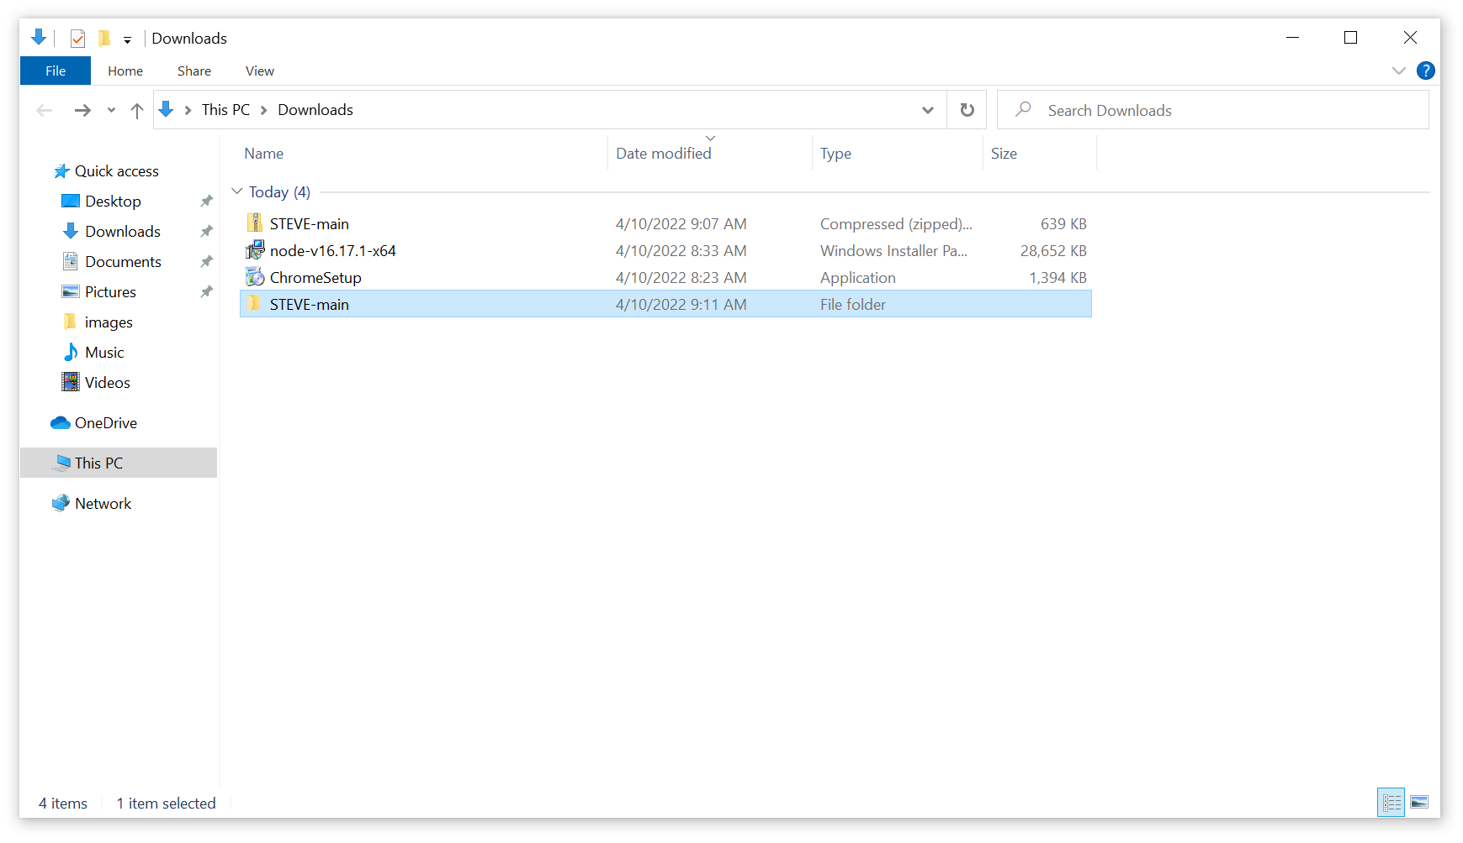

**6. Open the newly extracted folder called ‘STEVE-main’:**

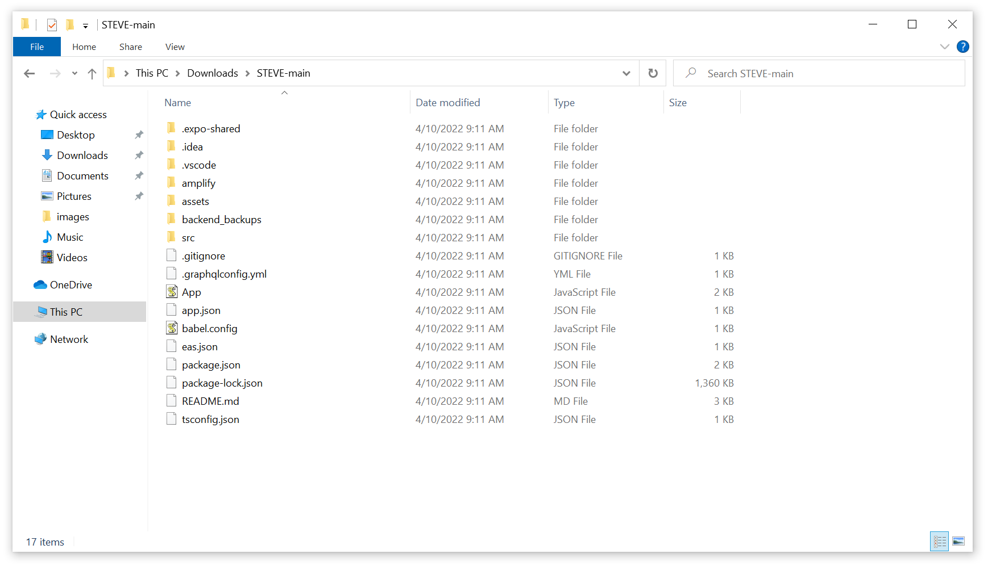

**7. Copy the path to the opened folder:**

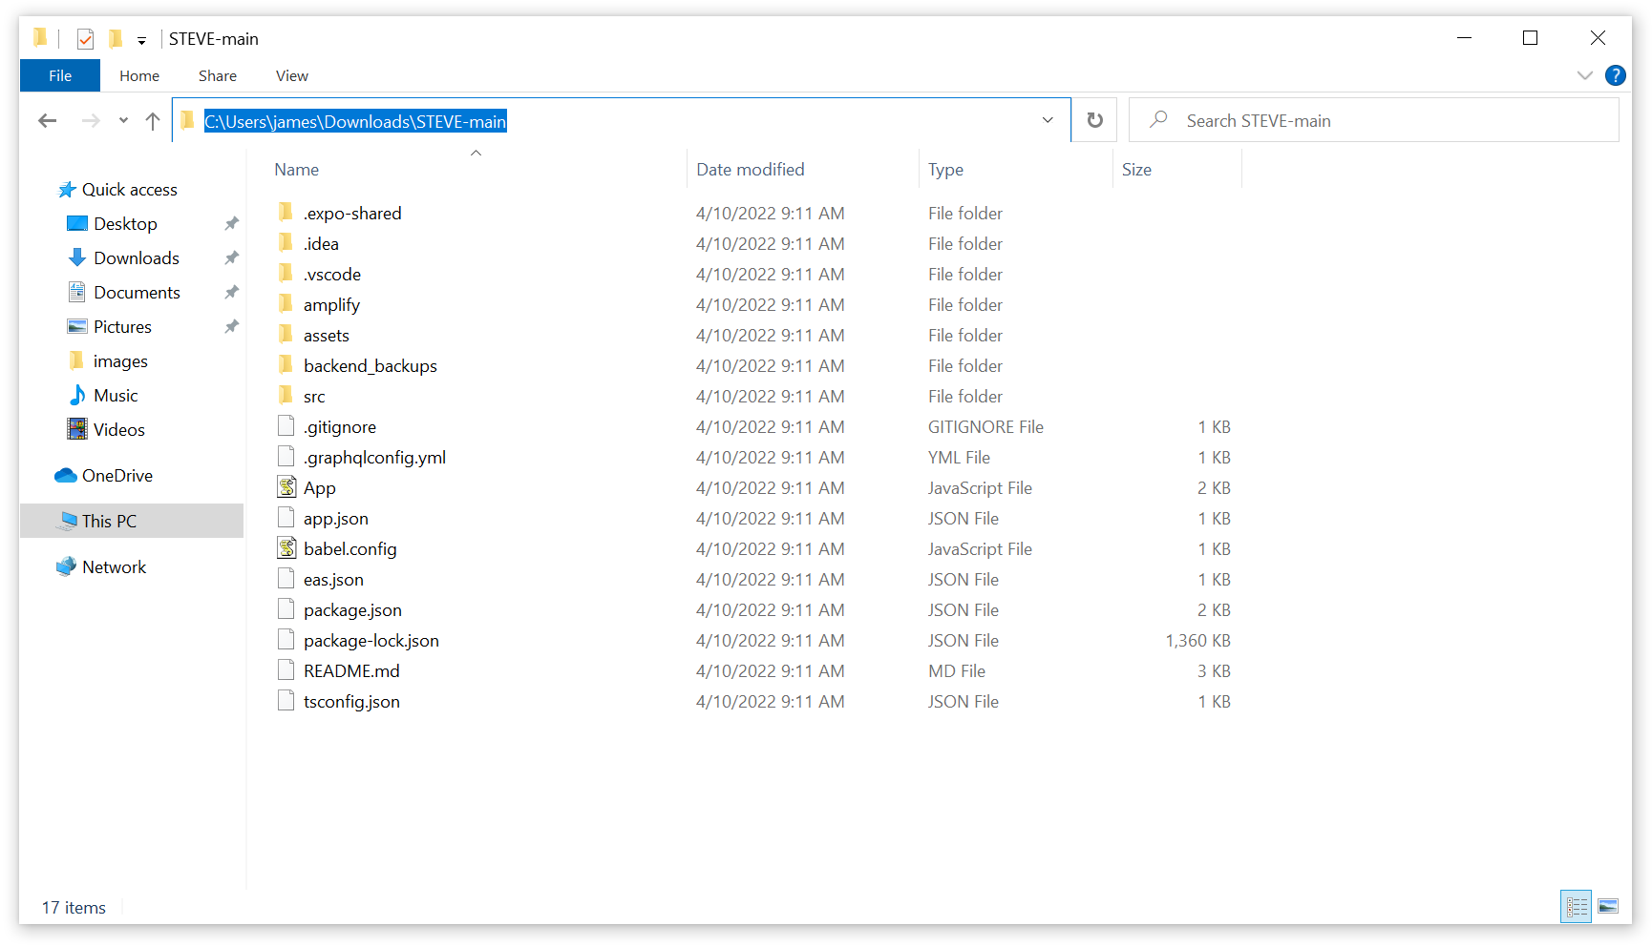

**8. Open up a new Command Prompt window and type in:**

cd

**and then paste the path that you just copied and press Enter:**



**9. type in**

npm install

**and press Enter. Wait for npm to install all the needed packages:**

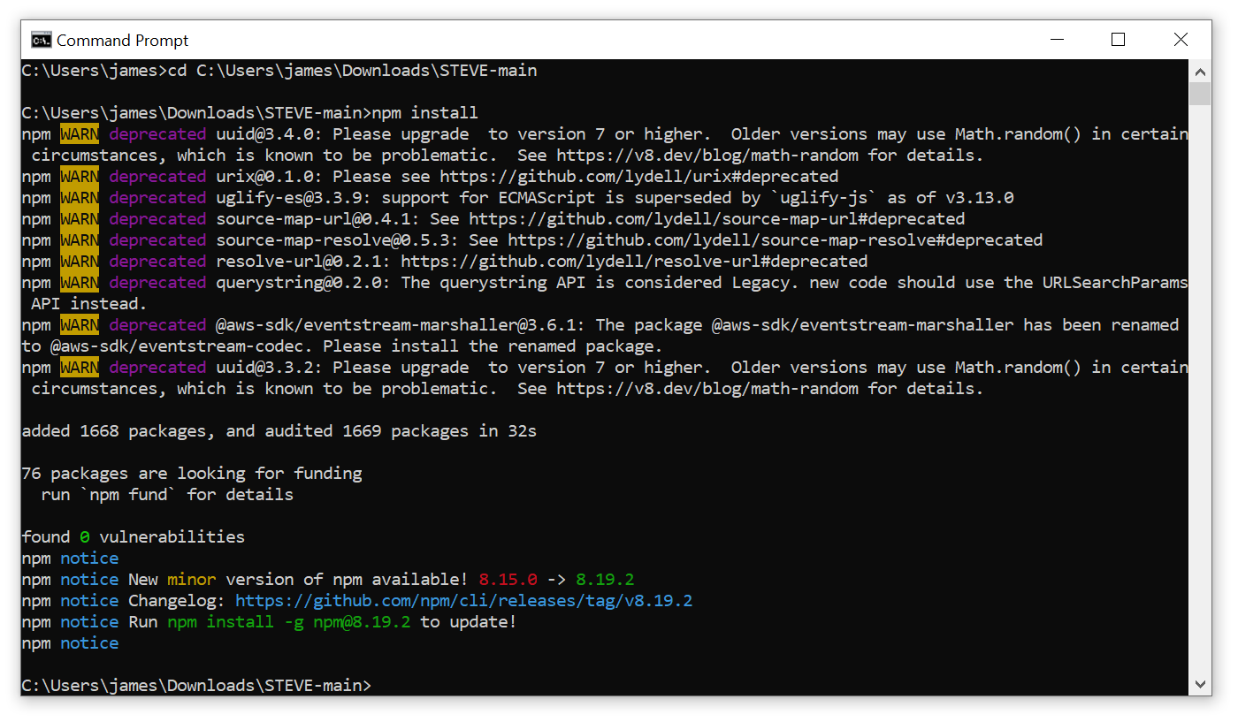

**10. Copy the supplied ‘aws-exports.js’ file into ‘STEVE-main\src’:**

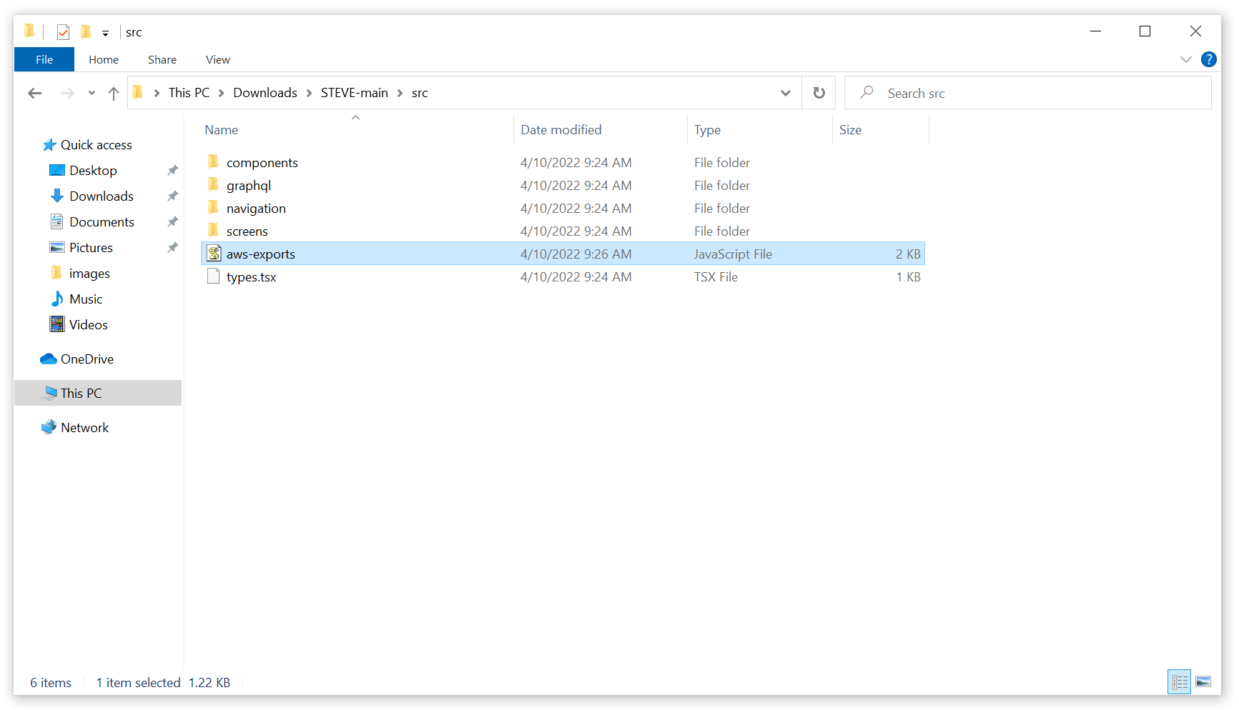

### Step 5: Install Android Studio & Configure an Android Emulated Device

**1. Navigate to** [**https://developer.android.com/studio**](https://developer.android.com/studio) **and click on the green button that says ‘Download Android Studio’:**

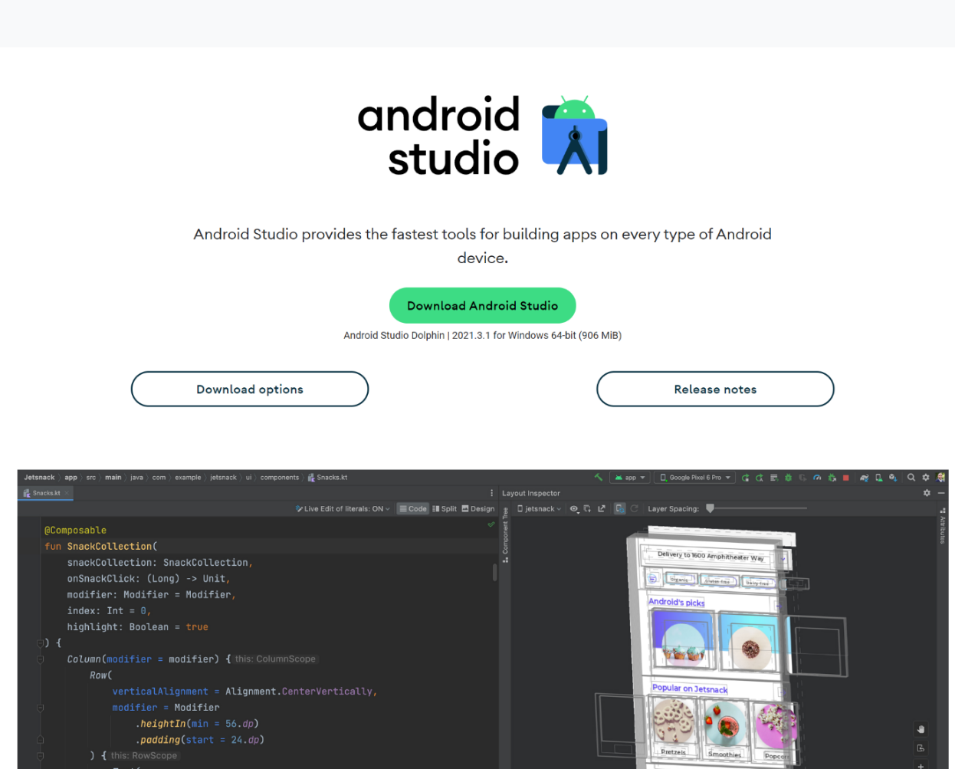

**2. Accept the terms and conditions and click on the green button to download Android Studio. Wait for the file to finish downloading:**

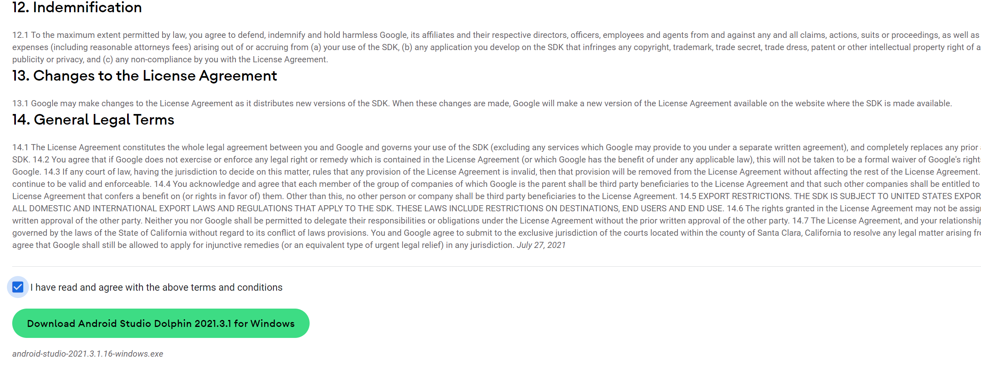

**3. Once the .exe file had finished downloading, click on it to begin the Android Studio installation process.**

**3a. If Windows asks if you want to allow the app to make changes to your device click on ‘Yes’.**

**4. Click ‘Next’:**

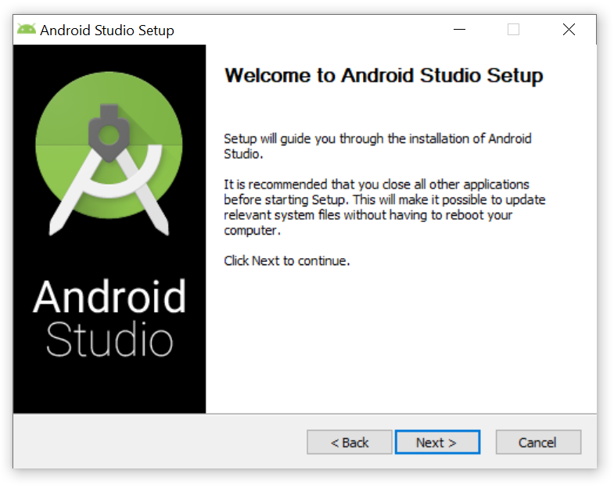

**5. Click ‘Next’:**

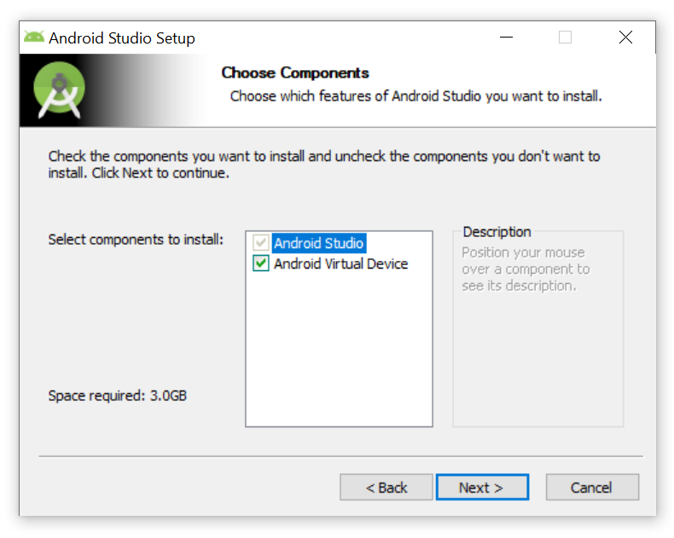

**6. Click ‘Next’:**

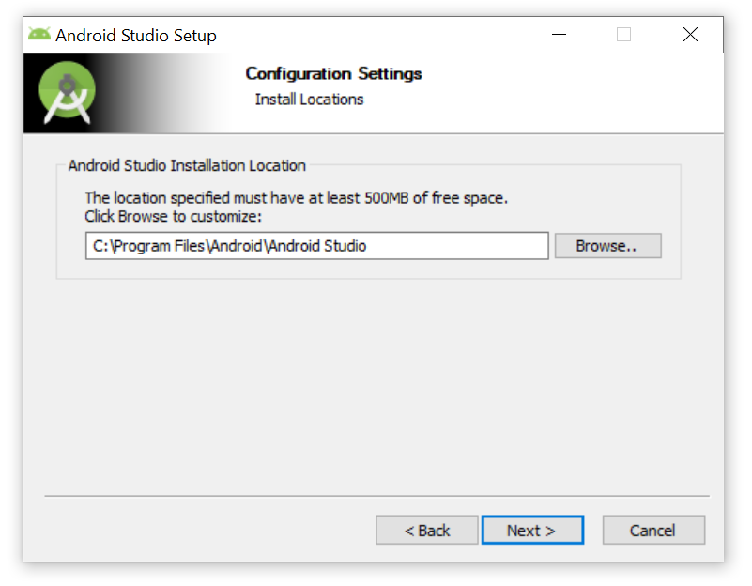

**7. Click ‘Install’ and wait for Android Studio to Install:**

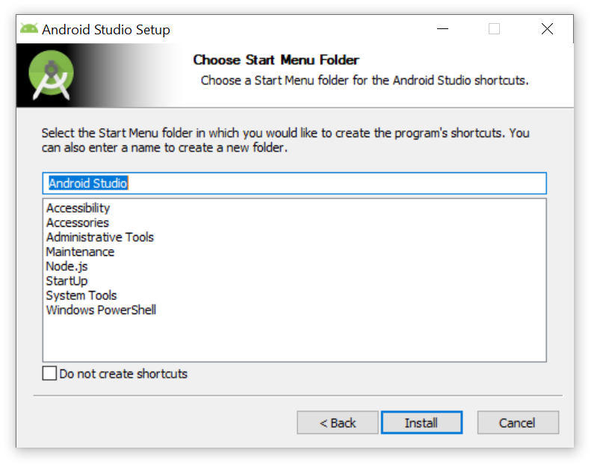

**8. Click ‘Next’:**

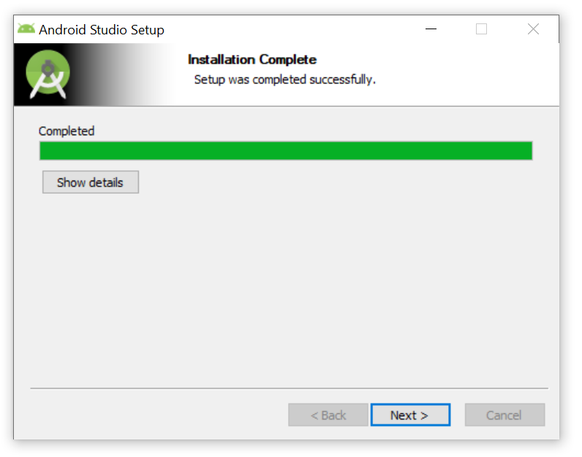

**9. Click ‘Finish’. Android Studio will now start:**

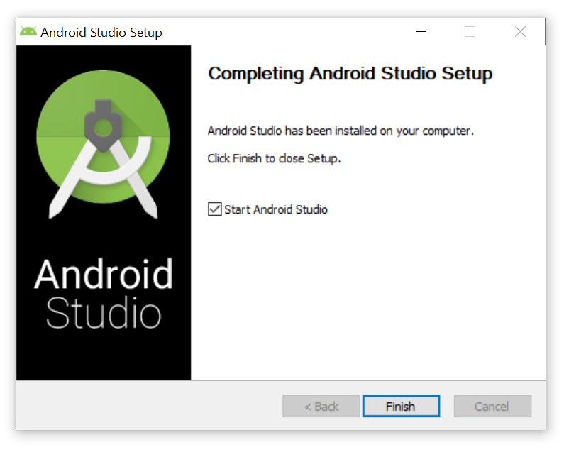

**10. Click ‘OK’:**

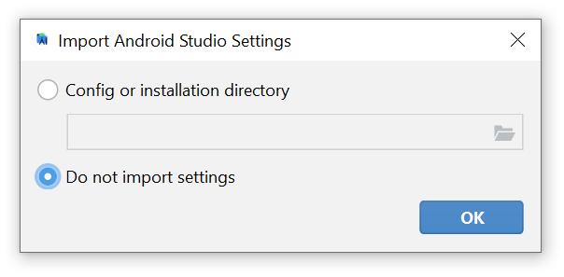

**11. Select ‘Don’t Send’ and click ‘Next’:**

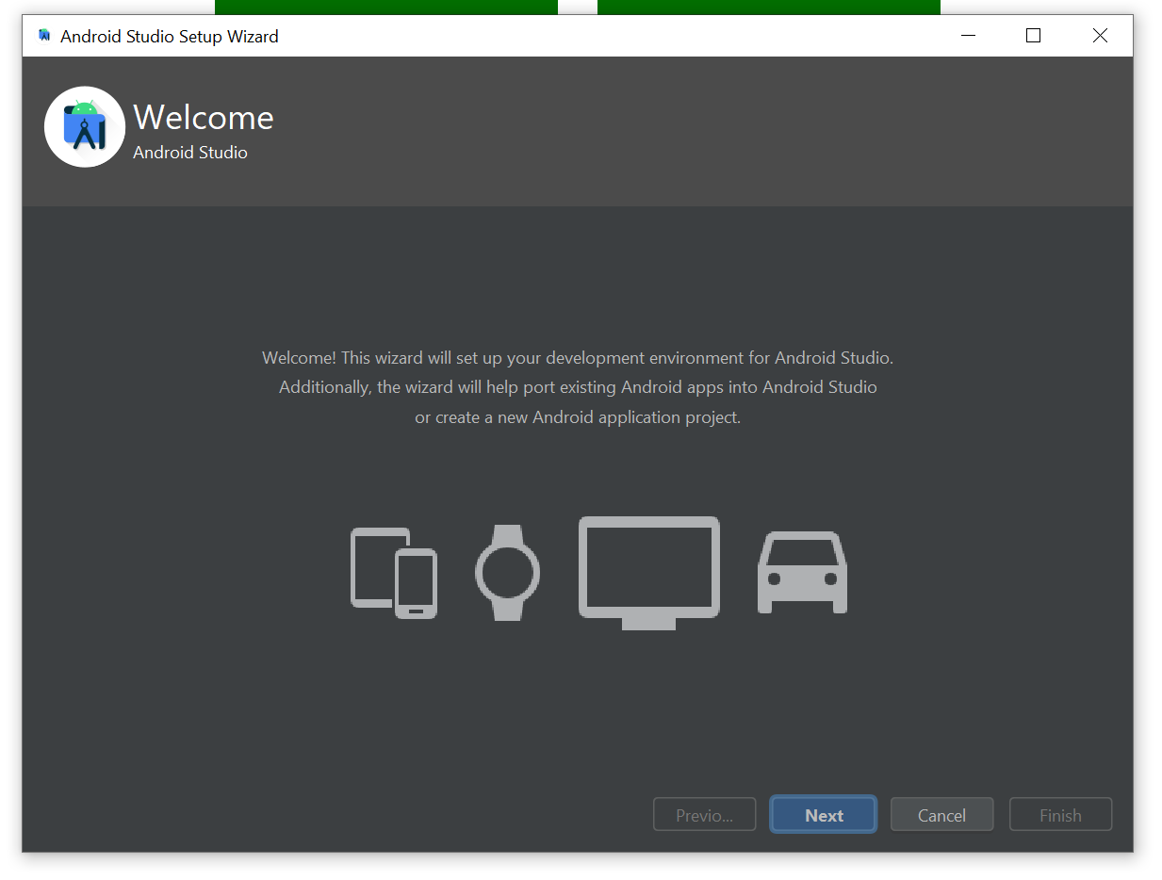

**12. Click ‘Next’:**

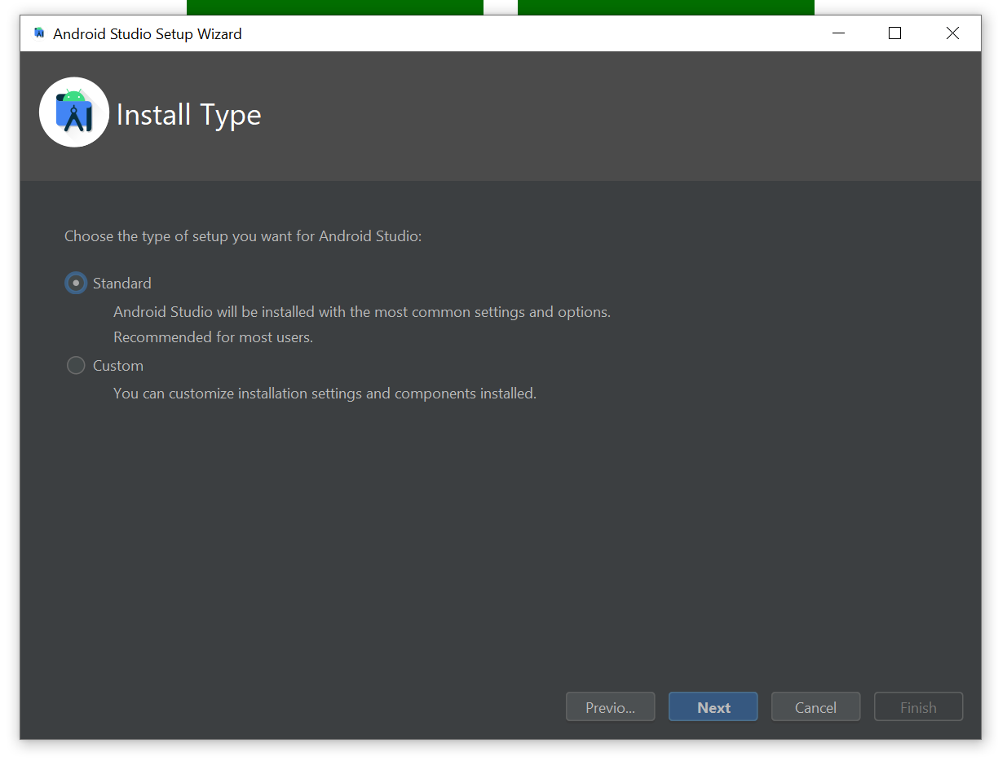

**13. Click ‘Next’:**

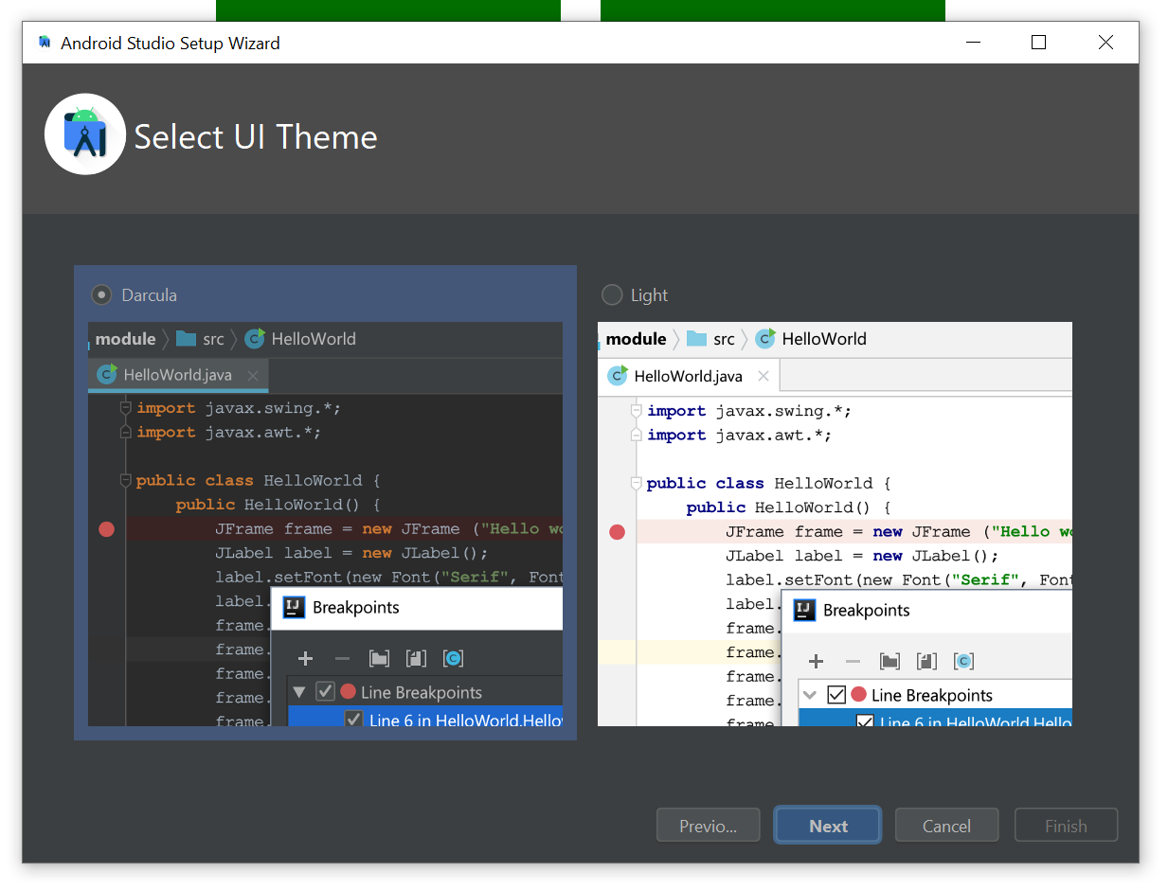

**14. Click ‘Next’:**

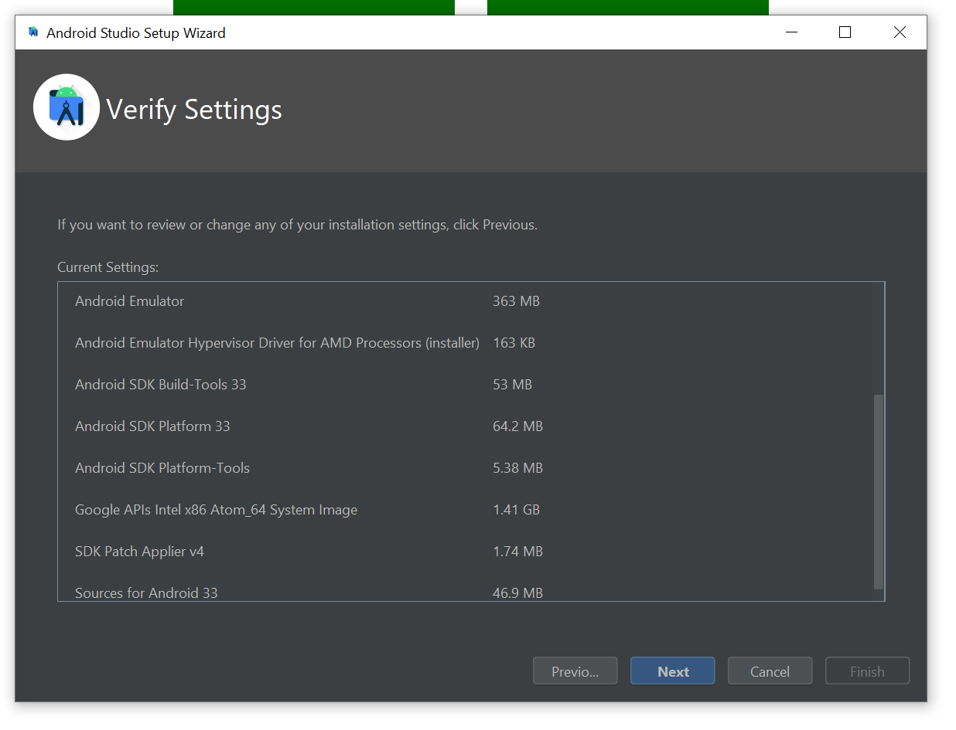

**15. Accept the ‘android-sdk-license' and the ‘android-sdk-preview-license' and click ‘Finish’ and wait for the download to finish:**

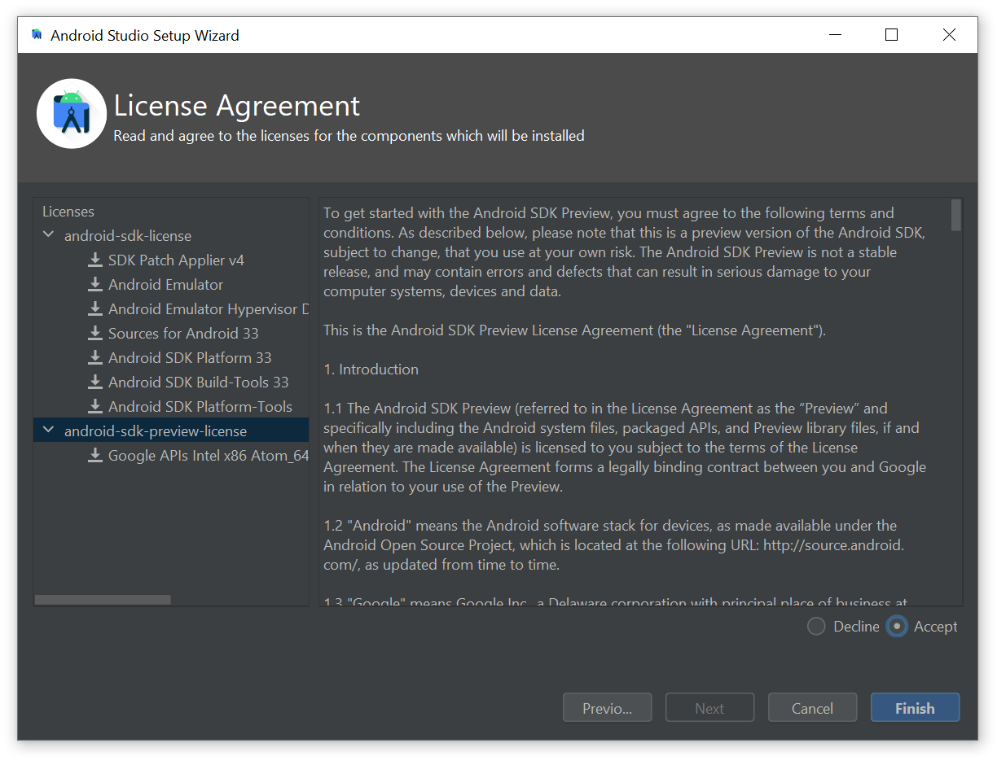

**15a. If Windows asks if you want to allow this app to make changes to your device click on ‘Yes’.**

**16. Click ‘Finish’:**

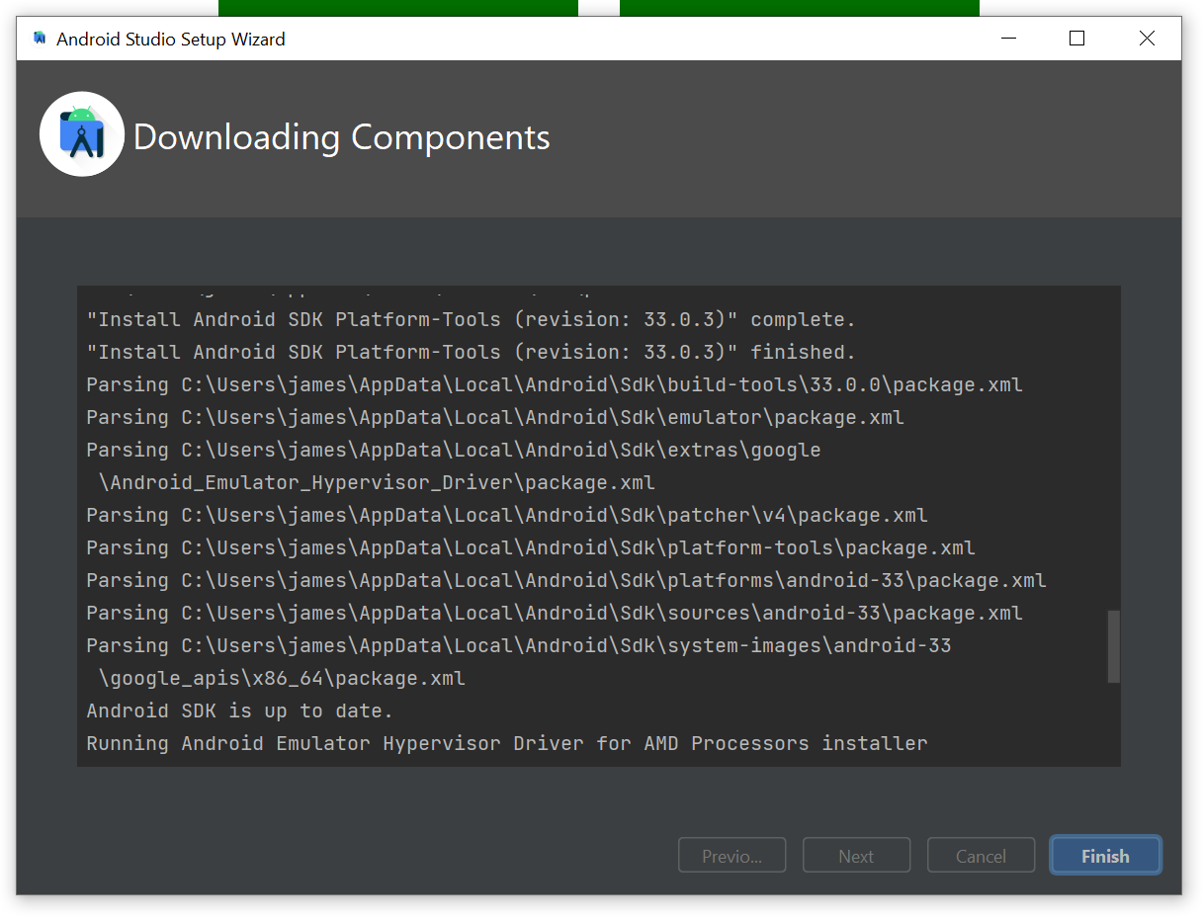

**17. Click on the blue text that says ‘More Actions’ and click on ‘Virtual Device Manager’:**

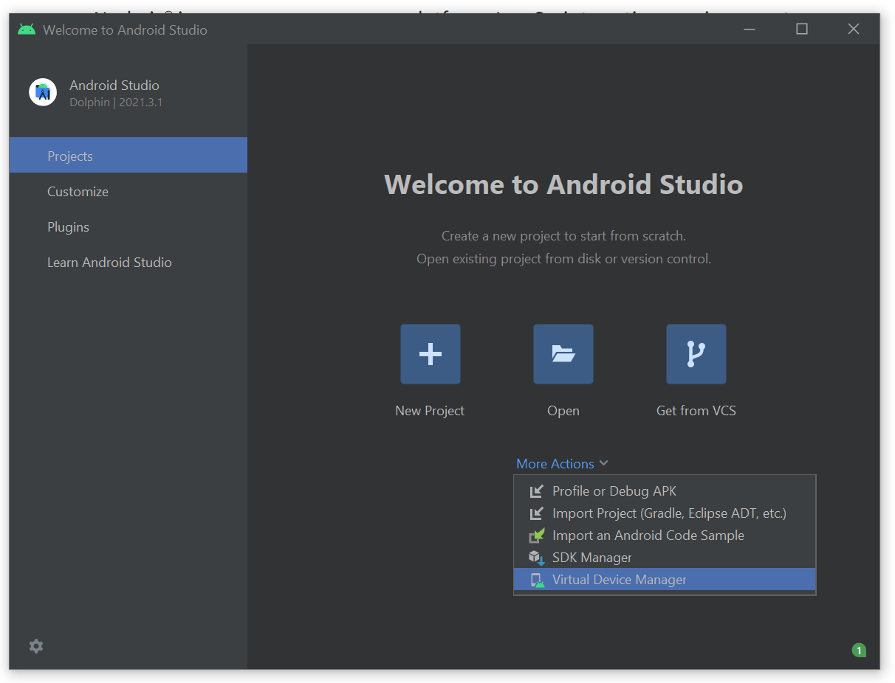

**18. Click on ‘Create device’:**

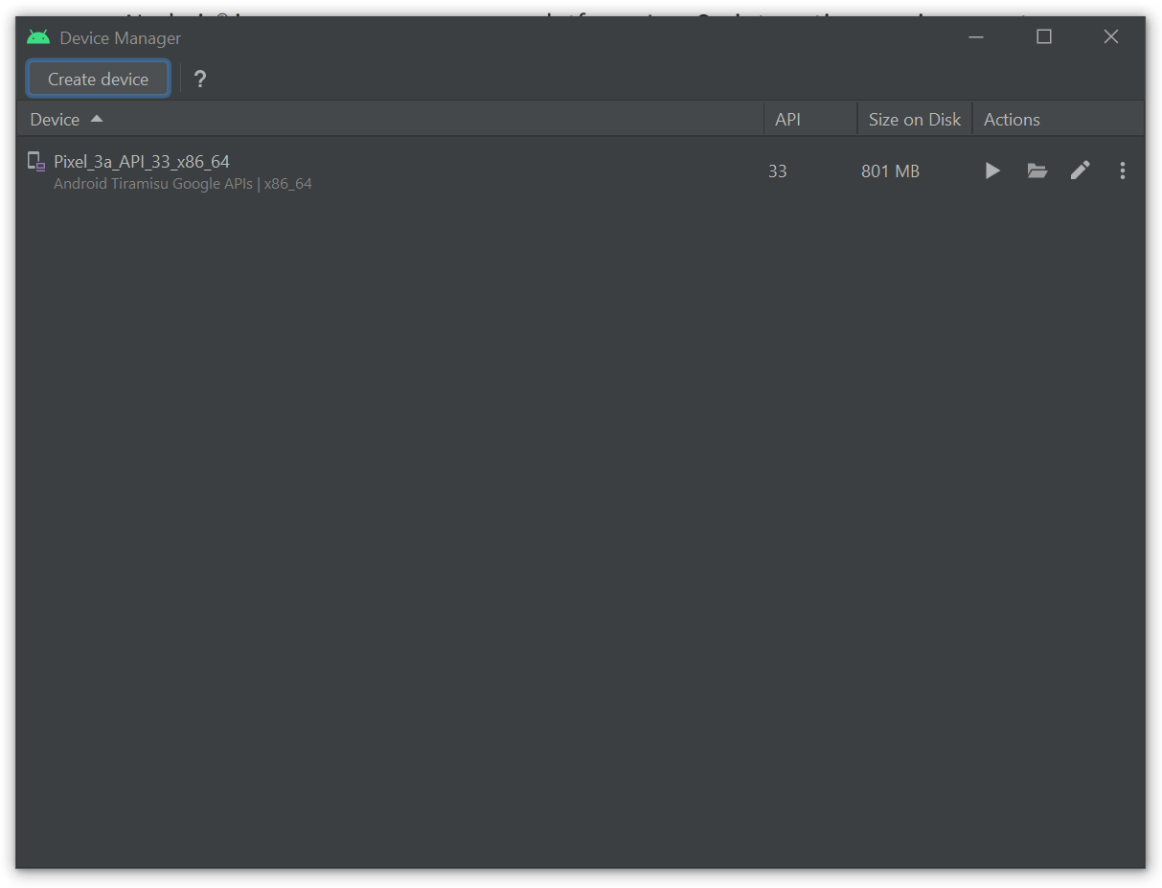

**19. Select ‘Pixel 5’ and click on ‘Next’:**

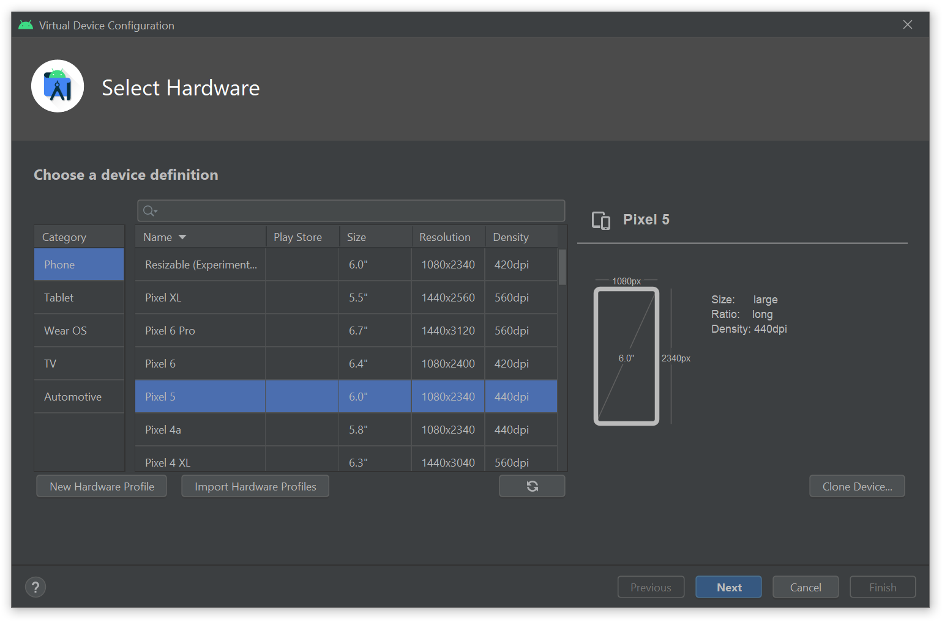

**20. Under ‘Release Name’, click on the Download icon next to ‘S’:**

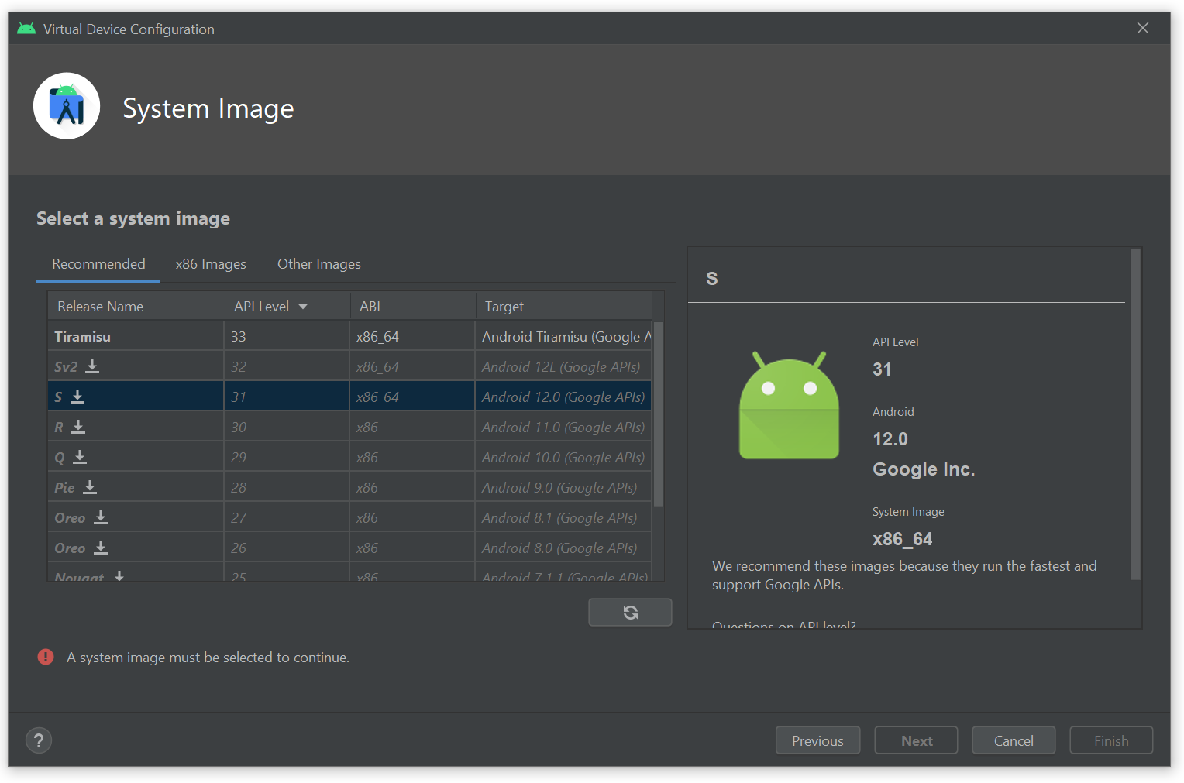

**21. Wait for the download to finish:**

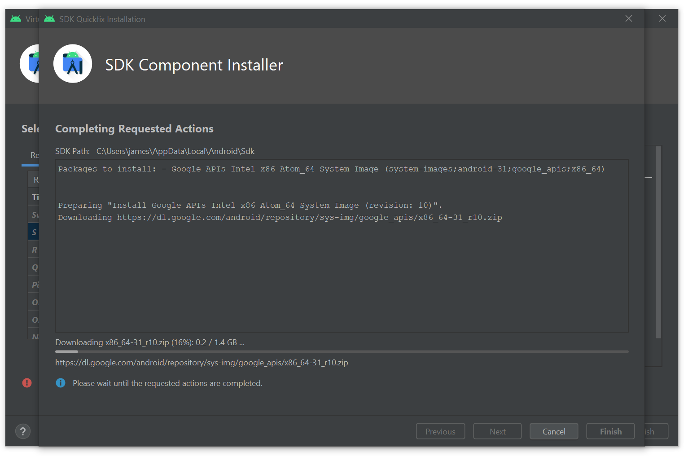

**22. Click on ‘Finish’:**

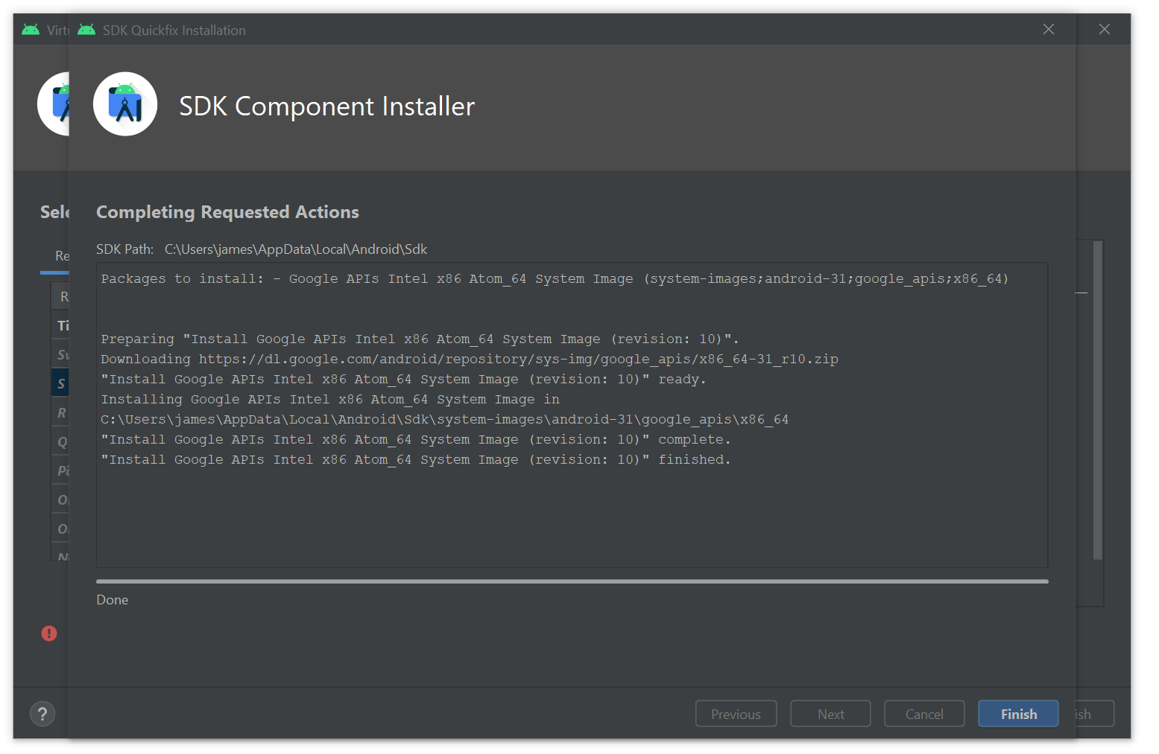

**23. Highlight the ‘S’ Release Name and press ‘Next’:**

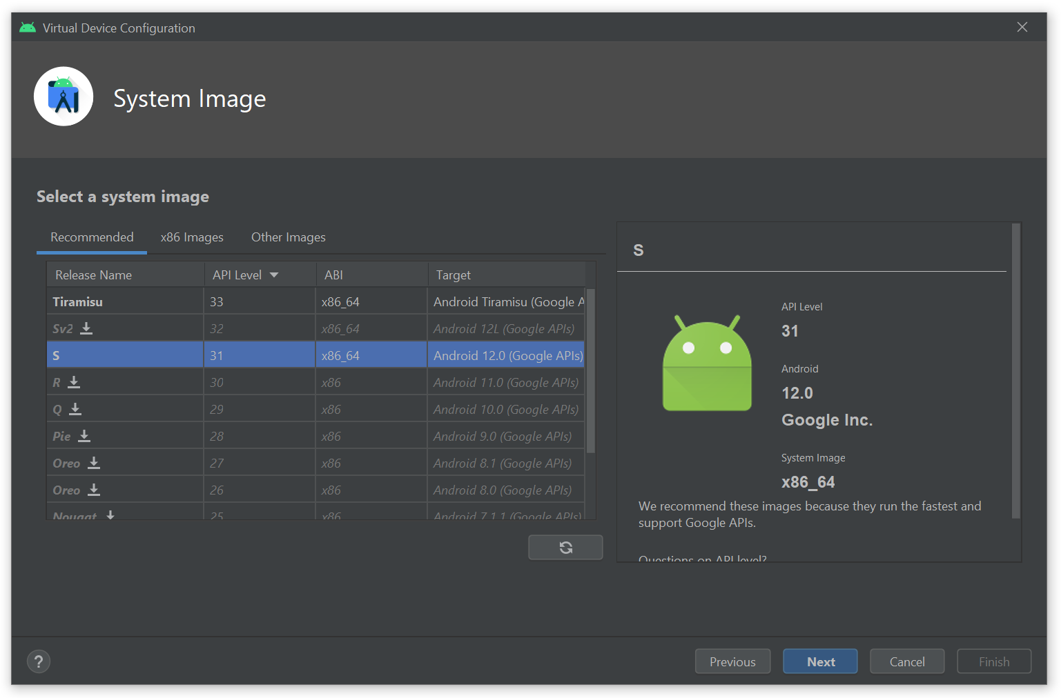

**24. Click on ‘Show Advanced Settings’**

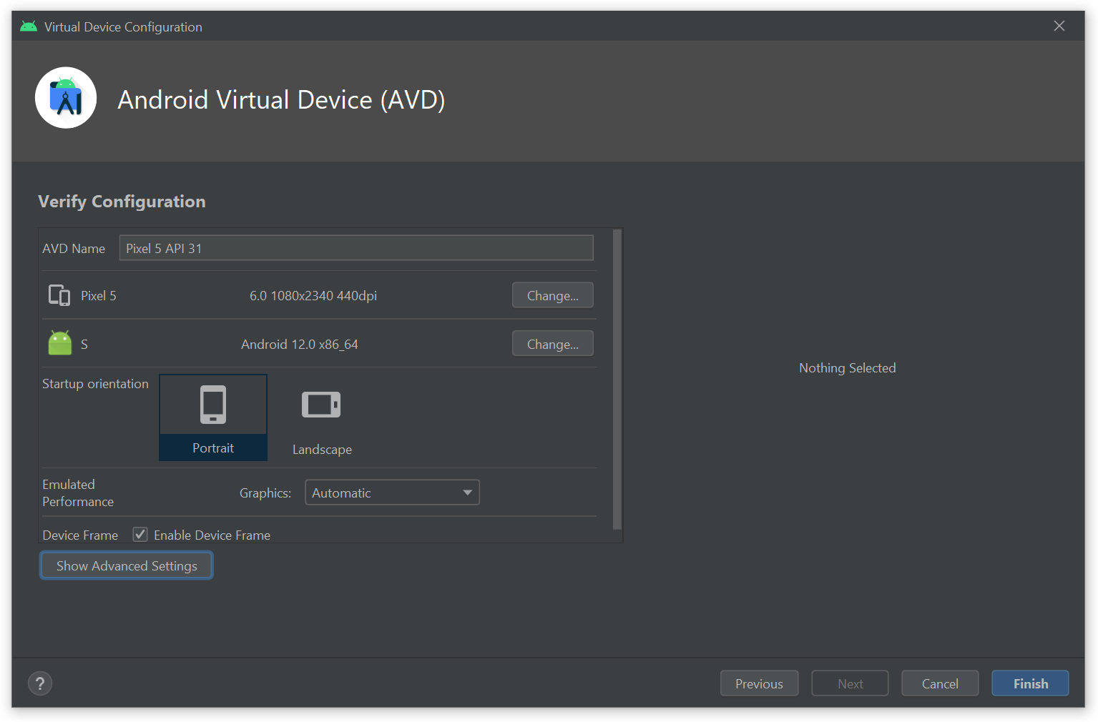

**25. Scroll down to where it says ‘Memory and Storage’ and set the ‘Internal Storage’ to 2000 MB and press ‘Finish’:**

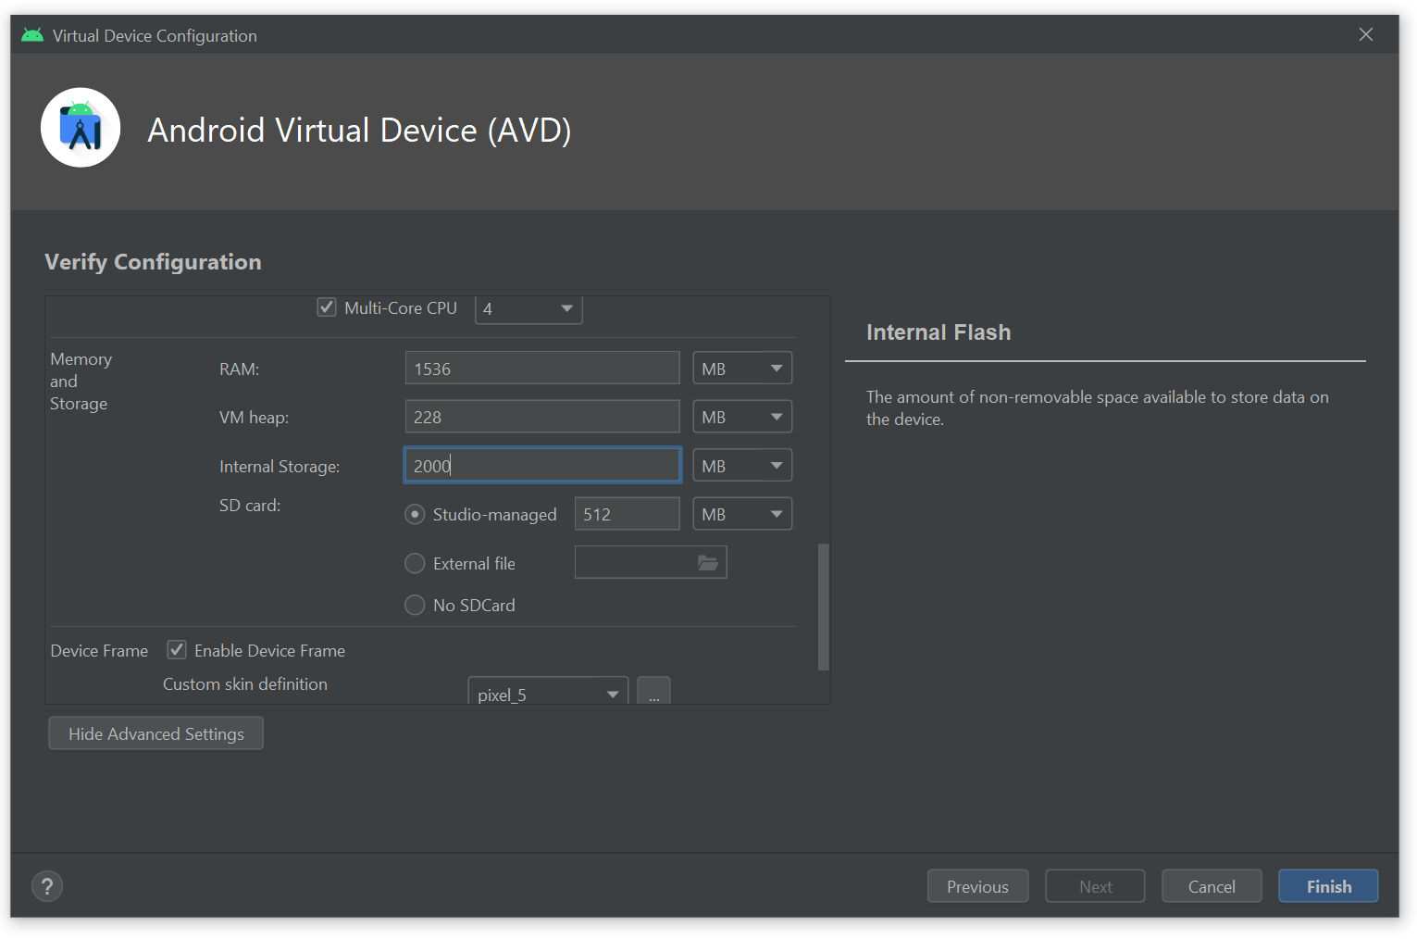

**26. For the new Pixel 5 emulated device you created, click on the white Play button that looks like a triangle:**

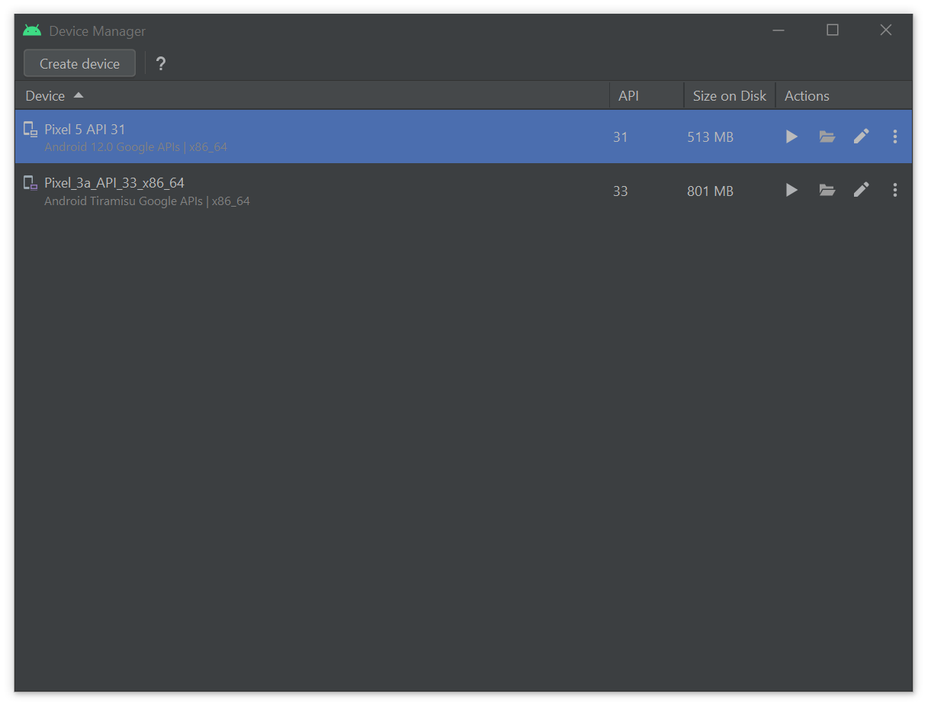

**27. If requested, click on Allow access to allow the device to connect through Windows Firewall:**

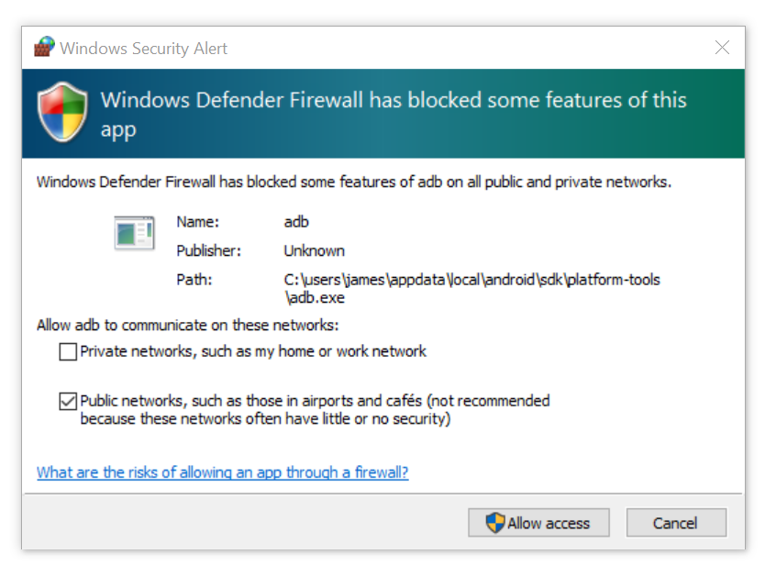

**28. Wait for the emulated Pixel 5 device to boot up:**

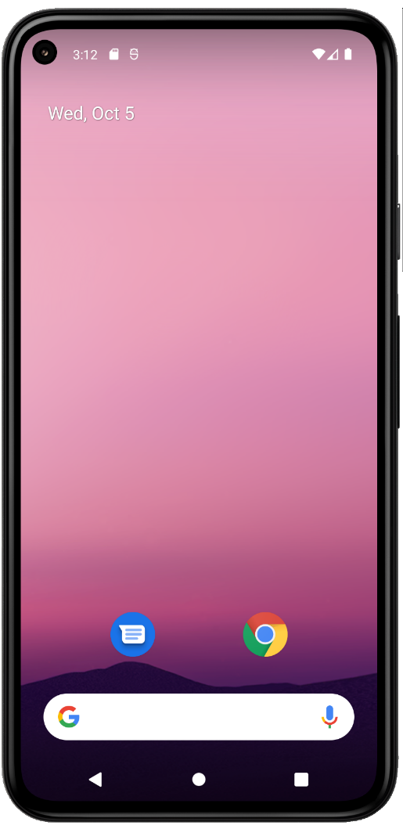

### Step 6: Installing Expo and booting up

**1. Once the device has booted up, open a Command Prompt and cd back into the STEVE-main directory:**

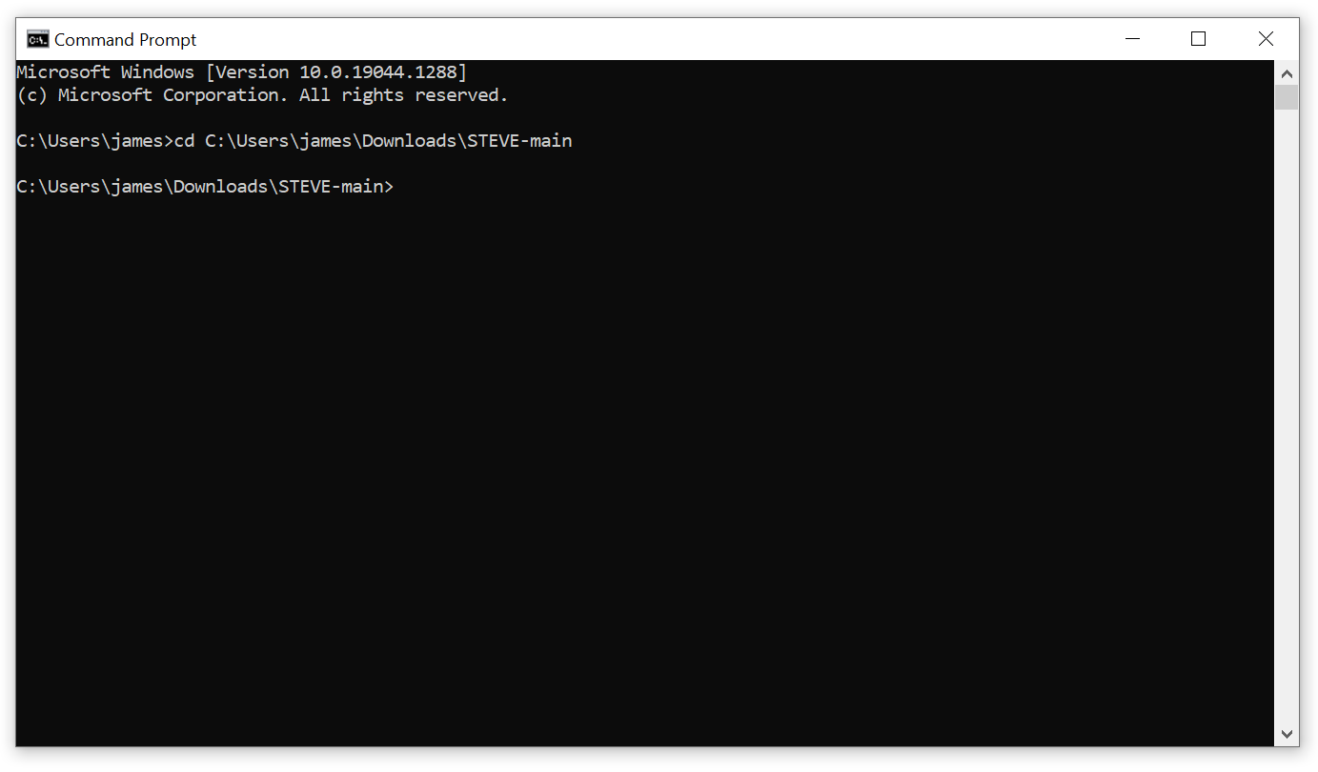

**2. Run:**

npx expo start

**and press Enter to install the Expo CLI globally:**

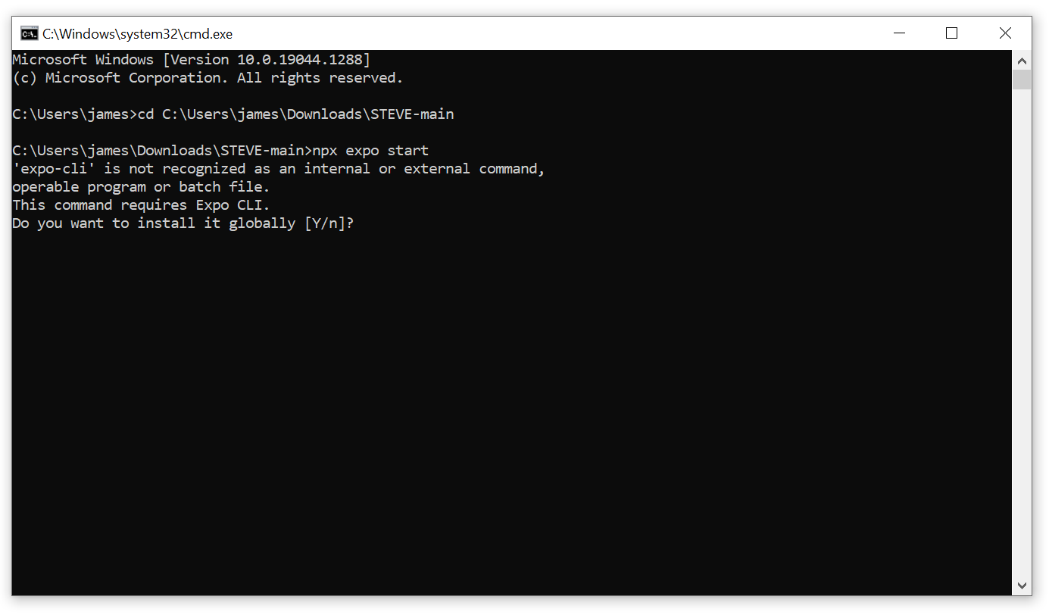

**2a. If Windows Defender Firewall asks if you would like to allow access, click on ‘Allow access’:**

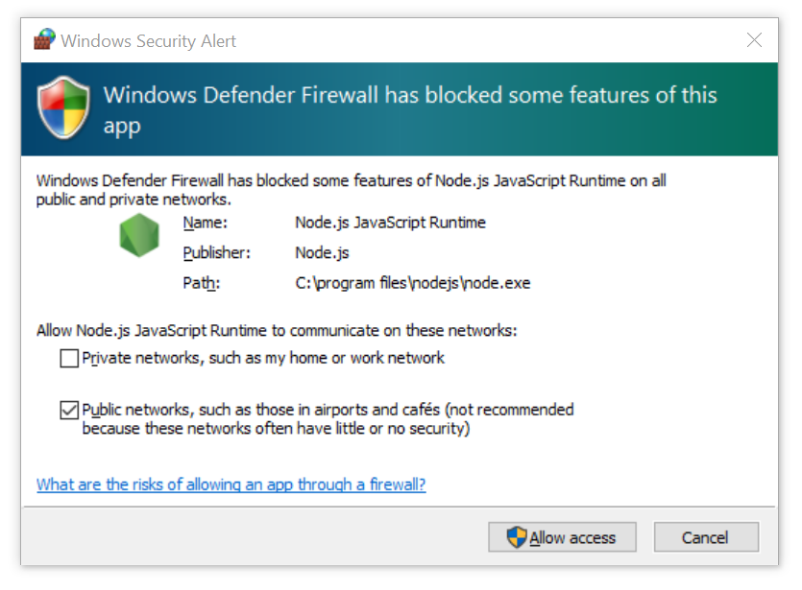

**3. Once the Expo CLI has been installed, the Expo CLI should have started and present a screen in Command Prompt that looks like this:**

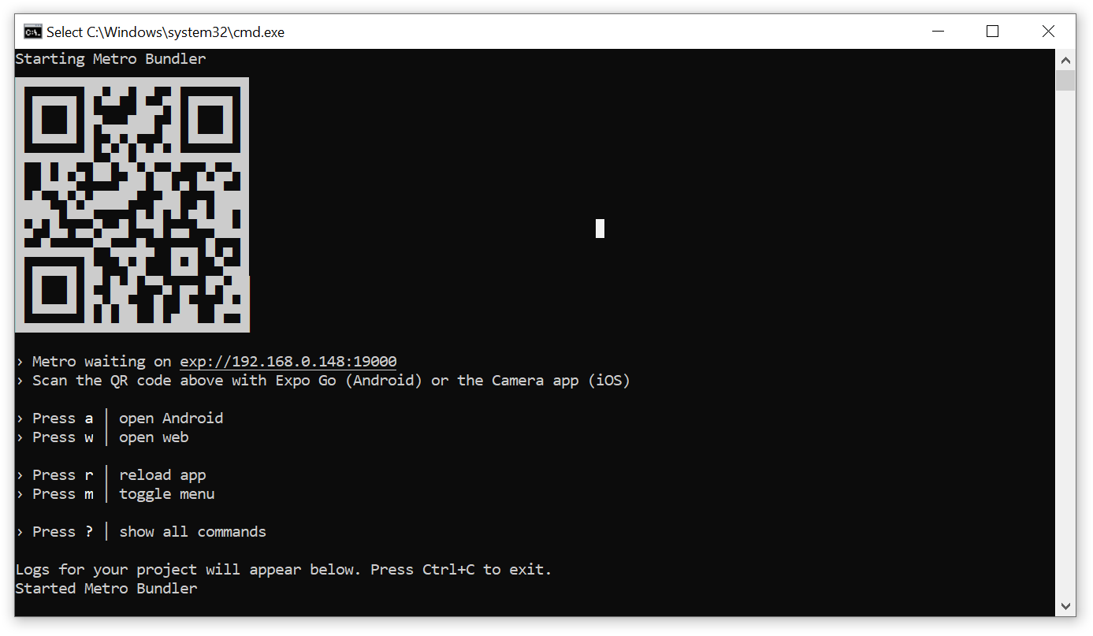

**4. Press ‘a’ in the Command Prompt Window to open the emulated Pixel 5 Android Device. The Expo Go app will now install on your emulated Pixel 5:**

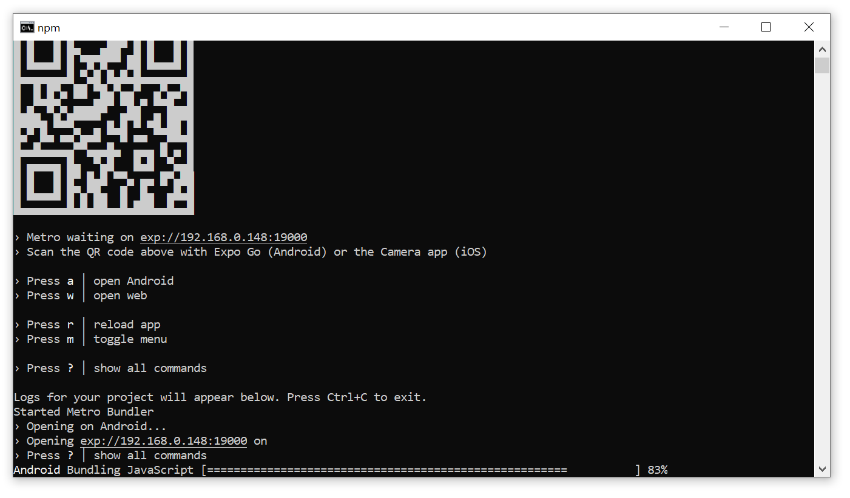

**5. If you go across to your emulated Pixel device, the Login page for the app will be shown:**

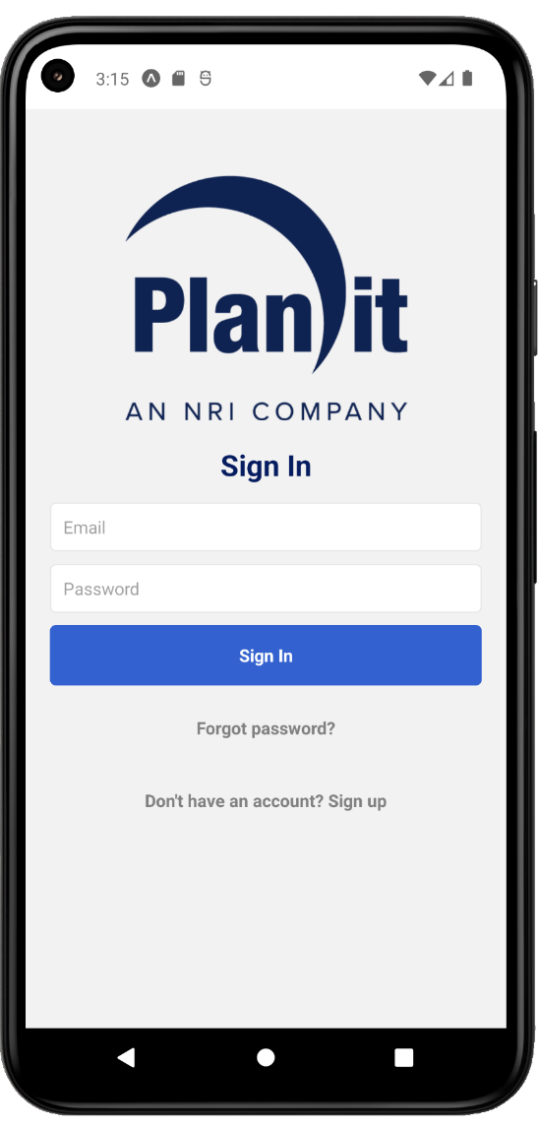

**6. Remember each session that when first signing into the app or creating an account, please allow 40-50 seconds between your first attempt and your second to allow the database compute functions to spin up. Once spun up, the database will only spin down again once it has been 20 minutes since the last API/SQL request.**

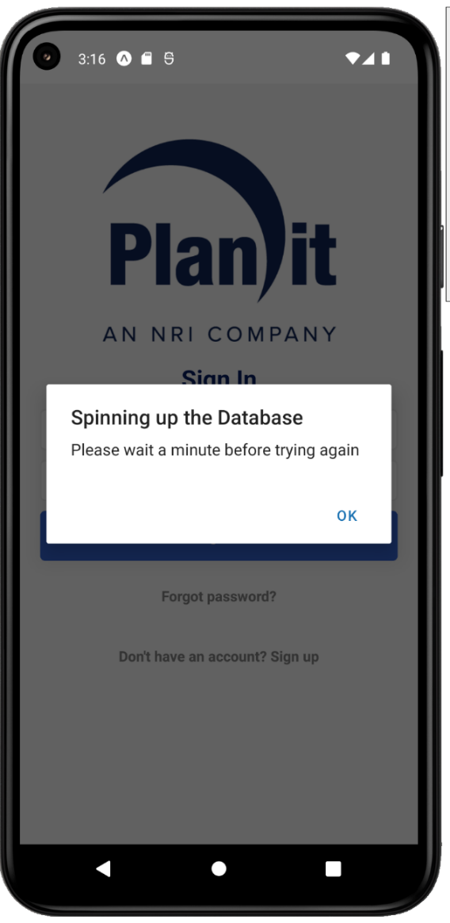

### Step 7: Cleaning Up

**1. If you’re done with the emulated Pixel 5 device, you may power it off in the same way you would an actual android phone:**

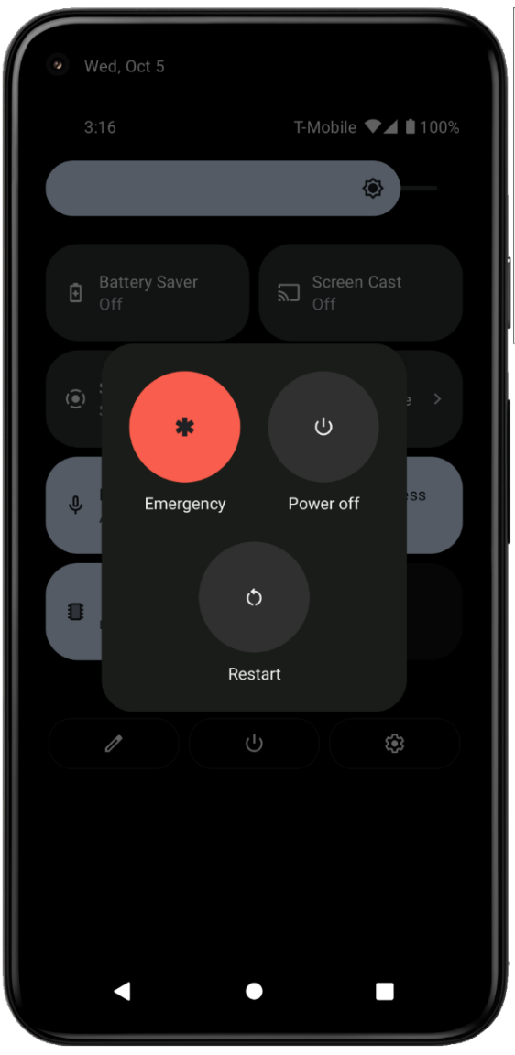

**2. Once shut down, you may close the Command Prompt window.**

### Step 8: Opening the app up again

**1. If you ever want to open the app up again, first start your emulated Pixel 5 Android Device in Android Studio:**

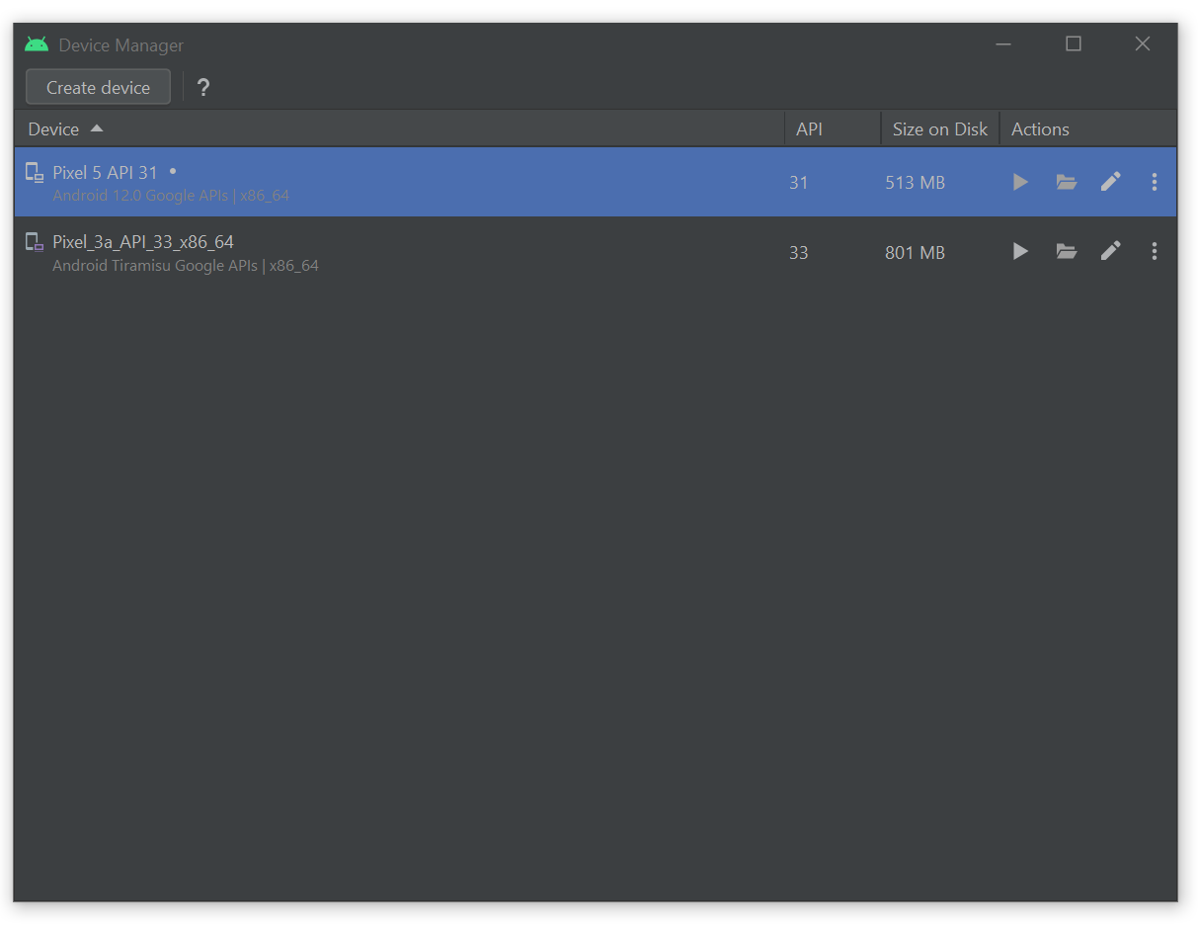

**2. Once the device has fully launched, open a Command Prompt and cd in the STEVE-main directory.**

**3. Then run:**

expo start

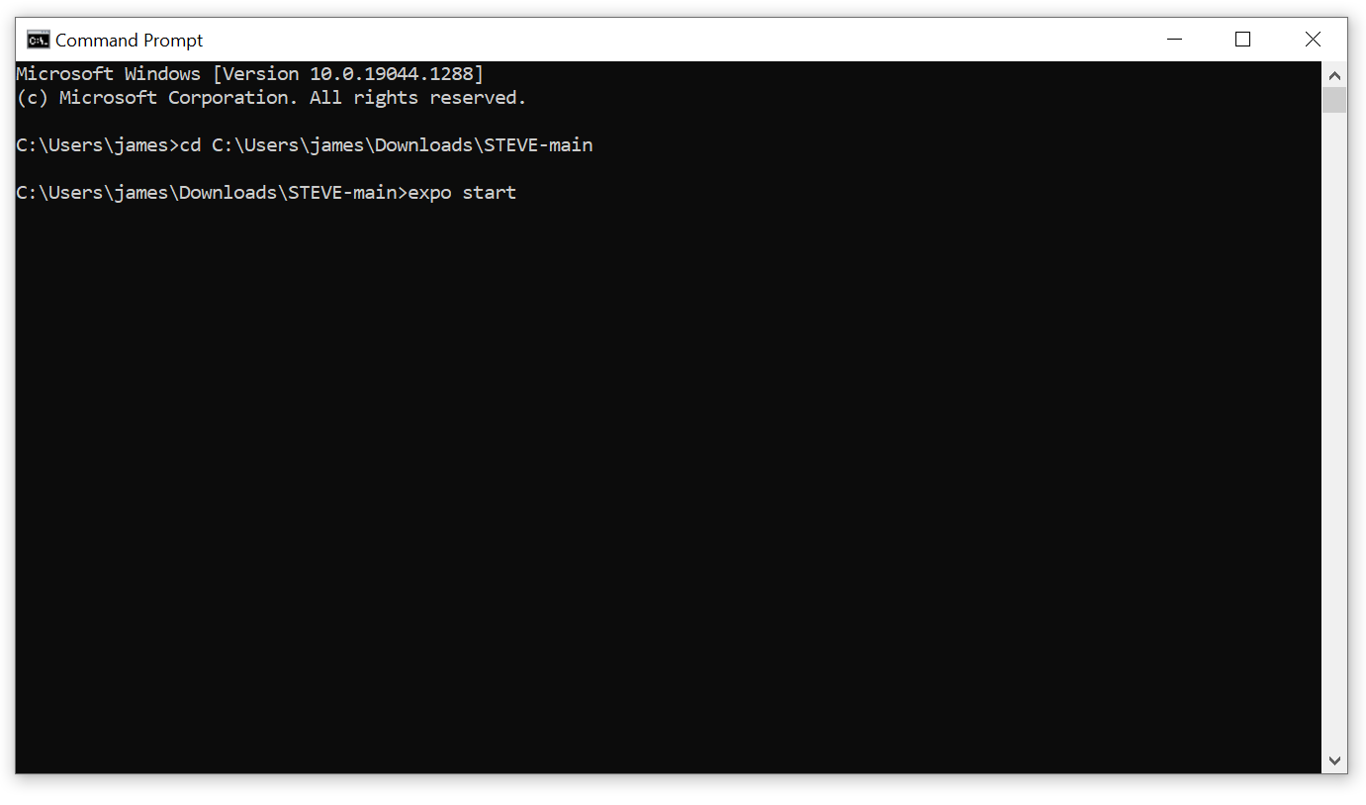

**4. Finally, press ‘a’ to launch the app**



# Glossary

**Amazon Aurora**

An AWS Backend-as-a-Service cloud relational database management system compatible with MySQL and PostgeSQL that allows the provisioning and scaling of a SQL database and integration with Amazon AppSync.

**Amazon Web Services (AWS)**

A Platform-as-a-Service cloud computing and hosting provider with very deep, broad and complex functionality created by Amazon.

**AWS Amplify**

An AWS service that helps to automate, create and connect a frontend application to an AWS backend implementation.

**AWS AppSync**

An AWS service that connects a frontend application to backend data sources through a GraphQL API.

**Cloudwatch**

An AWS observation and monitoring tool that allows the user to collect and monitor metrics to analyse them and act upon them.

**Cognito**

An AWS customer/user management tool that handles access control and the logic of users signing up, signing in and authenticating

**Dashboard**

A navigation tool that provides users the ability to navigate to different screens within an application.

**GraphQL**

An API query language with types designed to compete with traditional REST APIs.

**RDS**

An AWS relational database service to set up, manage and scale relational databases in the cloud.

**Secrets Manager**

An AWS security feature to handle the generation, storage and access to secret credentials and API keys.

**System Administrator**

A user who is in charge of maintaining and administering an application who has a high level of access.